Shorter than a Snooze

Quick and Effective Ideas to Support Quality Early Childhood Services

Camille Catlett
Frank Porter Graham Child Development Institute

(919) 966-6635 camille.catlett@unc.edu

Goal/Activity | Resources
What Comes First?  Goal: Learn sequences of development across domains  Activity:  - Draw a simple design (♥ ) on the back of the puzzle.  - Cut puzzle pieces apart, leaving frame intact.  - Mix up puzzle pieces, and then insert them in the correct developmental order. Tape pieces down when puzzle is complete. Turn puzzle over to check your answers | Developmental Milestone Puzzle
Oh Say, Can You See?  Goal: Develop skill for observing and objectively describing what children are doing  Activity:  - Make copies of the Observation Grid.  - Watch a brief video from the Videos for Observation section of the handout.  - Write down what you observe using objective descriptors.  - Compare notes with others who watched the same video. | Observation Grid  - Oh Say, Can You See resources
Oh See, Can You Say?  Goal: Increase understanding of the capabilities and challenges of each child; develop strategies for supporting each child  Activity:  - Select 1-2 children to observe carefully each week. Take notes on what you see. Consider:  What are this child’s strengths? What do they like? What do they find challenging? Who are their friends?  - Meet to compare notes. Discuss: What can you do to support each of the children you observed? How could you change the environment? Change the instructions? Change the materials? Change the topic? | Paper and pens for notetaking  - Oh See, Can You Say resources
How Many Concepts?  Goal: Identify ways to support development in multiple domains using every day activities (e.g., finger plays and songs, books)  - Finger plays and songs: Sing and go through the motions of a favorite finger play, such as the Itsy Bitsy Spider. Make a list of all the developmental domains that can be supported using that finger play.  - Favorite books: Read a favorite children’s book and identify the different concepts and domains addressed in the story (e.g., math, science, language, literacy, social studies, etc.) Discuss how to stretch the story out to emphasize different concepts and domains.  - New favorites with an emphasis on social-emotional development: Books Nooks | Rethinking Goldilocks and the Three Bears  - How Many Concepts resources

Goal/Activity | Resources
Let’s Go to the Movies  Goal: Develop skill at using effective teaching and assessment practices  Activity:  - Watch short films together and discuss how the concepts presented could be applied.  - Consider some of the following discussion questions: What did you see? What did you particularly like about what you saw? What ideas/practices did you observe? What In what ways are we already using these practices? In what ways could we incorporate them more effectively in our work?  - HINT: It’s often helpful to watch the film once to get the gist of the story, then watch it a second time to carefully note the effective practices. | Let’s Go To The Movies resources
Fabulous and Free  Goal: Develop skill at using effective teaching and assessment practices  - Natural Resources: Download and discuss Natural Resources that are relevant to your work.  - Growing Ideas Tipsheets and Resources for Guiding Early Childhood Practices: Download and discuss (or view) resources developed to support evidence-based practices.  - 15-Minute In-Services - Free resources (video, handouts, instructors guides) for providing professional development | Fabulous and Free resources
Take Care of You | See page 8 of the handout set

RESOURCES

Oh Say, Can You See
Monkey Business Illusion http://www.youtube.com/watch?v=IGQmdoK_ZfY
Alison Gopnick on Colbert
http://www.colbertnation.com/the-colbert-report-videos/251996/october-07-2009/alison-gopnik
Twins in kitchen http://www.youtube.com/watch?v=W9mcgKqQPcs
Clips for Practicing Observation, Documentation, and Assessment Skills http://www.cde.state.co.us/resultsmatter/RMVideoSeries_PracticingObservation.htm
Pathways Awareness Foundation videos (especially Is My Baby OK?) http://www.youtube.com/user/PathwaysAwareness

Oh See, Can You Say
Milbourne, S.A., & Campbell, P.H. (2007).CARA’s kit: Creating adaptations for routines and activities. Missoula, MT: DEC.

Campbell, P., Kennedy, A., & Milbourne, S. (2012). Cara’s kit for toddlers: Creating adaptations for routines and activities. Baltimore, MD: Brookes Publishing.

How Many Concepts?
Book Nooks http://csefel.vanderbilt.edu/resources/strategies.html
Universal Design for Learning http://npdci.fpg.unc.edu/universal-design-ud-universal-design-learning-udl

Your Tax Dollars at Work

Fabulous and Free
Natural Resources: To subscribe to the Natural Resources listserv, send an email with no message to
subscribe-natural_resources2@listserv.unc.edu
Note the hyphen and underscore characters.

15 Minute In-Services http://eclkc.ohs.acf.hhs.gov/hslc/tta-system/teaching/center/practice/ISS

Early Childhood Learning and Knowledge Center
http://npdci.fpg.unc.edu/resources/quality-inclusive-practices-resources-and-landing-pads

National Center on Cultural and Linguistic Responsiveness
http://eclkc.ohs.acf.hhs.gov/hslc/tta-system/cultural-linguistic

National Dissemination Center for Children with Disabilities http://nichcy.org/

Let’s Go to the Movies

Title | Source | Description | Cost
A Creative Adventure: Supporting Development and Learning through Art, Movement and Dialogue | http://eclkc.ohs.acf.hhs.gov/hslc/hs/resources/  video/Video%20  Presentations/ACreativeAdvent.htm | Using culturally, linguistically, and ability-diverse children and staff, this 13-minute video and guide depicts different kinds of creative activities (art, music, dance, play) that can support development and learning. The narrative provides important content (e.g., relationship between emergent literacy and dramatic play) and suggestions for adults (e.g., give them time, listen to their questions). The format of the guide offers research, trainer tips, activities and resources for each segment of the video. These products are also available in Spanish. | FREE
Rita Pierson: Every Kid Needs a Champion | http://www.youtube.com/watch?v=SFnMTHhKdkw | This clip highlights the qualities that every child deserves in a teacher: champion and unflagging advocate. Sadly, Rita Pierson died shortly after she recorded this TED Talk in 2013. | FREE
My Name is Jude | http://www.youtube.com/watch?v=99JKYiMbLcQ&feature=youtu.be | Here’s a fabulous family perspective on their child’s capability and how each early childhood professional can support that. | FREE
I’m Tyler: Don’t Be Surprised | http://www.imtyler.org | Ever find yourself looking for an inspiring video to use in a discussion about the benefits of early intervention or inclusion? Consider this one. Tyler is a typical high school student who happens to have cerebral palsy and some other challenges. This short DVD offers a peek into his life, a life in which people who practice “ability awareness” have realized that what a child CAN do is much more important than what he can’t do. Watch and learn what a difference you can make in one child’s participation in school and community life. | $5.00*

Let’s Go to the Movies (continued)

Title | Source | Description | Cost
Starting Small: Teaching Tolerance in Preschool and the Early Grades | Southern Poverty Law Center/ Teaching Tolerance  http://www.tolerance.  org/kit/starting-small | Video and training kit offer strategies for supporting inclusion, social-emotional development and anti-bias approaches in early childhood settings. The 58-minute DVD highlights seven exemplary programs at sites throughout the country. One free set of these materials is available to programs serving young children. A written request on letterhead from the principal, director or teacher is required. | FREE
*There is a $5.00 charge if you wish to purchase your own copy of I’m Tyler. You may watch the film online at no cost.

OBSERVATION GRID

Communication | Cognitive
Motor | Social-Emotional

Developmental Milestone Puzzle

Instructions: Arrange the cut-out squares into appropriate age / skill categories | 2-3 years | 3-4 years | 4-5 years | 5+ years
Large motor skills | Jumps in place on floor, with two feet together | Hops on one foot | Walks up and down stairs alone, alternating feet | Skips using alternate feet
Fine Motor Skills | Strings several large beads on a string | Builds a tower of nine small blocks | Copies a square using a crayon | Prints numerals “1” to “5”
Language Skills | Makes negative statements [for example, “Can’t open it.”] | Repeats at least one nursery rhyme and can sing a song | Tells the content of a story, but may confuse the facts | There are few obvious differences between child’s and adult’s speech
Social Skills | Plays house, imitating basic domestic activity | Joins in play with other children and begins to interact with them | Dramatic play is closer to reality, with attention paid to detail, time and space | Plays simple table games [such as “Candy Land”]
Self-help skills | Washes and dries hands with assistance | Pours well from small pitcher | Cuts and spreads soft or easy foods with a knife | Can tie a bow [for example, in tying shoes]

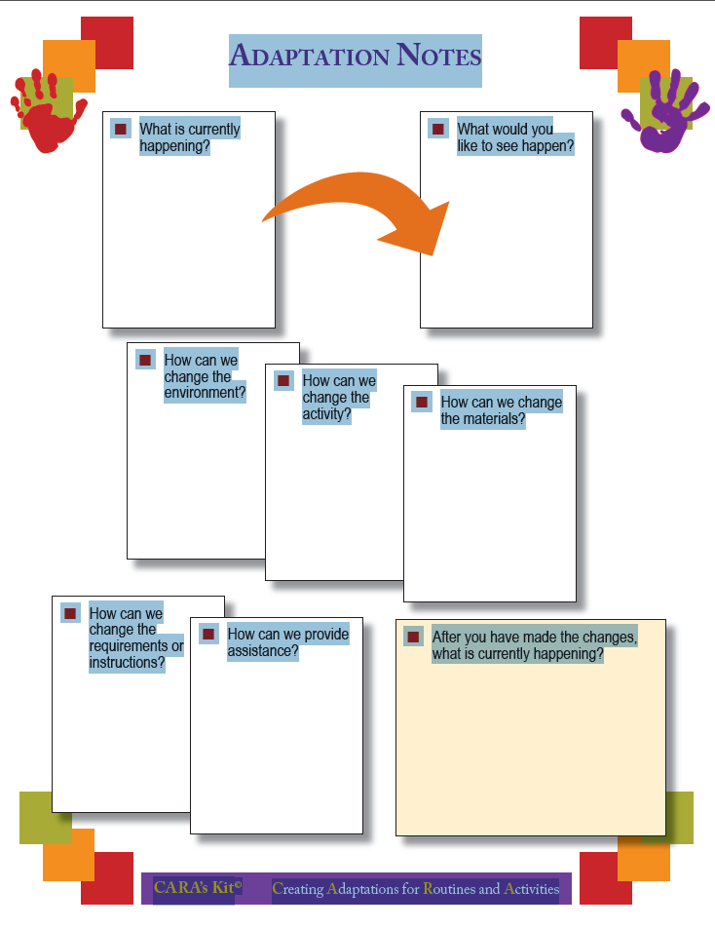
Rethinking Goldilocks and the Three Bears

Science: temperature (hot and cold)
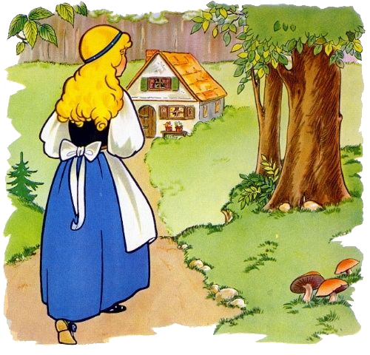]

Math: counting, size comparisons

Language:
Synonyms
Porridge – cereal, oatmeal
Forest – woods
Cottage – house
Afraid – scared

Superlatives (big, bigger, biggest; cold, just right, hot)

Social Studies: map of the woods, things in the bear’s home, the path they might take if they were to go on a walk

Safety: Is it wise to go walking alone?

Critical thinking:
- Has anyone ever used anything that belonged to you without your permission? How did you feel? WHY did you feel this way?
- Is it OK to enter someone’s house when they’re not home?

With thanks to Sherry Sancibrian

Two-Minute Rock Check

A teacher stood before his class and had some items in front of him. When the class began, wordlessly he picked up a large empty jar and proceeded to fill it with rocks, rocks about 2" in diameter. He then asked the students: is the jar full?

They agreed that it was.

So the professor then picked up a box of pebbles and poured them into the jar. He shook the jar lightly. The pebbles, of course, rolled into the open areas between the rocks. He then asked the students again: is the jar full?

They agreed that it was.

Then the teacher picked up a box of sand and poured it into the jar. Of course, the sand filled up everything else.

Now, said the teacher, I want you to recognize that this is your life.
- The rocks are the important things - your family, your partner, your health, your children - things that if everything else was lost and only they remained, your life would still be full.

- The pebbles are other things that matter like your job, your house, your car.

- The sand is everything else. The small stuff. If you put the sand into the jar first, there is no room for the pebbles or the rocks. The same goes for your life. If you spend all your time and energy on the small stuff, you will never have room for the things that are important to you.

Pay attention to the things that are critical to your happiness. Play with your children. Take time to get medical checkups. Take your partner out dancing. There will always be time to go to work, clean the house, give a dinner party, and fix the disposal.

Take care of the rocks first - the things that really matter. Set your priorities. The rest is just sand.

Handout developed by Camille Catlett (919) 966-6635 camille.catlett@unc.edu. This handout is available to download at http://www.fpg.unc.edu/presentations/shorter-snooze-quick-and-effective-ideas-support-quality-early-childhood-services

