From All to Each and Every:
Building a Consistent, Statewide Emphasis on Full Participation and Equity
Session 422

Amy Bolger  Vermont Child Development Division  Amy.Bolger@vermont.gov | Camille Catlett  FPG Child Development Institute  camille.catlett@unc.edu | Melissa Riegel-Garrett  Vermont Child Development Division  melissa.riegel-garrett@vermont.gov

- Evolving National Context for Full Participation and Equity

Transforming the Workforce for Children Birth Through Age 8: A Unifying Foundation
The Institute of Medicine’s seminal report supports building a workforce unified by the science of child development and early learning and the shared knowledge and competencies needed to provide consistent, high-quality support for the development and early learning of children from birth through age 8.
Source: http://www.nationalacademies.org/hmd/Reports/2015/Birth-To-Eight.aspx

Power to the Profession
Power to the Profession is a national collaboration to define the early childhood profession by establishing a unifying framework for career pathways, knowledge, and competencies, qualifications, standards, and compensation.
Sources: https://www.naeyc.org/our-work/initiatives/profession
https://www.naeyc.org/our-work/initiatives/profession/decision-cycles/power-profession-decision-cycles-3456

Draft Professional Standards and Competencies for Early Childhood Educators
The second public draft of this document includes references for each standard, a glossary, and, most importantly, a first draft of the leveling of the standards and competencies to the ECE I, II and III levels recommended in Power to the Profession.
Source: https://www.naeyc.org/resources/position-statements/draft-professional-standards-competencies

NAEYC Position Statement: Advancing Equity in Early Childhood Education
Although equity and diversity are referenced in our NAEYC’S core values and beliefs, they have never had a separate position statement focused solely on these issues. Based on multiple drafts and significant feedback, this position statement was approved by the Governing Board in April 2019.
Source: https://www.naeyc.org/resources/position-statements/equity-draft

Culturally Responsive Teaching
This document starts by defining culturally responsive teaching (CRT) and delineating the benefits to children and families that accrue from teachers who are prepared to implement CRT. Teacher competencies that promote CRT are spelled out and followed by an analysis of ways in which professional teaching standards are being used to build a diverse pool of educators who are prepared to demonstrate culturally responsive teaching. Author Jenny Muniz also shows how the teacher competencies in each state stack up and provides excerpts from excellent teaching standards to serve as models.
Source: https://d1y8sb8igg2f8e.cloudfront.net/documents/Culturally_Responsive_Teaching_2019-03-28_130012.pdf

- The Vermont Guiding Principles¹

- Models of Change
- Bradshaw, W. (2013). A framework for providing culturally responsive early intervention services. Young Exceptional Children, 16(1), 3-15. ¹
- Bank Street Center on Culture, Race and Equity Model of Change¹
https://www.bankstreet.edu/our-work-with-schools-and-communities/bank-street-education-center/center-on-culture-race-equity/ccre-approach/
- Equity Action Framework: Racial Equity in Early Childhood System¹
http://buildinitiative.org/Portals/0/Uploads/Documents/Work/LearningCommunity/2017BUILDNationalMeeting/EquityActionFramework.pdf

- Building a Consistent, Statewide Emphasis on Full Participation and Equity

- Vocabulary
- All → Each and every
- Parents → Families or Parents and Families
- Inclusion → Full participation

Early Childhood Inclusion
Early childhood inclusion embodies the values, policies, and practices that support the right of every infant and young child and his or her family, regardless of ability, to participate in a broad range of activities and contexts as full members of families, communities, and society. The desired results of inclusive experiences for children with and without disabilities and their families include a sense of belonging and membership, positive social relationships and friendships, and development and learning to reach their full potential. The defining features of inclusion that can be used to identify high quality early childhood programs and services are access, participation, and supports.
Source: DEC/NAEYC. (2009). Early childhood inclusion: A joint position statement of the Division for Early Childhood (DEC) and the National Association for the Education of Young Children (NAEYC). Chapel Hill: The University of North Carolina, FPG Child Development Institute. http://npdci.fpg.unc.edu/resources/articles/Early_Childhood_Inclusion

- NBCDI - Delivering on the Promise of Effective Early Childhood Education for Black Children: Eliminating Exclusionary Discipline and Concentrating on Inclusion https://tinyurl.com/y4wovfwv

- Personal/Individual
- Equity Resources handout¹
- Center for Equity & Excellence Community-Based Equity Audit
http://ireeinc.com/file_download/f9e45cdd-8b0e-414b-bae0-8b1f85b54161

- Professional
- Evidence for the Guiding Principles¹
- The Right Stuff (listserv) - https://fpg.unc.edu/presentations/right-stuff
  - Free annotated resource collections - https://fpg.unc.edu/presentations/vermont-resource-collections
  - Personas - https://fpg.unc.edu/presentations/vermont-resource-collections
  - Listening to Family Stories¹

- Institutional/Systemic
- Professional Development – Master Classes
- Systemic
  - Guiding Principles on each table
  - Endorsement
  - STARS evolution (QRIS) process
  - Build into applications

DISCUSSION: How can Vermont construct a QRIS system that advances equity for each and every child and family?

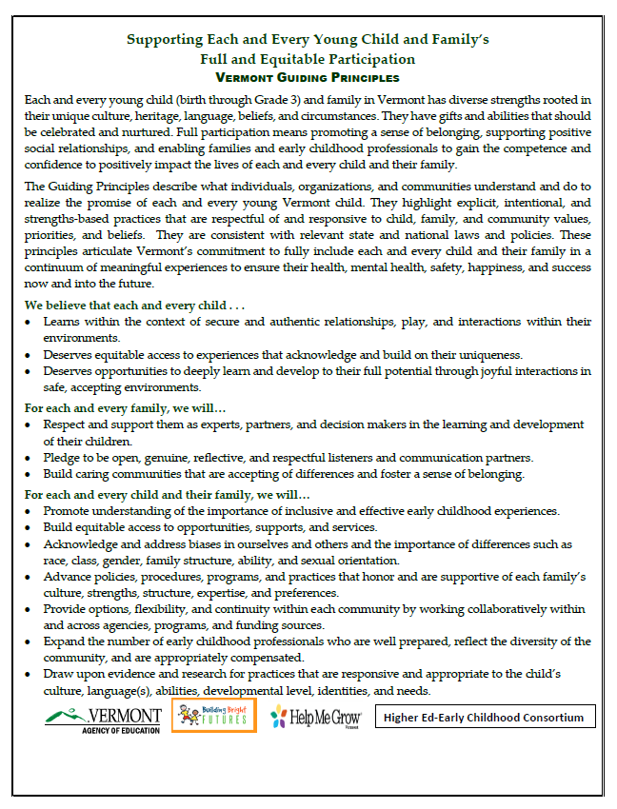
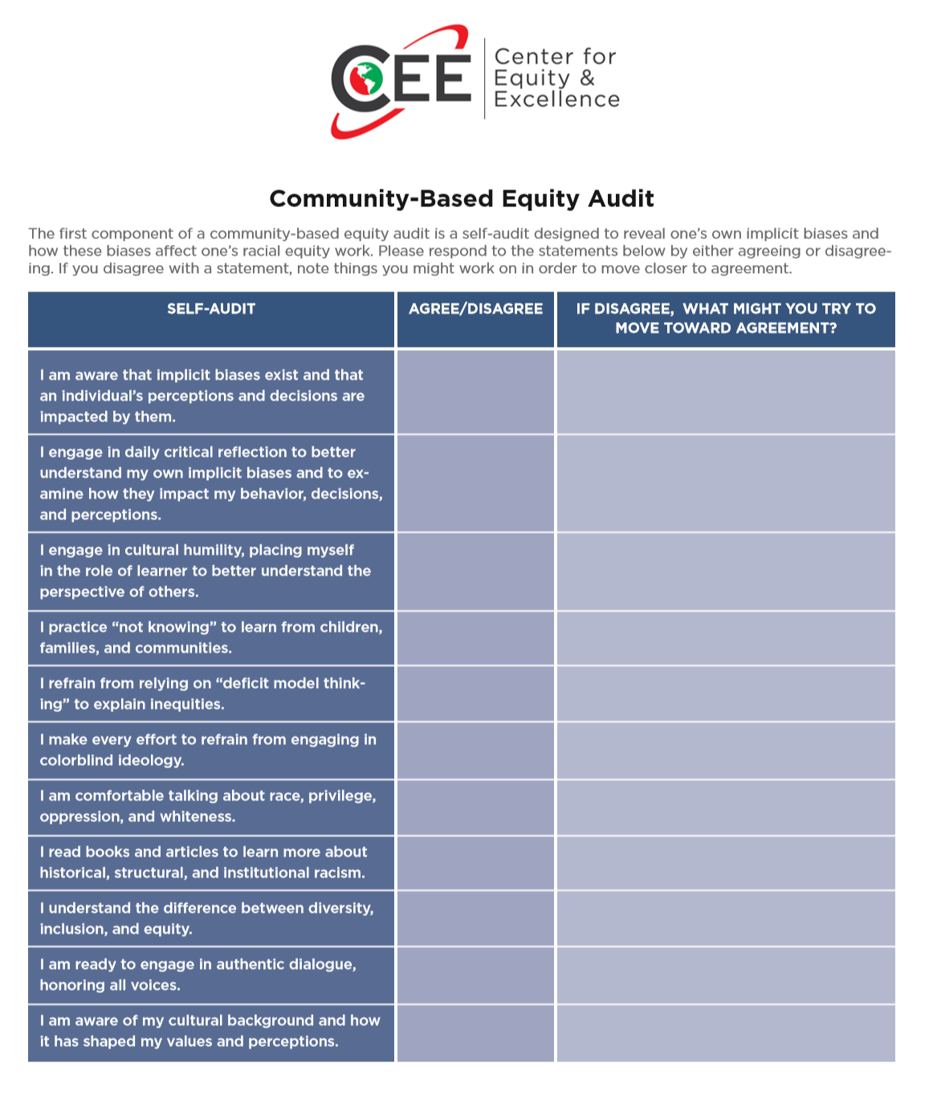
Center for Equity & Excellence Community-Based Equity Audit http://ireeinc.com/file_download/f9e45cdd-8b0e-414b-bae0-8b1f85b54161

Handouts and PowerPoints for this session are at https://fpg.unc.edu/presentations/all-each-and-every-1

