The Full Participation of Each Preschool Child

Activity 3: Discovering Your Personal Culture

Directions:

- Take 5-10 minutes to think about who you are as a cultural being.
Consider personal dimensions like
- Place of birth
- Birth order
- Where you have lived
- Gender
- Number of children/adults
- Religion
- Socio-economic status
- Disability or medical issues
- Race, ethnicity, and/or tribe
- Language(s) and/or dialect(s)
- Roles and relationships (mother, sister, guardian, etc.)
- Likes, dislikes, and biases
- Education
- Groups you belong to – Political? Social? Sports?
- Travels
- Life-shaping experiences (e.g., loss, illness, transitions)
- Family (in whatever way makes sense for you – blood relations, pets, friends, etc.)
- Preferred environments – Quiet? Noisy? Music playing?
- Group preferences – time alone? One-on-one interactions? Group interactions?
You may want to refer to the Iceberg of Culture illustration on page 2 for additional ideas.

- Write each dimension of your personal culture on the handout on page 3. Add as many circles as you need. Please take at least ten minutes to complete this personal culture map. Feel free to be creative with the size and the shape of your cultural vision. A sample is provided on page 4.

The more you know about your personal culture, the better you will be able to support the full participation of each preschool child.

- Put your map in a safe location and add to it as you discover new things about your personal culture.

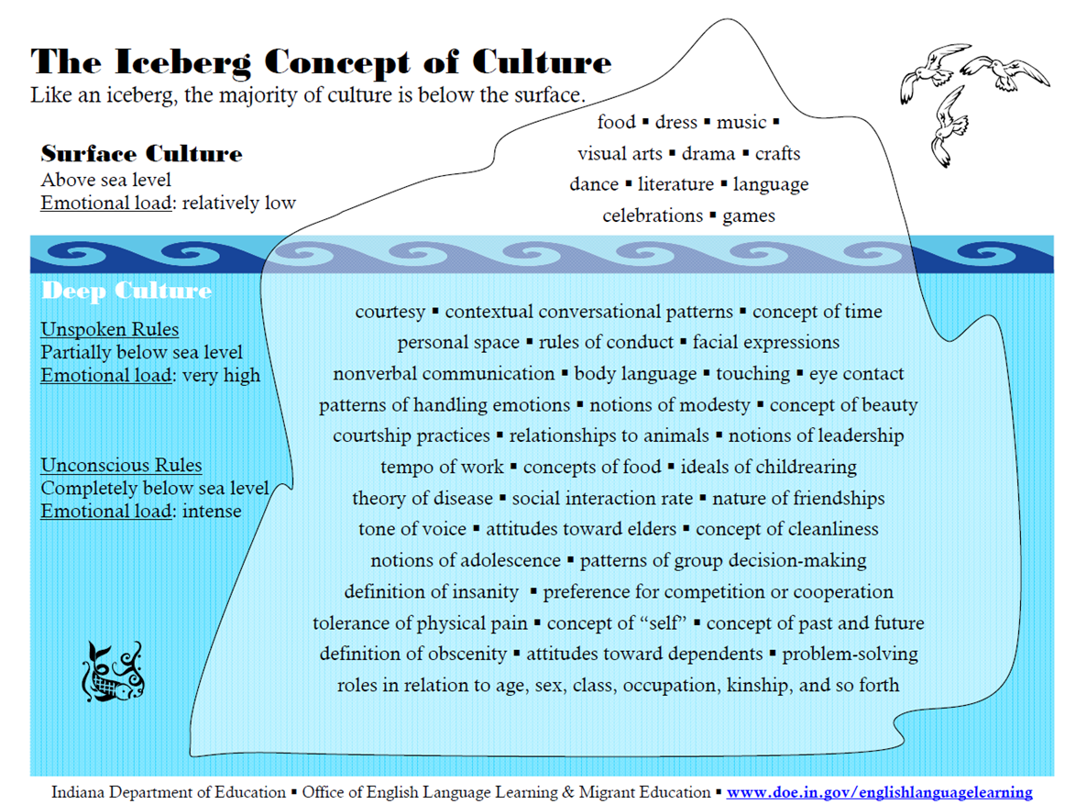
Personal Culture Map for ___________________________ (your name here)

