The Blueprint Process
for Enhancing Early Childhood
Preservice Programs and Courses

By
Camille Catlett
Frank Porter Graham Child Development Institute
Chapel Hill, NC

Susan P. Maude
Maude Consulting
Ames, IA

Mary Skinner
Tacoma Community College
Tacoma, WA

October 2016

This publication draws from and builds on the work of many talented professionals, and especially the colleagues from the following federally-funded projects:

Crosswalks: Outreach to Infuse Diversity in Preservice Education
Susan P. Maude, Susan Moore, Sylvia Sánchez, and Eva Thorp

Paraeducator Certificate with an Emphasis in Early Childhood Special Education:
Mary Skinner

The Partner Project: Working Together to Enhance Inclusive Early Childhood Environments:
Laurie Dinnebeil, Lyn Hale, and Bill McInerney

Supporting Change and Reform in Preservice Teaching in North Carolina (SCRIPT-NC):
Chih-Ing Lim and Tracey West

Using 21st Century Strategies to Educate Heartland Early Childhood Paraeducators:
Melanie Nollsch, Susan Simon, and Susan P. Maude

This document was written by Camille Catlett, with input from Susan P. Maude and Mary Skinner. The work was supported by a grant from the Office of Special Education Programs, U.S. Department of Education (H325N110010). The content and recommendations are those of the authors and do not necessarily reflect the opinions of the funding agency. Permission to copy, disseminate, or otherwise use information from this document for educational purposes is granted, provided that appropriate credit is given.

Recommended Citation:

Catlett, C., Maude, S. P., & Skinner, M. (2016, October). The blueprint process for enhancing early childhood preservice programs and courses. Unpublished manuscript.

If you have questions about the Blueprint Process,
please contact Camille Catlett (919/966-6635; camille.catlett@unc.edu).

Explicit and Intentional:
The Blueprint Process for Enhancing Early Childhood Preservice Programs and Courses

Recent research in the early childhood field has revealed that, when it comes to quality in early childhood programs, one size does not fit all. The learning and development of each child is influenced by gender, race, ethnicity, language, ability, socio-economic factors, and especially family—factors that comprise each child’s unique culture and circumstances. Here are a few examples:

- [Preschool] African-American children are 3.6 times more likely to receive one or more out-of-school suspensions than their white peers. Boys represent 54% of children enrolled in Pre-K, and yet they are 78% of the children being suspended (Office of Civil Rights, 2014).
- Under-resourced children score far lower than their more economically advantaged peers on virtually every standardized test, statewide or national, and the dropout rate for low-income students is five times greater than for their high-income counterparts (National Dropout Prevention Center, 2012).
- Dual language learners are heavily overrepresented among low-achieving students (within the bottom 5% – 25% of the achievement distribution) and severely underrepresented among high achievers (within the top 5% – 25% of the achievement distribution) (Lee, Grigg, & Donahue, 2007).
- Children with disabilities and their families continue to face significant barriers to accessing inclusive high-quality early childhood programs and too many preschool children with disabilities are only offered the option of receiving special education services in settings separate from their peers without disabilities. (2013 Part B Child Count and Education Environments Data File)

From the earliest days, “development and learning occur in and are influenced by multiple social and cultural contexts” (National Association for the Education of Young Children [NAEYC], 2009a). To be successful early learners, children “need to feel safe and secure in their many identities, feel pride in their families, and feel at home in their early childhood programs” (Derman-Sparks & Edwards, 2010, p. 3). To achieve their full potential, each child needs support from comfortable, confident, capable leaders and educators who recognize and capitalize in positive and effective ways on both their sameness and their differences.

Early childhood leaders are in the unique position of developing programs that embody a current and important trend – the shift from supporting all children to supporting each child. More than a word substitution, this switch acknowledges that each child benefits from administrators, educators, specialists, and programs that intentionally and explicitly support both who the children are and how they learn. This distinction is so important that NAEYC changed the language of their standards for the preparation of early childhood personnel. Where the standards used to speak to preparing students to work with all young children, they now require higher education programs to document how they are preparing future early childhood professionals to work with each child (NAEYC, 2009b).

Another example of the importance of getting more explicit about our commitments to supporting each child may be seen in a recent joint position statement from NAEYC and the Division for Early Childhood (DEC) (DEC/NAEYC, 2009). The document underscores that “the desired results of inclusive experiences for children with and without disabilities and their families include a sense of belonging and membership, positive social relationships and friendships, and development and learning to reach their full potential.” The importance of preparing future professionals with the capacity to support learners of diverse abilities in inclusive settings was further underscored by the September 2015 release of a policy statement on inclusion of children with disabilities in early childhood programs from the U.S. Departments of Health and Human Services, and Education (U.S. Department of Health and Human Services and U.S. Department of Education, 2015). The policy statement is explicit in the message that states should “ensure that state certifications, credentials, and workforce preparation programs have a strong focus on inclusion.”

Programs of higher education are in the unique position of growing the future professionals who will work with each child and family. Effectively preparing early childhood professionals for diverse and inclusive classrooms will require an explicit and intentional emphasis on individualizing to support each child across the full sequence of preparation (Institute of Medicine (IOM) and National Research Council (NRC), 2015).Consistent research findings highlight that changing one assignment, one reading, or including one course is not enough.

This publication offers guidance and examples for a sequence of planning and implementation which is designed to bring that explicit and intentional emphasis to an existing preservice program. In the pages that follow, readers will find an overview of the Crosswalks model on which the process is based and a step-by-step introduction to the Blueprint Process. Resources for using the Blueprint Process are provided, along with illustrations and a glossary of terms.

Background

To grow early childhood professionals who are comfortable, confident, and capable of effectively supporting each learner and his or her family, considerable thought needs to be given to the integrated sequence of coursework and practical experiences in which college students participate. In 2003, the Office of Special Education Programs (OSEP) of the U. S. Department of Education funded the development, testing and evaluation of the Crosswalks model. The purpose of Crosswalks was to explore the possibility of developing a process for supporting bachelor’s degree early childhood programs to incorporate an explicit and intentional emphasis on cultural and linguistic diversity in coursework, field experiences, and program practices. Core values of the Crosswalks model were evidence-based practice, effective instructional strategies, and national standards for personnel preparation, braided into an explicit and intentional sequence of preparation (see Figure 1).

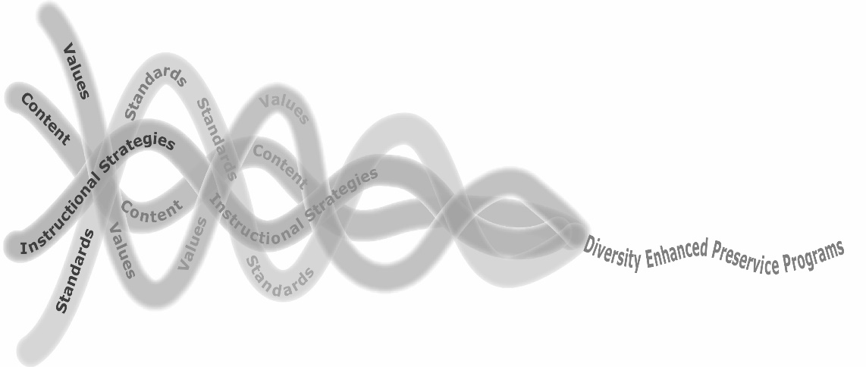
The original randomized experimental design studied the effectiveness of the Crosswalks model in supporting changes in the emphasis on cultural and linguistic diversity in pre-service birth-Kindergarten higher education programs.

Figure 1. Crosswalks design

The Crosswalks model was organized around a 5-step planning process:
- Develop a shared vision and commitment;
- Conduct individual and program assessments;
- Identify gaps and needs with partners;
- Develop priorities and plans for change; and
- Provide professional development, resources and supports.

Ongoing evaluation and feedback were essential to the continuous improvement process of the Crosswalks model. Another critical and consistent feature in this process, which was targeting enhancements to higher education programs, was participation of faculty, administrators, community partners (e.g., future employers, practicum site representatives), program graduates, and family members. Results for programs that participated in the Crosswalks model included statistically significant changes in faculty knowledge and skill, along with important enhancements in both courses and field experiences (Maude, Catlett, Moore, Sánchez, Thorp, & Corso, 2010).

In 2009, OSEP announced a new grant competition, designed to prepare early childhood educators to more effectively support children of diverse abilities and inclusion. The competition sought specifically to foster enhancements in associate degree programs that were preparing personnel for diverse early childhood roles which included paraeducators. To support several grantees in this competition, one of which was Tacoma Community College (TCC), a new version of the Crosswalks model, the Blueprint Process, was developed. The Blueprint Process features a sequence of activities and supports for building an emphasis on cultural, linguistic and ability diversity into a preservice program, along with a consistent emphasis on evidence-based practices. As of August 2016, this process is being used at colleges and universities in eight states.

The Blueprint Process

The Blueprint Process is designed to be implemented in three phases, and supported by ongoing professional development, resources, and evaluation if possible. Details on each phase of the process are provided below. Completing the Blueprint Self-Assessment (see page 16) is a good initial step for programs that are considering using the Blueprint. It will highlight areas that may need attention and help in deciding who participates, which courses deserve attention, and how to integrate individual changes into a cohesive
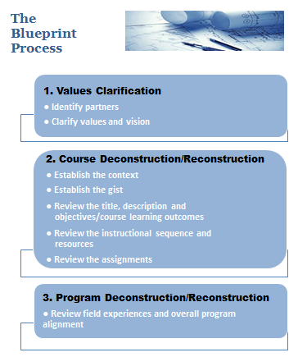
whole that aligns with a program’s values and vision.

What follows is a description of each step in the Blueprint Process. It was designed to be implemented by a college or university program that is interested in identifying opportunities for enhancement in coursework, field experiences and program practices. Parts of the process can also be used by individual instructors to examine syllabi and identify opportunities for enhancement.

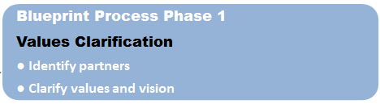

The initial phase of the process asks programs to consider both who is important and what is important, by identifying and engaging partners and clarifying values and vision.

Identify partners – One successful component of the Crosswalks model was the engagement of
campus and community partners in the enhancement process. The feature has been effectively incorporated by each program using the Blueprint Process and the benefits have been many (see sidebar). Partners have typically been invited to a
Benefits of Engaging Campus and Community Partners in the Blueprint Process

- Increased public awareness of the quality of the program and the commitment of the faculty
- Increased opportunities for field placements
- Increased employment of program graduates
- Increased participation on program advisory board
- Community partner and administrator advocacy for program faced with budget cuts from campus

meeting to provide their expertise and input as it relates to the program and the quality of the pro-gram graduates. The meeting has incorporated time for introductions, an overview of the program, input to the development of the Graduate of the Future (below), and the opportunity to contribute to a program inventory that highlights both points of pride and areas for enhancement.

Examples of important partners to engage in the Blueprint Process include:
- Recent graduates of the program who are currently working in the field (and can share what they wish they had learned more about);
- Programs that frequently hire early childhood professionals;
- Programs that serve as field experience sites;
- Colleagues who are knowledgeable about children of
diverse abilities (e.g., disability specialists, program coordinators) and their families;
- Colleagues who are knowledgeable about children who are culturally and linguistically diverse and their families;
- Community partners who are themselves diverse;
- Adjunct instructors;
- Faculty members who teach electives in the program;
- Campus partners with knowledge and expertise (e.g., advisors, diversity organizations);
- Representatives of programs with which your program articulates (e.g., feeder schools); and
- College administrators who supervise/oversee the program of study

Once partners are engaged, it is also important to keep them informed. This can happen through updates (e.g., email, print) and/or through ongoing participation in the Blueprint Process.

Clarify values and vision – An effective activity for establishing a shared set of values with partners is the Graduate of the Future. Directions for this activity are:

- Provide each participant with small (3” x 3”) sticky notes

- Label a sheet of flip chart paper with the words Graduate of the Future, draw a simple figure of a gender-neutral graduate, and post the paper where everyone can see. (A blank sample is provided on page 19).

- Ask partners to think about the important capabilities of future graduates. In other words, ask participants to write down, on sticky notes, the things they want program graduates to know and be able to do. (NOTE: Instructors and administrators should also participate in this activity so it produces a shared vision.)

- As partners finish writing, invite them to post those capabilities on the sheet of flip chart paper.

- After everyone has posted, invite partners to look at the full picture of what they want each Graduate of the Future to know and be able to do. Encourage them to fill out additional sticky notes if there are new ideas or missing qualities.

- After the meeting, transcribe the sticky notes to create a version of the Graduate of the Future that reflects all inputs. A completed sample is provided on page 20.

- Share the completed Graduate of the Future with all partners and use it to inform decisions about all aspects of the Blueprint Process.

The Graduate of the Future can be a very useful part of the Blueprint Process. By providing copies during all course deconstruction/reconstruction and program deconstruction/reconstruction conversations, it will serve as a reminder of a shared vision of the future. As the sample on page 20 illustrates, additional qualities may be added to the graduate as the Blueprint Process unfolds. A process for using the Graduate of the Future to support overall program alignment will be described in Phase 3 of the Blueprint Process.

The Graduate of the Future is a simple, interactive, and engaging activity that can be used in a variety of ways. For example, a community partner helped identify the desired qualities of a Graduate of the Future
for a nearby college. She then modified the activity to support the hiring of a new director for an early childhood program. The partner invited board members and family members to identify a Director of the
Future, an activity that helped clarify the qualities being sought in a new leader. Additional ideas for using the Graduate of the Future activity in a program or an individual course are included in the sidebar below.

Once the values and vision for future graduates have been
established, it will be important to look at how they align
Ideas for Using the Graduate of the Future

- Provide students with a copy of the Graduate of the Future. Ask them to highlight areas in which they feel well prepared and areas in which they feel least prepared. Then ask students to create a personal development plan for building their knowledge and skill in an area in which they feel least prepared.

- At the beginning of the program (e.g., Introduction to Early Childhood Education), give each student a blank Graduate of the Future. Ask each student to identify the qualities they think are essential in a future early childhood professional. Repeat the assignment toward the end of the program (e.g., Practicum or Student Teaching). Ask students to compare the two “graduates” and discuss what they see.

- Use a completed Graduate of the Future to show alignment with a state or national framework. For example, sort the qualities of the graduate by the six NAEYC standards.

- Provide copies of the Graduate of the Future at program/department Advisory Board meetings. As new priorities for future professionals emerge, they may be added to the drawing.
with other program frameworks. For example, programs
with, or seeking, NAEYC accreditation will want to look at
how the Graduate of the Future jives with the program’s
mission. It may also be helpful to look at how the character-
istics of the “graduate” align with the six NAEYC standards.
When this is done, Phase 2 can begin.

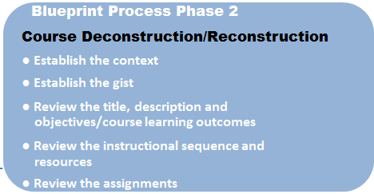

Phase 2 features a thoughtful sequence of activities that
are designed to examine all components of an individual
course to determine the extent to which the course
reflects program values (points of pride) or does not
(opportunities for enhancement). While the course
deconstruction/reconstruction process may be done by
an individual, the process is greatly enhanced when
additional partners also join in. Similarly, if several
instructors teach the same course, they can either decon-
struct individually and pool their ideas for reconstruction,
or deconstruct/reconstruct as a group.

Before getting started, gather all relevant course materials,
including:
- Course syllabus;
- Course text(s) and readings;
- Course assignments, including student directions and rubrics;
- Course calendar (the overview of topics that are addressed in each week of the course); and
- Course instructional activities, including online discussion forums.

The resources will vary depending on whether the course is taught online or face-to-face. Use the Course Deconstruction Worksheet (page 21) to capture your initial impressions as it may be used in a pre/post fashion to document changes.

Establish the context – Consider the following questions: Who takes this course? Where does this course fall in the sequence of the program? Capture the answers on the Course Deconstruction Worksheet (page 21). Answering these questions will help to keep a focus on the learners, what they know, and what they want from the course in mind as you proceed through the Blueprint Process.

Establish the gist – Imagine that one of your students is trying to explain this course to his or her grandmother in one sentence. What values/key concepts would you want that student to capture in his/her description? Capture your answer on the Course Deconstruction Worksheet. In the Blueprint Process, it can be tremendously helpful to be very clear about the purpose of the course. For example, one program, in reviewing the gist of their course on families, realized that they most wanted students to complete the course with a commitment to assume nothing about families. Capturing the gist of the course helped the instructors to refashion the examples the used to incorporate a stronger emphasis on assumptions and helping students avoid them.

Review title, description, and objectives/course learning outcomes – In some programs, course titles and descriptions are mandated by the state. For example, in North Carolina, all core early childhood courses at the associate degree level, have the same course number, title, and description. If this is the case, there are several options.
- If the title and description are not as explicit as you would like, and you cannot make any changes, it might be a good idea to pay even closer attention to making the other sections of the course as explicit as possible.

- If the title and description are not as explicit as you would like, and you can make changes, consider adding a sentence that documents the specific features of this course. For example, in North Carolina, instructors are able to add one sentence to the course description. Some have elected to write something like “This course incorporates the use of evidence-based practices to support young children of diverse cultures, languages, and abilities and their families.”

We have found that one piece of information that is consistently missing from course descriptions is the age range addressed in the content. A classic example is one state’s child development course which is titled Child Development: Birth through Middle Childhood. No two faculty members in that state can agree on the exact age that signifies middle childhood. In Phase 3, when looking across a program for consistency and cohesion, it’s difficult to do that easily when course titles or descriptions are not explicit.

At this point, capture any changes you might like to make in the title and/or description and record them on the Course Deconstruction Worksheet.

Review course objectives/learning outcomes – As with course titles and descriptions, course objectives/course learning outcomes are sometimes mandated by the state. As described above, it may or may not be possible to add more explicit language. If changes are possible, and desired, note them on the
Course Deconstruction Worksheet.

Review the instructional sequence and resources – Start with the instructional sequence. There are several ways to examine the instructional sequence to determine the extent to which it explicitly and inten-tionally reflects the values your program has prioritized (e.g., an emphasis on evidence-based practices that support children of diverse abilities in inclusive settings). Two options are described below.

- In the syllabus or course calendar, find the list of week-by-week course topics or themes. Write each theme at the top of a sheet of chart paper, and then post the sheets of paper on the wall in numerical order, from the first week of class to the last. With partners, look at this sequence, and pose the questions from the Course Deconstruction Worksheet.
  - Does the sequence reflect the values?
  - Does the sequence flow logically?
  - Is the content thoughtfully distributed across the course?

Discuss what you’ve noticed, then move the chart paper sheets around to address desired changes in sequence. Or add new sheets of chart paper to incorporate new areas of emphasis. Even if a course is taught using a more emergent approach, it should still be possible to identify possible themes and to reflect on parameters for addressing those themes in ways that would reflect program values and priorities.

- Ask partners to review course materials using the Blueprint Course Rubric (see example on page 23). Request that they use the Notes section to highlight both assets (i.e., ways in which the components of the course reflect the desired values and content) and opportunities for enhancement. Use the results to prioritize changes.

The indicators of the rubric can easily be adjusted to discover how a course reflects other kinds of alignment. While the indicators in the example are related to cultural, linguistic, and individual diversity, they could also be set up to assess alignment with other quality frameworks like the DEC Recommended Practices (Division for Early Childhood, 2014) or state early learning guidelines/standards.

Too frequently, the reason for a particular sequence of instructional topics is the order of chapters in the course text. As a result, it is often the case that content related to children of diverse cultures, language,
and abilities come near the end of the course, which does not provide students many opportunities to acquire or apply practices related to individualizing for these learners or families.

Capture ideas for changes in the instructional sequence, and then take a look at the instructional resources that are being used in each segment of the course. Use the questions in the Blueprint Self-Assessment to guide your thinking: Do the activities, readings, handouts, guest speakers, online forums, and other instructional strategies reflect the program values and vision?

Consistent findings have highlighted that one different article won’t change the emphasis in a course, but evidence from Kidd, Sánchez, & Thorp (2008) has highlighted five instructional strategies that can make a significant difference. These include:
- Readings that explicitly address issues of diversity, including race, equity, culture, poverty, and social justice;
- Field experiences in diverse settings with diverse professionals;
- Opportunities to interact with diverse families;
- Critical reflection on readings, experiences, and dilemmas; and
- Opportunities for facilitated dialog and discussion.
This research underscores the importance of the resources that are used, including both the content of the material and the insights and applications to be derived from the material.

Consider the resources that are currently being used in each segment of this course, and capture ideas for enhancement on the Course Deconstruction Worksheet. At this point in the process focus on the capabilities you want to enhance and the explicit perspectives you want to incorporate. Ideas about where to find alternative resources will be addressed later in the process.

Review the assignments – There are several ways of looking at the assignments in a given course. Two important considerations are: a) do the assignments provide opportunities to measure achievement of each learning objective/outcome and b) do the assignments require students to demonstrate both knowledge acquisition and knowledge application (the components of effective professional development as described in National Professional Development Center on Inclusion, 2008).

One strategy for examining both components would be to use the Blueprint Assignment Alignment Chart (page 25). To use this tool, list course assignments in the numbered slots of the left hand column of the chart. Then number each course objective/learning outcome. Review each assignment, then place a check in the box(es) of each objective/learning outcome with which that assignment aligns. Finally, indicate whether this is an assignment that measures knowledge acquisition, knowledge application, or both. The Blueprint Assignment Alignment Chart also provides space for noting which assignments have companion field experiences.

You can adapt the Blueprint Assignment Alignment Chart to support different program priorities. For example, if a program is pursuing NAEYC accreditation or reaccreditation, an assignment alignment chart might look like the one below. Completing a chart like this for each course would provide course-specific information and would make it easy to see which standards, key elements, and supportive skills are emphasized across all courses.

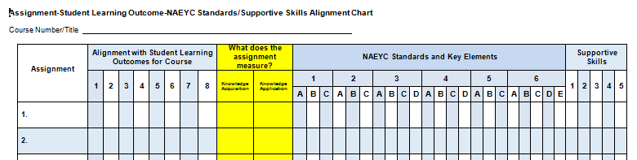

Similarly, you could create an assignment alignment chart could be created to examine alignment with other quality frameworks like the DEC Recommended Practices or state early learning standards. A third option would be to examine the alignment with the three components of developmentally appropriate practices: a) developmentally appropriate as reflected in state early learning guidelines/standards; b) contextually appropriate (i.e., reflective of culture, language, circumstances, etc.); and c) individually appropriate (i.e., reflective of differences in ability, gifted).

Another approach would be to use the Blueprint Self-Assessment to show how course assignments measure up. Consider what you have learned from this step in the process. Do your assignments explicitly and intentionally measure all objectives/outcomes? Are there assignments that stress both knowledge acquisition and knowledge application? And, when you examine the rubrics for the assignments, do they reflect an explicit emphasis on evidence-based practices, diversity, or other core values?

A third strategy would be to look at the sequence of assignments at the same time as you examine the instructional sequence, as described on page 9. Regardless of which strategies you use, summarize findings and opportunities for enhancement on the Blueprint Self-Assessment Worksheet.

At this point, stop and reflect on what you’ve learned about the course you’re working on and the enhancements you would like to make. Here’s where all the work you’ve done on deconstruction will shift to strengthing the course through reconstruction.

Reconstructing the course –It’s important to make the shift from examining each course component (deconstruction) to incorporating new methods, resources, and requirements in that course (reconstruction). Here’s one process for doing that.

- Review the findings about each course and identify the things you’d like to change.

- Identify additional resources (evidence sources, print materials, activities, assignments, video clips, and/or websites) to support the targeted changes. Do this with two purposes in mind: 1) instructional materials that will support student activities, assignments and discussions; and 2) content resources that can bring additional insights to instructors or be used as supplemental materials for students. Pages 26-27 show sections of a course syllabus before and after the Blueprint process for a program that wanted to increase the emphasis on cultural, linguistic, and individual diversity. The revised course calendar on page 27 includes a column on the right that can support the two purposes described above. While producing a course calendar with this level of detail can take time, it will ensure that all instructors, current and future, are consistent in their emphasis on core course and program values. This format also makes it easy to look across syllabi to see if the same resources are being used in multiple courses.

- Keep in mind that enhancements will take different forms. In some cases, new content may need to be added. In others, existing materials may need to be revised. For example, if an instructor wants to increase the emphasis on evidence-based practices for supporting children of diverse in a curriculum course, they may adjust assignments (and rubrics) to incorporate more explicit requirements related to individualizing instruction.

- A challenge to the enhancement process is skillfully integrating new areas of emphasis. Too often when a course is being updated to reflect two areas of specific emphasis (e.g., supporting dual language learners and full participation of children of diverse abilities) the end result is three times as much reading and work. It’s important to focus on supporting opportunities for learners to integrate the perspectives so they are well prepared to individualize for each and every child. Here’s an example. An article in Young Children called Phonological Awareness is Child’s Play! http://www.naeyc.org/files/yc/file/200901/BTJPhonologicalAwareness.pdf would be a great
reading for a language/literacy course as it skillfully addresses phonological development in both English and Spanish.

- When you have reconstructed the course to your satisfaction, you may want to invite a colleague to review your work an offer suggestions. This is one reason that doing the deconstruction/recon-struction in pairs can be helpful.
Instructors who want to consider enhancements to a single course may also find components of the Blueprint Process useful. For example, an instructor could:
- Use the Course Deconstruction/Reconstruction section of the Blueprint Self-Assessment (page 17) to examine the components of the course. Based on the responses, identify changes that it would be important to make.

- Ask a knowledgeable colleague to use the Blueprint Course Rubric to rate the course. (NOTE: This assessment should be based on a review of physical course documents like the syllabus.) After revisions, the same colleague could re-rate the course to confirm enhancements. The “notes” section of the rubric could be used to track changes.

- Use the Blueprint Assignment Alignment Chart to examine the distribution of content across course expectations and to assess the extent to which assignments require the application of new content.
One thing that will help with the process is Table 1 highlights four sources that should provide support in this aspect of the process.

Table 1. Projects with Resources to Support the Blueprint Process

Project Name | Type of Resources | URL
Heartland Equity and Inclusion Project, Heartland Community College (IL) | Sample syllabi, activities, handouts, content questions, discussion questions, readings and resources | http://www.hcc.cc.il.us/heip/
Preparing Early Childhood Professionals for Inclusion, Teaching Research Institute, (OR) | Course enhancements, sample syllabi, resources | http://teachingresearchinstitute.org/projects/pepi/enhancements
Supporting Change and Reform in Preservice Teaching in North Carolina, Frank Porter Graham Child Development Institute | Landing pads of resources, PowerPoints with activities and assignments, archived webinars | http://scriptnc.fpg.unc.edu/resource-search
Using 21st Century Strategies to Educate Heartland Early Childhood Paraeducators, Kirkwood Community College (IA) | Course curriculum maps (showing intentional distribution of key values across all courses in the program) | http://www.kirkwood.edu/site/index.php?p=33656

Higher education programs have also used the Blueprint Process to incorporate a consistent priority of their own choosing. For example, one program, with a priority for emphasizing play across the program, built in opportunities to look at the presence or absence of play in all phases of the process. The Blueprint Self-Assessment has a blank at the end of each section for incorporating a program-specific priority.

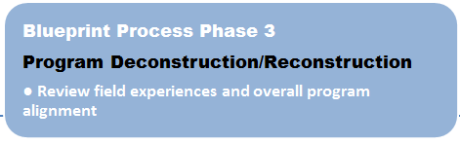

Like the original Crosswalks model, the Blueprint Process recognizes that to prepare students to work effectively to support each child and family, instructors and administrators, working in concert with family members and community partners, need to integrate explicit and intentional attention to relevant evidence-based practices into all facets of their preservice programs, including field experiences. While Phase 2 of the Blueprint Process looked at individual courses, Phase 3 considers ways to look at how those pieces form a cohesive whole. This phase of the process addresses both the range of practical experiences (observation, practicum, student teaching) and a process for examining overall program alignment. The steps of an approach that has been used effectively as part of the Blueprint Process (described below) can be an effective way to look at both components.

Review Field Experiences and Overall Program Alignment
- For each course in the core program sequence, prepare a sheet of flip chart paper. List the course title and description at the top, then the course objectives/learning outcomes, and finally the required field experiences. NOTE: In listing the field experiences, include the age of the children, opportunities to connect with families, and the setting for the experience.
- Post the sheets of flip chart paper on the walls in the sequence a student might ideally take the courses.
- Ask partners in this exercise to read the questions on the third page of the Blueprint Self-Assessment.
- Ask partners to walk from course to course, noticing the scope and sequence of both the content and the field experiences. It can be helpful for partners to make this walk with sticky notes in hand so they can share ideas or pose questions as they go.
- As a group, discuss what you see in the current sequence. Clarify questions that have been posed and consider adjustments in the sequence of content and field experiences that would better support your students.
- Discuss how the sequence supports alignment with state and national frameworks, based on data compiled from the review of individual syllabi.
- While the flip charts are still on the wall, provide partners with a copy of your Graduate of the Future and a highlighter. Ask them to walk around again, highlighting capabilities that will be developed through the courses and field experiences listed.
- As a group, discuss any capabilities that were not highlighted. Clarify how those capabilities are being supported and/or discuss opportunities to build an emphasis on those capabilities into the sequence.
- Develop a plan and timeline for addressing the findings.
- Review the revisions as a group and commit to revisiting the overall program regularly to respond to new mandates and incorporate additional evidence-based practices.

It is unreasonable to expect future professionals to create environments and support interactions and experiences that are consistent with evidence-based practices using only their imagination. Instead, a variety of opportunities to watch, interact, learn, try, and improve are essential. This can include:
- Opportunities to observe in diverse settings and to connect those observations to an understanding of
the formative assessment process, including how to use data to make informed decisions;
- Participation in 3-way conversations with families and interpreters;
- Interactions in settings serving children who are culturally, linguistically, and socio-economically
diverse;
- Experiences in settings in which children of diverse abilities are fully included;
- Opportunities to practice scaffolding to support children who are gifted; and
- Exposure to settings that serve children of diverse ages.

Additional Considerations

The Blueprint Process can be very effective in supporting desired changes in a preservice program. As you consider implementing such a process, there are several additional considerations to keep in mind.

- The process takes time. When you as an individual instructor or your program make the commitment to using this approach, develop a timeline for implementation. It would be reasonable to implement this process across 1-2 quarters or semesters. Plan to start with the values clarification, then move to deconstructing/reconstructing one course. The first course will take three times longer than subsequent courses because the process and tools will be new and unfamiliar.

- Time for partners to participate in the process is essential. Faculty members and their partners are typically among the busiest professionals in our field. Any efforts to provide support for partners to participate in this process will increase the likelihood that they will participate consistently and actively. For full time instructors, this may mean release time. For adjunct instructors or community partners, this may mean stipends, or, at the very least, finding times to meet that are convenient for them.

- So is establishing a shared vocabulary. One important lesson from using the Blueprint Process in different states and settings, and with colleagues with diverse perspectives is the importance of developing a shared lexicon.
  - This may mean agreeing to use new terminology (e.g., dual language learners instead of English language learners).
  - This may mean sharing terms (e.g., early childhood special education colleagues becoming familiar with developmentally appropriate practices at the same time that early childhood colleagues are learning to incorporate assistive technology).
  - This may mean agreeing that students need to learn multiple related terms (e.g., individualized/differentiated or accommodations/adaptations/modifications)

- And so is professional development for instructors. Identifying new content, assignments, and experiences for your students is one aspect of the Blueprint Process. Another aspect is supporting instructors to be knowledgeable about and comfortable implementing the new practices and conversations that will evolve from the reconstruction. A thoughtful sequence of professional development, focused on both instructional content and effective pedagogy, will be important to incorporate in the process. In Crosswalks, for example, increases in knowledge and skill of instructors could be directly linked to professional development those instructors had received.

- New resources will be needed. High-quality, no-cost, evidence-based resources are increasingly avail-able to support higher education courses. The projects in Table 1 (page 12) are good sources for high quality, evidence-based and free materials.

Good luck!

The Blueprint Self-Assessment

Phase | Step | Key Considerations | No | Somewhat | Yes | Important?
 |  |  |  |  |  | No | Somewhat | Yes
- Values Clarification | Identify partners | Are adjunct instructors involved?
 |  | Are community partners involved (e.g., future employers, directors of diverse local programs, field experience sites, disability specialists)?
 |  | Are graduates of your program who are currently working in the early childhood field involved?
 | Clarify values and vision | Have you and your partners identified what you want graduates of the future to know and be able to do?
 |  | Have you specified the capabilities you want your graduates to have vis-à-vis supporting children of diverse abilities and their families?
 |  | Have you specified the capabilities you want your graduates to have vis-à-vis supporting inclusion?
 |  | Have you specified the capabilities you want your graduates to have vis-à-vis supporting cultural diversity?
 |  | Have you specified the capabilities you want your graduates to have vis-à-vis supporting linguistic diversity?
 |  | Have you specified the capabilities you want your graduates to have vis-à-vis using evidence-based practices?
 |  | For programs seeking NAEYC accreditation, have you identified your mission/vision?
 |  | For programs seeking NAEYC accreditation, have you identified your conceptual framework?
 |  | Have you identified areas in which your program is currently supporting movement toward your vision?
Phase | Step | Key Considerations | No | Somewhat | Yes | Important?
 |  |  |  |  |  | No | Somewhat | Yes
2. Course Deconstruction/Reconstruction | Establish the context for the course | Have you considered who takes this course?
 |  | Have you considered where this course falls in the sequence of the program?
 | Establish the gist of the course | Have you identified the major values you want students to take away?
 |  | Have you identified the key concepts you want students to acquire?
 | Review course title and description | Do the title and description clearly and explicitly reflect the values and vision?
 |  | Does the course title match the gist?
 |  | Does the course description match the gist?
 |  | Does the description specify the ages of children to be addressed?
 | Review course objectives/  learning outcomes | Do the objectives/outcomes reflect the values?
 |  | Do the objectives/outcomes match the gist?
 |  | Do the objectives/outcomes align with evidence-based practices?
 |  | Are the objectives/outcomes measurable?
 | Review the instructional sequence and resources | Does the sequence of instruction reflect the values?
 |  | Does the sequence of instruction flow logically?
 |  | Is the content thoughtfully distributed across the course?
 |  | Do the instructional resources (e.g., activities, readings, handouts, guest speakers, forums) consistently reflect program values and vision?
 |  | If there is a text, does it support the objectives/outcomes and the values?
 | Review the assignments | Do the assignments provide opportunities to measure achievement of each learning objective/outcome?
 |  | Do the assignments require students to demonstrate both knowledge acquisition and knowledge application?
 |  | Do the assignments occur in a logical sequence?
 |  | Do the assignments reflect the values?
 |  | Do the rubrics incorporate explicit emphasis on the values?
Phase | Step | Key Considerations | No | Somewhat | Yes | Important?
3. Program Deconstruction/Reconstruction | Review field experiences including observations, practica, and student teaching | Are field experiences thoughtfully aligned with course experiences to promote discussion, reflection, and evidence-based practices?
 |  | Do the field experiences support encounters with children across the continuum of development?
 |  | Do the field experiences provide opportunities to experience quality inclusive practices?
 |  | Do the field experiences provide opportunities to interact with children of diverse abilities and their families?
 |  | Do the field experiences provide opportunities to interact with children who are culturally diverse and their families?
 |  | Do the field experiences provide opportunities to interact with children who are linguistically diverse and their families?
 |  | Do the field experiences provide opportunities for both knowledge acquisition and knowledge application?
 |  | Do the field experiences promote opportunities to implement evidence-based practices?
 |  | Do the field experiences build a continuum of teaching skills?
 |  | For programs seeking NAEYC accreditation, do the field experiences provide hands-on learning opportunities in a variety of settings (e.g., child care, preschool, Head Start)?
 |  | For programs seeking NAEYC accreditation, do the field experiences provide hands-on learning opportunities with a variety of age groups (e.g., infant-toddler, preschool, kindergarten, early elementary)?
 | Review overall program alignment | Are the courses offered in a sequence that will build capability, from initial experiences to knowledge acquisition and knowledge application?
 |  | Does the sequence of instruction build the capabilities desired for your Graduate of the Future?
 |  | Do the assignments build on each other, from course to course?

Graduate of the
Future (blank)

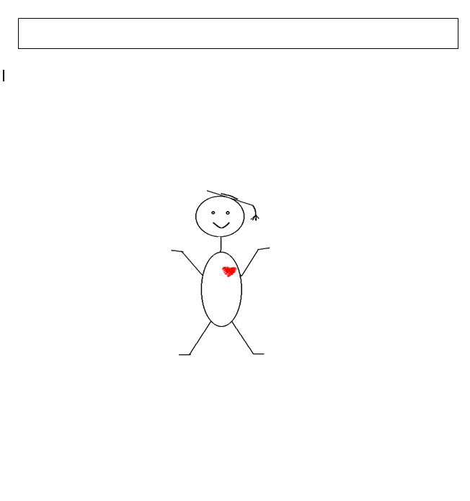
Graduate of the Future (sample)

Family-Centered
- Understands family dynamics
- Collaborates effectively with families
- Know that parents know their children best. Therefore utilizing knowledge of parents will enhance the experience for their child

Experienced
- Lots of practical experience
- Hands-on experience in a birth to three program
- Knows relevant rules and regulations that apply to their job

Reflective (6)

Knowledgeable/Skilled
- Knows and understands the content they teach
- Highly qualified per state/OSPI guidelines so they can be hired(e.g., 72 credits at 100 level or higher)
- Knowledgeable about preventive interventions that work
- Skilled in adapting to support the needs of each learner, including those with disabilities
- Knowledgeable about planning and assessment
- Able to design environments for learning at different levels and in different ways
- Able to articulate the strengths of early learning as they relate to young children of varying abilities
- Knowledgeable about how to access and share community resources with families and colleague
- Prepared to engage in analysis of how systems impact education
- Knowledgeable about a variety of screening processes
- Strengths-based and optimistic about the abilities of each and every child
- Solid skills in core content areas (math, literacy, language, writing)
- Spontaneous with emergent curriculum ideas
- Understands basics of many types of disabilities and special needs (e.g., medical, cognitive) and how they may impact the total child
- Understands the needs of each child and how to meet them
- Knows the skills and resources they have to offer each child and family
- Has a repertoire of creative instructional strategies
- Skilled in behavior management
- Thoughtfully observes children
- Knows how to use people friendly language
- Knows how to use data to make effective decisions

Responsive to Cultural, Linguistic, and Ability Diversity
- Understands the impact of “isms” on children and families as well as opportunities for access, participation and supports
- Have specific skills for addressing CLAD in classrooms
- Engaged in strengthening cultural skills
- Knowledgeable about second language acquisition and serving dual language learners
- Accepting of all kinds of diversity
- Open to different perspectives and world views

Positive Qualities and Attributes
- Adaptive to change
- Flexible (3)
- Critical thinker (5)
- Intentional
- Skilled writer
- Risk taker
- Ready for fun and messes
- Problem solver
- Creative
- Innovative
- Really like what they do
- Feels comfortable and competent
- Feels like a professional
- Open to new ideas and possibilities (3)
- Intuitive
- Open to integrative concepts
- Empathetic
- Humble
- Thoughtful
- Spontaneous
- Enthusiastic
- Curious about children and how they develop
- Thoughtful observer; able to observe children, then revise beliefs and practices
- Compassionate
- Mature
- Uses discretion
- Honors confidentiality

Collaborative (3)
- Able to collaborate with therapists and general education colleagues who are working with a child
- Team player
- Feels like an essential partner
- Open to sharing with and learning from others
- Understand their role on the team

Lifelong Learner (4)
- Eager to learn
- Proactive about pursuing learning
- Education is a priority
- Passion for learning
- Open to mentoring
- Learns from errors/missteps

Evidence-based
- Grounded in state and national standards

The Blueprint Course Deconstruction Worksheet

Process Element | Course Details
What’s the context?
What’s the gist?
What’s the title?
What are the objectives/learning outcomes for the course?
What’s the instructional sequence?

Process Element | Course Details
What’s the assignment alignment?
What are the instructional resources?
What are the practica/field experience opportunities?
What will you do next?
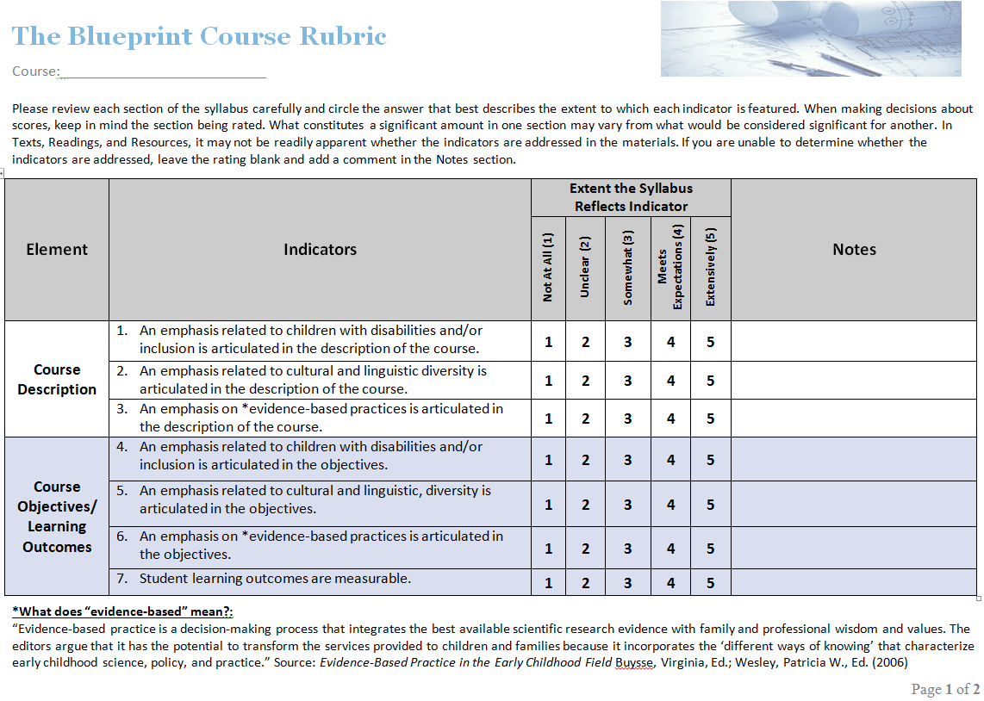
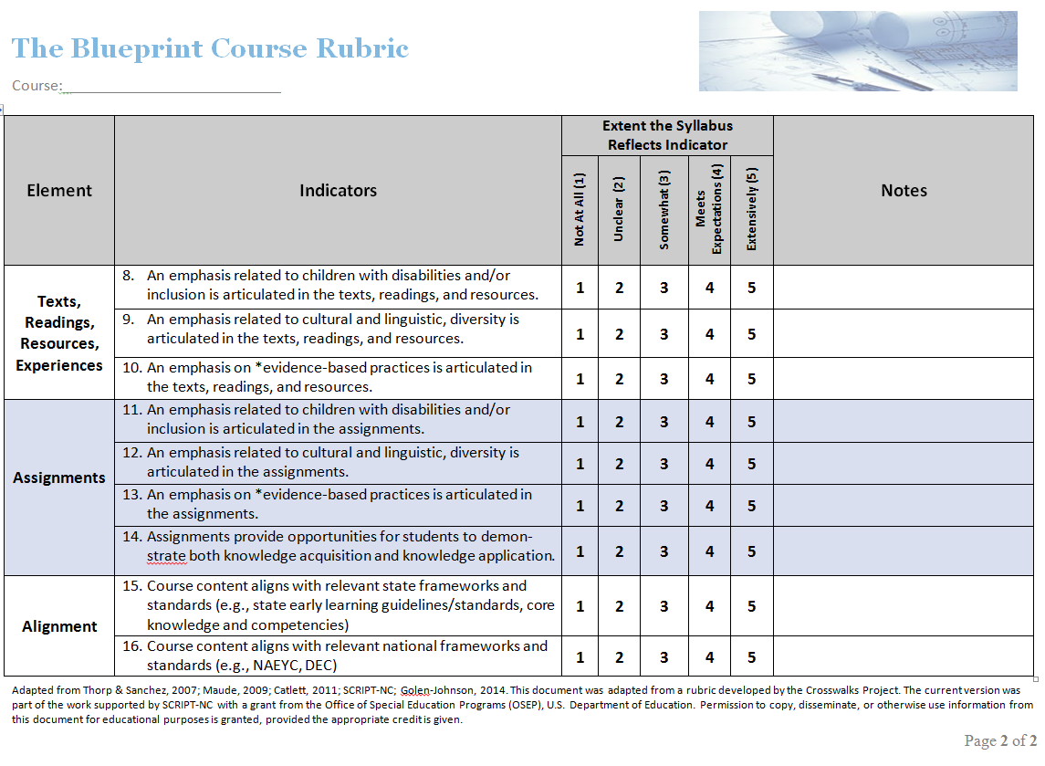
The Blueprint Assignment
Alignment Chart

Course:___________________________

Assignment | Alignment with Course Objectives/Learning Outcomes |  |  |  |  |  |  |  | What does the assignment measure? |  | What, if any, are the field experiences related to this assignment?
 | 1 | 2 | 3 | 4 | 5 | 6 | 7 | 8 | Knowledge Acquisition | Knowledge Application
1.

2.

3.

4.

5.

6.

7.

8.

Introduction to Early Childhood Education Syllabus (before and after the Blueprint Process)

Course Description
Before  An overview of the early childhood field from personal and historical perspectives. Also includes current issues, trends, and best practice. | After  This course offers an overview of the early childhood profession. This will include historical perspectives, current trends, professional expectations, settings, and evidence-based best practice described by the National Association for the Education of Young Children, the Division for Early Childhood, and the Council for Exceptional Children. This course addresses children birth to eight years old, including those who are culturally, linguistically, and ability diverse.

Course Learning Objectives
Before  - Identify the professional and personal traits necessary for early childhood educators  - Identify career options within the early childhood field  - Write short and long term goals and identify steps to attain them  - Identify the contributions of major historical and current figures in ECE  - Identify current issues and trends affecting ECE, including societal and political influences  - Identify developmentally appropriate practices as they relate to working with young children  - Identify appropriate goals for an early childhood program  - Identify the major curriculum models in ECE and list the strengths and weaknesses of each |  |  | After  - Identify career options within the early childhood education as well as the variety of settings that include children who are culturally, linguistically, and ability diverse  - Identify the professional and personal traits necessary for early childhood educators  - Locate the licensing, NAEYC accreditation, and/or state requirements for starting and continuing an early childhood program that supports each young learner, including those who are culturally, linguistically, and ability diverse. Create a Philosophy of Education that lists professional goals for working in such programs.  - Name some of the major theorists, theories, and research that have created the framework of current early childhood education/early intervention  - Discuss current issues and trends affecting early childhood education, as well as approaches that support young learners, including those who are culturally, linguistically, and ability diverse  - Describe what evidence-based, developmentally appropriate practice (DAP) and intentional play are as they relate to working with young children, including those who are culturally, linguistically, and ability diverse  - Explain ways to evaluate and report progress for individual young children in the form of IFSPs, IEPs, developmental checklists, evaluations, and grades to families and other early childhood colleagues  - Identify a variety of early childhood curriculum models and program philosophies  - Explain what inclusion is, based on the Joint Position Statement of the Division for Early Childhood (DEC) and the National Association for the Education of Young Children (NAEYC). This will include information on Free and Appropriate Public Education (FAPE) and the Family Educational Rights and Privacy Act (FERPA).
Course Calendar (before)
Class 1 - Early Childhood Education: What is it? Where is it? Who’s doing it?  Class 2 - NAEYC Membership; You and early childhood education  Class 3 - Developmentally Appropriate Practice  Class 4 - History and theories  Class 5 - Implementing early childhood programs; Code of Ethical Conduct  Class 6 - Standards and you; Observations and assessments |  |  |  | Class 7 - Class Presentations  Class 8 - Child development and learning – Birth to 3rd Grade; Media Violence  Class 9 - Diversity and Special Needs  Class 10 - Guiding children’s behavior; Behavior management techniques  Class 11 - Parents, families, and the community
Sample Section of Course Calendar (after)
Class | Discussion Topics & Activities (For Instructor & Students) | Readings and Assignments for Homework  (For Instructor & Students) |  |  | Instructional Resources and Strategies  (For Instructor Only)
Class #8 | Evidence-based, developmentally appropriate practice and intentional play with young children who are culturally, linguistically, and ability diverse | Read the following:  “Screening Guidelines” by First Signs  Early Childhood Inclusion: A Joint Position Statement of the Division for Early Childhood (DEC) and the National Association for the Education of Young Children (NAEYC)  Chapter 9: “Assessing Young Children's Learning” and Chapter 10: “Early Childhood Education: Family Involvement” in Getting It Right From the Start.  “What is Assessment?” on page 131, “What is Authentic Assessment?” on page 132, “What is Observation?” on page 133, and “Family-Centered Teaching” on page 190 of Early Childhood Education (8th Edition) Instructor’s Manual and Test Bank by George S. Morrison  Homework: Write a list of at least FIVE questions you would like to ask an Early Childhood Special Education Teacher about developmental concerns, services, and/or evaluations for young children with special needs. |  |  | This week will cover Objective #6: “Understand what evidence-based, developmentally appropriate practice (DAP) and intentional play are as they relate to working with young children who are culturally, linguistically, and ability diverse.”  In addition to covering the readings for homework and discussing Homework #3, also cover the following (in discussion/small group format): ”Brain Research…” on page 84, “Nature and Nurture…” on page 85, “Parten’s Types of Social Play” on page 99, “Piaget’s Stages of Cognitive Play” on page 100, “Multicultural Infusion Principles” on page 163, “Guidelines for Fostering Multicultural Awareness” on page 164, and “Multiple Intelligences Theory” on page 166 of the book Early Childhood Education (8th Edition) Instructor’s Manual and Test Bank  Go to Issues and Concerns Regarding the Applicability of DAP Guidelines to Young Children with Disabilities at http://coefaculty.valdosta.edu/jrernest/5150_ecse/DAP-FAQ.htm  Show the NAEYC DVD DAP and Intentionality, then have students work in small groups to create lists of DAP materials and activities WITH INTENTION for children of diverse cultures, languages, and abilities in four different age groups (infant/toddler, preK, K, 1st-3rd)

Glossary

Developmentally Appropriate Practice
In all aspects of their work with children, early childhood practitioners must consider these three areas of knowledge:
- What is known about child development and learning—referring to knowledge of age-related characteristics that permits general predictions about what experiences are likely to best promote children’s learning and development

- What is known about each child as an individual—referring to what practitioners learn about each child that has implications for how best to adapt and be responsive to that individual variation

- What is known about the social and cultural contexts in which children live— referring to the values, expectations, and behavioral and linguistic conventions that shape children’s lives at home and in their communities that practitioners must strive to understand in order to ensure that learning experiences in the program or school are meaningful, relevant, and respectful for each child and family

Evidence-based practice
Evidence-based practice is a decision-making process that integrates the best available research evidence with family and professional wisdom and values. (Buysse & Wesley, 2006; Buysse, Wesley, Snyder, & Winton, 2006)

Inclusion
Early childhood inclusion embodies the values, policies, and practices that support the right of every infant and young child and his or her family, regardless of ability, to participate in a broad range of activities and contexts as full members of families, communities, and society. The desired results of inclusive experiences for children with and without disabilities and their families include a sense of belonging and membership, positive social relationships and friendships, and development and learning to reach their full potential. The defining features of inclusion that can be used to identify high quality early childhood programs and services are access, participation, and supports. (DEC/NAEYC, 2009)

Inclusion in early childhood programs refers to including children with disabilities in early childhood programs, together with their peers without disabilities; holding high expectations and intentionally promoting participation in all learning and social activities, facilitated by individualized accommodations; and using evidence-based services and supports to foster their development (cognitive, language, communication, physical, behavioral, and social-emotional), friendships with peers; and sense of belonging. This applies to all young children with disabilities, from those with the mildest disabilities, to those with the most significant disabilities. (U. S. Department of Health and Human Services, U. S. Department of Education, 2015)

Professional development
Professional development is facilitated teaching and learning experiences that are transactional and designed to support the acquisition of professional knowledge, skills, and dispositions as well as the application of this knowledge in practice. The key components of professional development include: (a) the characteristics and contexts of the learners (i.e., the “who” of professional development, including the characteristics and contexts of the learners and the children and families they serve); (b) content (i.e., the “what” of professional development; what professionals should know and be able to do; generally defined by professional competencies, standards, and credentials); and (c) the organization and facilitation of learning experiences (i.e., the “how” of professional development; the approaches, models, or methods used to support self-directed, experientially-oriented learning that is highly relevant to practice). (National Professional Development Center on Inclusion, 2008)

References
2013 Part B Child Count and Education Environments Data File. Retrieved from http://www2.ed.gov/policy/speced/guid/earlylearning/joint-statement-full-text.pdf
Buysse, V., & Wesley, P. W. (Eds.). (2006). Evidence-based practice in the early childhood field. Washington, DC: Zero to Three.
Buysse, V., Wesley, P. W., Snyder, P., & Winton, P. (2006). Evidence-based practice: What does it really mean for the early childhood field? Young Exceptional Children, 9(4), 2-11.
Catlett, C., Maude, S. P., Nollsch, M., & Simon, S. (2014). From all to each and every: Preparing early childhood professionals to support children of diverse abilities. In K. Pretti-Frontczak, J. Grisham-Brown, & L. Sullivan (Eds.), Young Exceptional Children Monograph Series No. 16: Blending practices for all children (pp. 111–124). Los Angeles, CA: Division for Early Childhood.
Division for Early Childhood. (2014). DEC recommended practices in early intervention/early childhood special education 2014. Retrieved from http://www.dec-sped.org/recommendedpractices
DEC/NAEYC. (2009). Early childhood inclusion: A joint position statement of the Division for Early Childhood (DEC) and the National Association for the Education of Young Children (NAEYC). Chapel Hill: The University of North Carolina, FPG Child Development Institute. Retrieved from http://npdci.fpg.unc.edu/resources/articles/Early_Childhood_Inclusion
Derman-Sparks, L., & Edwards, J. O. (2010). Anti-bias education for young children and ourselves. Washington, DC: National Association for the Education of Young Children.
Institute of Medicine (IOM) and National Research Council (NRC). (2015). Transforming the workforce for children birth through age 8: A unifying foundation. Washington, DC: The National Academies Press.
Kidd, J. K., Sánchez, S. Y., & Thorp, E. K. (2008). Defining moments: Developing culturally responsive dispositions and teaching practices in early childhood preservice teachers. Teaching and Teacher Education, 24(2), 316-329.
Lee, J., Grigg, W., & Donahue, P. (2007). The nation’s report card: Reading 2007. Washington, DC: U.S. Department of Education, Institute of Education Sciences, National Center for Education Statistics.
Maude, S. P., Catlett, C., Moore, S. M., Sánchez, S. Y., Thorp, E., & Corso, R. (2010). Infusing diversity constructs in preservice teacher preparation: The impact of a systematic faculty development strategy. Infants and Young Children, 23(2), 1-19.
Maude, S. P., Catlett, C., Moore, S. M., Sánchez, S. Y., & Thorp, E. K. (2006). Walking the walk: Effective practices in preparing personnel to work with culturally, linguistically, and ability diverse young children and their families. Zero to Three, 26(3), 28-35.
NAEYC. (2009a). Developmentally appropriate practice in early childhood programs serving children from birth through age 8. Position statement. Washington, DC: Author. Retrieved from http://www.naeyc.org/positionstatements/dap
NAEYC. (2009b). NAEYC standards for professional preparation. Washington, DC: Author. Retrieved from http://www.naeyc.org/positionstatements/ppp
National Dropout Prevention Center. (2012). Poverty and school success: Challenges and opportunities with under-resourced students. Clemson, SC: Center of Excellence to Prepare Teachers of Children in Poverty. Retrieved from http://www.dropoutprevention.org/webcast/41-poverty-and-school-success-challenges-and-opportunities-under-resourced-students
National Professional Development Center on Inclusion. (2008). What do we mean by professional development in the early childhood field? Chapel Hill: The University of North Carolina, FPG Child Development Institute, Author. Retrieved from http://npdci.fpg.unc.edu/sites/npdci.fpg.unc.edu/files/resources/NPDCI_ProfessionalDevelopmentInEC_03-04-08_0.pdf
Office for Civil Rights (2014, March). Data snapshot: School discipline. Retrieved from http://www2.ed.gov/about/offices/list/ocr/docs/crdc-discipline-snapshot.pdf?utm_source=JFSF+Newsletter&utm_campaign=0f6e101c7e-Newsletter_July_2013&utm_medium=email&utm_term=0_2ce9971b29-0f6e101c7e-195307941
U. S. Department of Health and Human Services/U.S. Department of Education. (2015, September 14). Policy statement on inclusion of children with disabilities in early childhood programs. Washington, DC: Author. Retrieved from http://www2.ed.gov/about/inits/ed/earlylearning/inclusion/index.html

The Crosswalks model did not include an emphasis on ability diversity and inclusion because all participating programs were blended (early childhood-early childhood special education) and already required that focus.
In this document, the term “program practices” refers to both the visible manifestations of the programs’ values and commitments. These might include how the core values of the program are identified and implemented, how community partners are authentically engaged, how commitments to diversity are reflected in physical spaces and program practices like recruitment, etc.
Source: Catlett, C., Maude, S. P., & Skinner, M. (2016, October). The blueprint process for enhancing early childhood preservice programs and courses. Unpublished manuscript.
Source: Catlett, C., Maude, S. P., & Skinner, M. (2016, October). The blueprint process for enhancing early childhood preservice programs and courses. Unpublished manuscript.
Source: Catlett, C., Maude, S. P., & Skinner
Source: Catlett, C., Maude, S. P., & Skinner, M. (2016, October). The blueprint process for enhancing early childhood preservice programs and courses. Unpublished manuscript.
Source: Catlett, C., Maude, S. P., & Skinner, M. (2016, October). The blueprint process for enhancing early childhood preservice programs and courses. Unpublished manuscript.

