Borrow From the Best
free resources and strategies for addressing cultural, linguistic, and individual diversity in your teaching and professional development

Camille Catlett  FPG Child Development Institute  camille.catlett@unc.edu | Katherine Cowles  University of Vermont  Katherine.Cowles@uvm.edu | Lauren MacKillop  University of Vermont  Lauren.MacKillop@uvm.edu | Susan Torncello  University of Vermont  Susan.Torncello@uvm.edu

From All to Each and Every

What are children asking of us?
Dear Teacher
https://www.youtube.com/watch?v=kYS3TzhSm4Y

Buckets | Sample Evidence-Based Practices | More information about this aspect of evidence-based practice
Supporting young children who are dual language learners (DLLs) | Early Language Development Standards  Early Spanish Language Development Standards  https://www.wida.us/standards/EarlyYears.aspx | Resources to Support the Full Participation of Young Children who are Dual Language Learners and their Families¹  http://fpg.unc.edu/presentations/vermont-resource-collections
Building resilience: Supporting young children who have experienced trauma or maltreatment | Helping Young Children Who Have Experienced Trauma: Policies and Strategies for Early Care and Education  https://www.childtrends.org/publications/  ecetrauma/ | Building Resilience: Resources for Supporting Young Children Who Have Experienced Trauma and Maltreatment and Their Families¹ http://fpg.unc.edu/presentations/vermont-resource-collections
Supporting young children with or at risk for disabilities | DEC Recommended Practices http://ectacenter.org/decrp/ | Supporting Inclusive Practices for Young Children with Diverse Abilities¹  http://fpg.unc.edu/presentations/vermont-resource-collections
Culture, diversity and equity | Diversity-Informed Infant Mental Health Tenets  https://imhdivtenets.org/ | Culture, Diversity, and Equity Resources¹ http://fpg.unc.edu/presentations/vermont-resource-collections

Integrating the Practices
CONNECT 5-Step Learning Cycle http://community.fpg.unc.edu/connect-modules/5-step-learning-cycle

Supporting Each and Every Young Child and Family’s Full and Equitable Participation: Vermont Guiding Principles
http://fpg.unc.edu/presentations/full-and-equitable-participation-principles
Getting Explicit about Content and Values in Course/Presentation Design

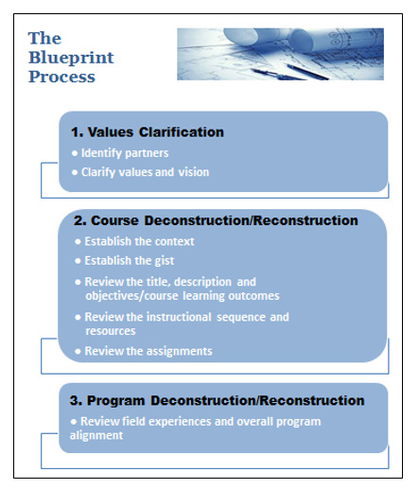
Catlett, C., Maude, S., & Skinner, M. (2016, October). The blueprint process for enhancing early childhood preservice programs and courses. Unpublished manuscript. http://fpg.unc.edu/resources/blueprint-process-enhancing-early-childhood-preservice-programs-and-courses

Assume nothing¹
The Danger of a Single Story https://www.ted.com/talks/chimamanda_adichie_
the_danger_of_a_single_story?language=en

Personas http://fpg.unc.edu/presentations/vermont-resource-collections

Resources, activities and assignments
- SCRIPT-NC http://scriptnc.fpg.unc.edu/resource-search
- Vermont Resource Collections http://fpg.unc.edu/presentations/vermont-resource-collections
- Master Class 1: Supporting Diverse Young Children and Their Families http://fpg.unc.edu/presentations/master-class-1
- Master Class 2: Supporting Young Children Who are Dual Language Learners and Their Families http://fpg.unc.edu/presentations/master-class-2
- Master Class 3: Environments and Interactions to Support Young Learners of Diverse Abilities http://fpg.unc.edu/presentations/master-class-3
- From Article to Action – coming soon to http://www.dec-sped.org

Free internet sources for images
- Milestones in Action Photo Video Library https://www.cdc.gov/ncbddd/actearly/milestones/milestones-in-action.html
- NY Public Library Domain Collections http://www.nypl.org/research/collections/digital-collections/public-domain

Free sources for videos
- Results Matter Video Library http://www.cde.state.co.us/resultsmatter/rmvideoseries
  - Catalog http://www.cde.state.co.us/resultsmatter/rmvideolibrarycatalog
- CONNECT Modules http://community.fpg.unc.edu/connect-modules/
- Illustrations of DEC Recommended Practices http://ectacenter.org/decrp/type-illustrations.asp

Listservs
BabyTalk – monthly, birth to 36 months
To join the listserv, send an email with no message to subscribe-babytalk@listserv.unc.edu
Past issues are archived at http://fpg.unc.edu/resources/baby-talk-archive

Natural Resources – weekly, birth through Grade 3
To subscribe, send an email with no message to subscribe-natural_resources2@listserv.unc.edu

Faculty Finds – targeted to faculty & professional development providers; content and instructional resources, tools
Send an email with no message to subscribe-facultyfinds@listserv.unc.edu
Past issues are archived at http://fpg.unc.edu/resources/faculty-finds

Resources within Reason – bi-monthly, birth-8, emphasis on children with or at risk for disabilities and inclusion
Subscribe or view past issues at http://www.dec-sped.org/resources-within-reason
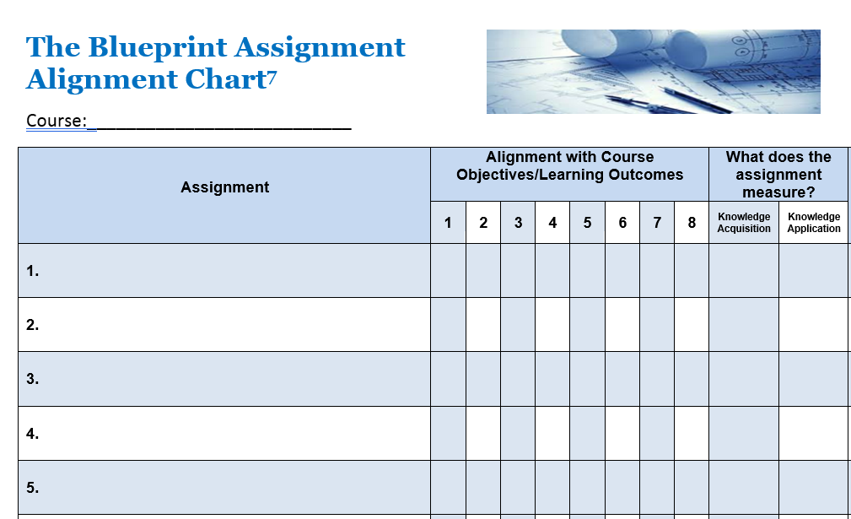

Check Your Intentionality
Course/Presentation: ______________________________________________________
Topics | Explicit and Intentional Emphasis |  |  |  | What will be accomplished?
 | Family Engagement | Children who are DLLs | Children with Disabilities; Inclusion | Racial/ethnic Diversity; Equity | Knowledge Acquisition | Knowledge Application

Everyday leadership: Drew Dudley https://www.ted.com/talks/drew_dudley_everyday_leadership

This handout and other resources in it may be downloaded at http://fpg.unc.edu/presentations/borrow-best

