LEADING FROM THE MIDDLE

Orientation/What’s in Your Leadership Backpack?

- A New Context for Leadership

Wheatley, M. J. (2009). Turning to one another: Simple conversations to restore hope to the future (pages 32-33). San Francisco: Berrett-Koehler Publishers, Inc.

Resources to Support a New Context for Leadership¹

Center for Creative Leadership https://www.ccl.org/

Maternal and Child Health Leadership Competencies https://leadership.mchtraining.net/

O’Neill, C., & Brinkerhoff, M. (2018). Five elements of collective leadership for early childhood professionals. St. Paul, MN: Redleaf Press.

Waters, J.T., Marzano, R.J., McNulty, B.A. (2003). Balanced leadership: What 30 years of research tells us about the effect of leadership on student achievement. Aurora, CO: Mid-continent Research for Education and Learning. ¹ https://www.mcrel.org/wp-content/uploads/2016/06/Balanced-Leadership%C2%AE-What-30-Years-of-Research-Tells-Us-about-the-Effect-of-Leadership-on-Student-Achievement.pdf

Whole Leadership Framework
https://mccormickcenter.nl.edu/wp-content/uploads/2018/03/Whole-Leadership-Framework.jpg

EXAMPLES
- Maryland Early Intervention Leadership Academy
- Urban design project sneaking puzzles & hopscotch into abandoned lots https://qz.com/1256248/the-urban-thinkscape-project-sneaks-games-into-public-spaces-to-help-kids-learn-better/

- What Informs Your Leadership?

Checklist for Personal Values¹

DEC Leadership Practices with Examples¹

FISH Philosophy http://www.fishphilosophy.com/fish-philosophy-story/

The happy secret to better work: Shaun Achor https://www.youtube.com/watch?v=fLJsdqxnZb0

Kouzes and Posner: The Leadership Challenge
http://www.leadershipchallenge.com/About-section-Our-Approach.aspx

Vision and Direction in Leadership Checklist¹

EXAMPLES
- Leading in a Social Age/Masterminds Marcia Blum
  - Leading in a Social Age https://prekteachandplay.com/2017cde-state-meeting/

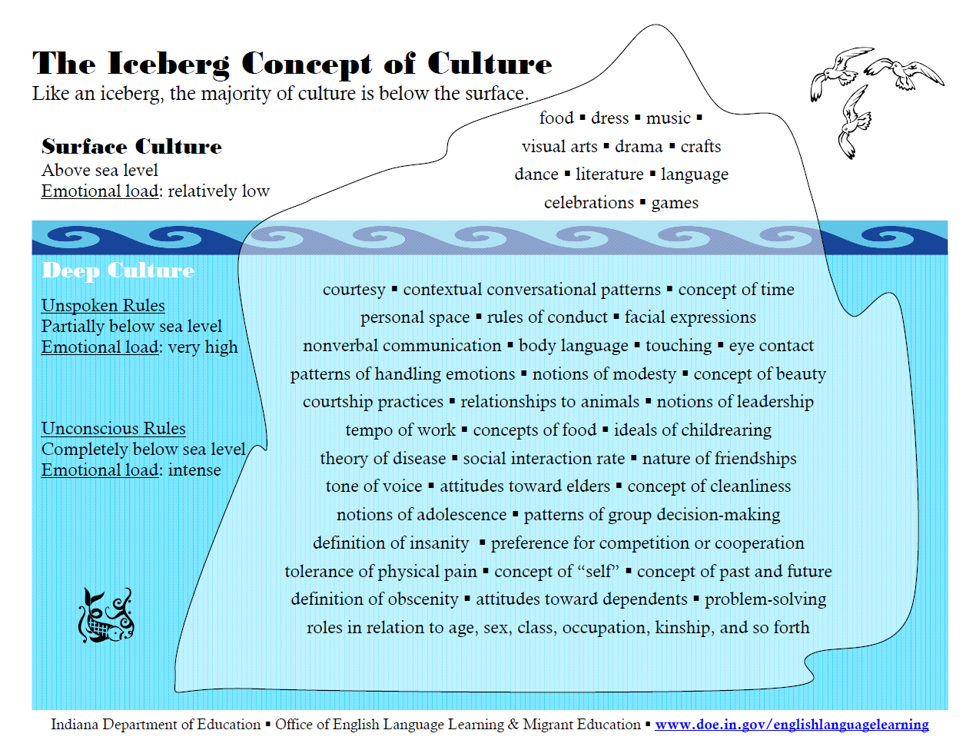
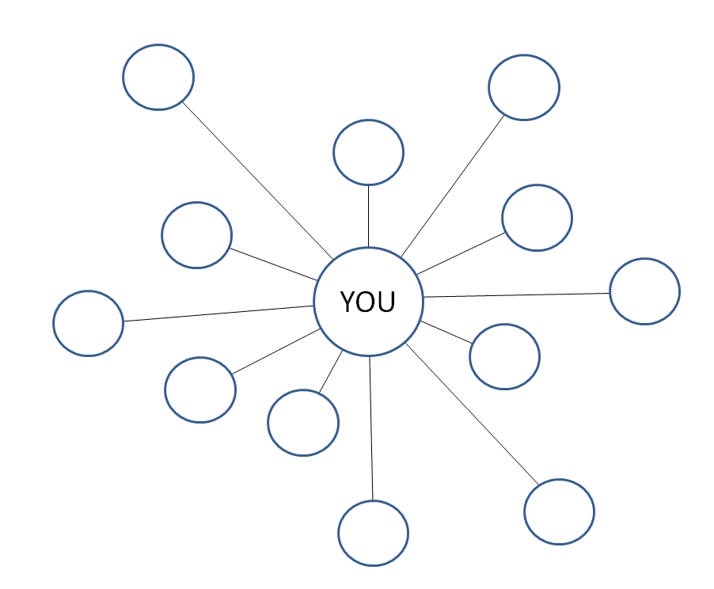

Who inspires you?

Characteristics?

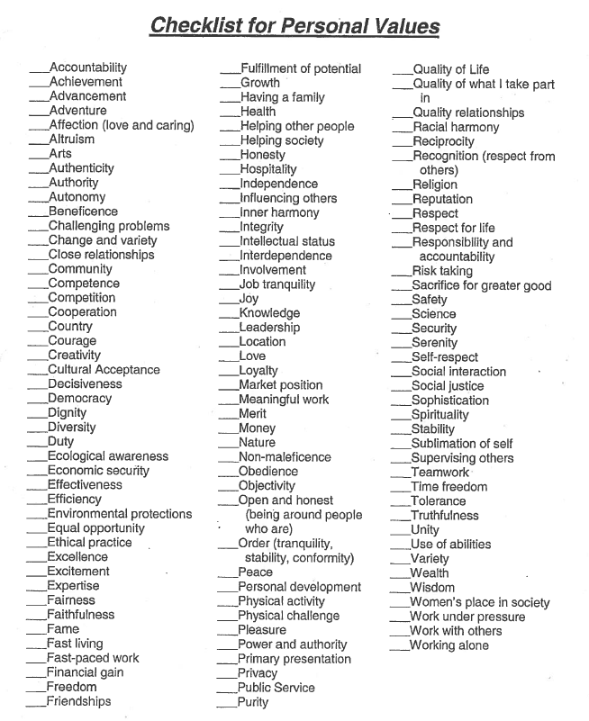
- From All to Each and Every

Evidence-Based Practice
Evidence-Based Practice Empowers Early Childhood Professionals and Families
http://community.fpg.unc.edu/sites/community.fpg.unc.edu/files/imce/documents/FPG_Snapshot_N33_EvidenceBasedPractice_09-2006.pdf

Developmentally Appropriate Practices
NAEYC. (2009). Developmentally appropriate practice in early childhood programs serving children from birth through age 8. https://www.naeyc.org/files/naeyc/file/positions/PSDAP.pdf

What is known about child development and learning—referring to knowledge of age-related characteristics that permits general predictions about what experiences are likely to best promote children’s learning and development

What is known about the social and cultural contexts in which children live— referring to the values, expectations, and behavioral and linguistic conventions that shape children’s lives at home and in their communities that practitioners must strive to understand in order to ensure that learning experiences in the program or school are meaningful, relevant, and respectful for each child and family

What is known about each child as an individual—referring to what practitioners learn about each child that has implications for how best to adapt and be responsive to that individual variation

Implementation Science
- Implementation Process http://ectacenter.org/implementprocess/

- Moving from Evidence to Implementation of Early Childhood Programs https://www.ncbi.nlm.nih.gov/books/NBK395707/

- The National Implementation Research Network’s Active Implementation Hub http://implementation.fpg.unc.edu/

Filling the Buckets

Supporting Young Children who are Dual Language Learners
- Resources to Support the Full Participation of Young Children who are Dual Language Learners and their Families¹
- Bradshaw: A Framework for Culturally Responsive Practices¹
- Self-Assessment Tool for DLL Competencies and Dispositions¹
- Puentes Culturales http://www.puentesculturales.com/

Supporting Young Children who have Experienced Trauma or Maltreatment
- Building Resilience: Resources for Supporting Young Children Who Have Experienced Trauma and Maltreatment and Their Families¹

- The Future of Healing: Shifting from Trauma Informed Care to Healing Centered Engagement
https://medium.com/@ginwright/the-future-of-healing-shifting-from-trauma-informed-care-to-healing-centered-engagement-634f557ce69c

Supporting Young Children With or at Risk for Disabilities
- Supporting Inclusive Practices for Young Children with Diverse Abilities¹

Being Reflective of and Responsive to Culture, Diversity and Equity
- Culture, Diversity, and Equity Resources¹
- Diversity-Informed Infant Mental Health Tenets https://imhdivtenets.org/
Integrating the Practices
CONNECT 5-Step Learning Cycle http://community.fpg.unc.edu/connect-modules/5-step-learning-cycle

Magic 8 Practices
Farran, D. C., Meador, D., Christopher, C., Nesbitt, K. T., & Bilbrey, L. E. (2017), Data-driven improvement in prekindergarten classrooms: Report from a partnership in an urban district, Child Development, 88(5), 1466-1479. http://onlinelibrary.wiley.com/doi/10.1111/cdev.12906/abstract

- Reduce time spent in transition. Time moving from one activity to another is time when children aren’t learning or engaged, which also increases the likelihood of negative behaviors.
- Improve level of instruction. Asking children open-ended, inferential questions and asking them to reflect on what they’ve learned or make predictions based on what they know improves student retention of new material and better prepares them for kindergarten.
- Create a positive climate. Using positive language to reinforce desired behavior rather than disapproving of specific student actions has a positive effect on children’s ability to self-regulate.
- Increase time teachers listen to children. Children whose teachers spent significant time listening to them showed a stronger grasp of math concepts, letters and sight words. Children who spoke more frequently also had stronger self-regulation and vocabulary skills.
- Plan sequential activities. When children participated in activities that followed a logical order, like completing a puzzle or writing a message, they engaged in higher level thinking, which improved their problem-solving skills.
- Promote cooperative interactions between children. Children who worked often with peers were more involved in classroom activities, had better language skills, and were better at self-regulation.
- Foster high levels of child involvement. Children are better at reading comprehension, vocabulary and math when they are actively involved in an activity, like when a teacher asks them to answer questions or make predictions about the book she’s reading.
- Provide math opportunities. Children who take part in multi-part math problems and discuss math concepts are better prepared for kindergarten and early math success, which is a strong predictor of late elementary school achievement.

EXAMPLES
- Supporting Each and Every Young Child and Family’s Full and Equitable Participation: Vermont Guiding Principles¹

- NAEYC Position on advancing diversity and equity – watch a video, provide your comments at https://www.naeyc.org/resources/blog/advancing-diversity-and-equity

- El Grupo de Familias – Susan Moore

- Family Engagement

Family Engagement Resources¹

Reconciling Leadership and Partnership¹

Rose’s IEP¹

EXAMPLES
- Family Leadership Training Institute of Colorado: Leadership Opportunities http://fltiofcolorado.colostate.edu/resources/leadership-opportunities/

- Parents Encouraging Parents (PEP) Chris Miller
  - For more information, contact Joy Thiessen-Barrett barrett_j@cde.state.co.us
- Transdisciplinary Play Based Assessment Chris Miller
  - For more information, contact Toni Linder Toni.Linder@gmail.com

- Finding, Using and Sharing Resources

Images
- Milestones in Action Photo Video Library

https://www.cdc.gov/ncbddd/actearly/milestones/milestones-in-action.html
- NY Public Library Domain Collections http://www.nypl.org/research/collections/digital-collections/public-domain

Listservs

BabyTalk – monthly, birth to 36 months. To join the listserv, send an email with no message to subscribe-babytalk@listserv.unc.edu Past issues are archived at http://fpg.unc.edu/resources/baby-talk-archive

Faculty Finds – targeted to faculty & professional development providers; content and instructional resources, tools. To subscribe, send an email with no message to subscribe-facultyfinds@listserv.unc.edu

Past issues are archived at http://fpg.unc.edu/resources/faculty-finds

Natural Resources – weekly, birth through Grade 3, one-way early childhood listserv. To subscribe, send an email with no message to subscribe-natural_resources2@listserv.unc.edu

Resources within Reason - Every other month this one-way listserv provides a page of free resources on a topic related to supporting young children with or at risk for disabilities and their typically developing peers. View past issues or sign up at http://www.dec-sped.org/resources-within-reason

Videos
- Results Matter Video Library http://www.cde.state.co.us/resultsmatter/rmvideoseries
  - Catalog http://www.cde.state.co.us/resultsmatter/rmvideolibrarycatalog
- CONNECT Modules http://community.fpg.unc.edu/connect-modules/
- Illustrations of DEC Recommended Practices http://ectacenter.org/decrp/type-illustrations.asp

EXAMPLES
Baby Talk
Summer Learning Ambassador Toolkit http://buildthefoundation.org/become-a-summer-learning-ambassador-with-the-new-ncecf-toolkit/

Forming Questions/Identifying Strategies and Partners
Drew Dudley: Everyday leadership https://www.ted.com/talks/drew_dudley_everyday_leadership

- Inclusion

Early Childhood Inclusion: A Joint Position Statement of the Division for Early Childhood (DEC) and the National Association for the Education of Young Children (NAEYC) http://npdci.fpg.unc.edu/resources/articles/Early_Childhood_Inclusion

Early childhood inclusion embodies the values, policies, and practices that support the right of every infant and young child and his or her family, regardless of ability, to participate in a broad range of activities and contexts as full members of families, communities, and society. The desired results of inclusive experiences for children with and without disabilities and their families include a sense of belonging and membership, positive social relationships and friendships, and development and learning to reach their full potential. The defining features of inclusion that can be used to identify high quality early childhood programs and services are access, participation, and supports.

- The Myth of Average https://www.youtube.com/watch?v=4eBmyttcfU4
- Leading and Growing in a Culture of Reciprocal Trust¹

- Resources to Support Inclusive Practices¹

Soukakou, E.P. (2016). Inclusive Classroom Profile (ICP). Baltimore: Paul Brookes. http://www.brookespublishing.com/resource-center/screening-and-assessment/inclusive-classroom-profile/

*Practices (from the ICP)
- Adaptations of Space, Materials, and Equipment
- Adult Involvement in Peer Interactions
- Adults’ Guidance of Children’s Free-Choice Activities and Play
- Conflict Resolution
- Membership
- Relationships Between Adults and Children
- Support for Communication
- Adaptations of Group Activities
- Transitions Between Activities
- Feedback
- Family-Professional Partnerships
- Monitoring Children’s Learning

EXAMPLE
5th Grade Friends Fight School to Include Brady https://www.youtube.com/watch?v=TaoJe4ntfa0

- Professional Development
National Professional Development Center on Inclusion. (2008). What do we mean by professional development in the early childhood field? Chapel Hill: The University of North Carolina, FPG Child Development Institute, Author. http://npdci.fpg.unc.edu/sites/npdci.fpg.unc.edu/files/resources/NPDCI_ProfessionalDevelopmentInEC_03-04-08_0.pdf

EXAMPLE
- Vermont Master Classes
- Boulder Early Childhood Council Susan Moore
- Early Childhood Council of Boulder County PD Training Calendar Summer 2018¹

- Collective Capability
Five Elements of Collective Leadership¹

Interprofessional Education Collaborative Expert Panel. (2011). Core competencies for inter-professional collaborative practice. Washington, D.C.: Inter-professional Education Collaborative. https://nexusipe-resource-exchange.s3-us-west-2.amazonaws.com/IPEC_CoreCompetencies_2011.pdf

Mixed-delivery model https://www.researchforaction.org/publications/partnering-for-pre-k-opportunities-to-scale-up-pittsburghs-collaborative-early-learning-model/

Teaming and Collaboration Resources from Kristen Klaassen¹

EXAMPLE
Effective Teaming to Support Quality Inclusive Practices - Mesa County Valley School District 51 Early Childhood Department Kim Self, Kristie Donathan, and Amber Hart
Power to the Profession https://www.naeyc.org/our-work/initiatives/profession/overview
- Advocacy

Get the facts
- First 2000 Days http://www.first2000days.org/

- High-quality preschool can support healthy development and learning
https://www.childtrends.org/publications/high-quality-preschool-can-support-healthy-development-and-learning

Social Media Made Easy http://afterschoolalliance.org/documents/STEM/SocialMediaMadeEasy.pdf

Fake it til you become it https://www.youtube.com/watch?v=RVmMeMcGc0Y

EXAMPLES
- Confidence and Competence: Partners in Policymaking (C2P2) https://disabilities.temple.edu/programs/leadership/c2p2ei.shtml

North Carolina Early Childhood Foundation
- Creating opportunities for bi-partisan leadership http://buildthefoundation.org/2018/06/statement-by-the-north-carolina-early-childhood-foundation-on-the-north-carolina-budget-proposal/

- Making a Difference

The art of leadership: Madeleine Albright https://luskin.ucla.edu/the-art-of-leadership-madeleine-albright/

Paula Jorde Bloom on Self-Monitoring¹

This handout was developed for the 2018 Minnesota 2018 Summer Institute. Resources from this session are available at http://fpg.unc.edu/presentations/leading-middle

