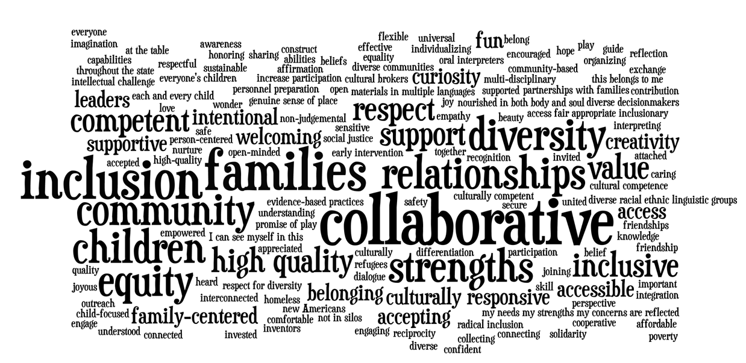

Ensuring Each Child’s Full Participation: A Critical Conversation
Summary
May 26, 2016

Agenda Item | Content | Resources
Pre-Meeting Activity | In preparation for the Critical Conversation, participants were asked to identify words they thought it would be essential to see in a set of guiding principles to support the full participation of each child. The inputs from participants were compiled and translated into the word art that appears above using Wordle (http://www.wordle.net). The largest words are those that were mentioned most frequently. | This Wordle and all handouts and products from the Critical Conversation are available at http://fpg.unc.edu/presentations/critical-conversation
Participants | Invitations to participate in the Critical Conversation were extended to over 150 early childhood colleagues from throughout the state of Vermont, including Guiding Principles Work Group members and individuals identified by the Work Group. Efforts were made to engage individuals who reflected diversity in terms of their race, ethnicity, geographic location, role, and perspective. While the 60 individuals who participated did not reflect tremendous racial or ethnic diversity, they were diverse in a variety of ways. For example, 10% of participants indicated that they were the parent of a child or children with a disability. | A list of the participants in the Critical Conversation is available at http://fpg.unc.edu/presentations/critical-conversation as Appendix A.
Welcome | Kim Keiser welcomed participants to the Critical Conversation and expressed appreciation for the time and commitment of participants. Kim mentioned the importance of the task of developing a set of explicit Guiding Principles that describe “how we are accountable.” (NOTE: As a member of the Guiding Principles Work Group, Kim participated in a yearlong sequence of meetings that led up to the Critical Conversation). | The agenda for the day is available at http://fpg.unc.edu/presentations/critical-conversation

Agenda Item | Content | Resources
Impetus for the Guiding Principles | Cynthia Greene highlighted the two rich resources that will significantly inform work to develop Guiding Principles: Vermont’s Early Childhood Framework: Our Commitment to Realizing the Promise of Each Vermont Child and Vermont’s Early Childhood Action Plan. (NOTE: Cynthia played a significant leadership role in the development of both resources). Cynthia described the Guiding Principles as a natural extension of these foundational documents and highlighted words from page 3 that describe the need for the Action Plan to be “a living document” that will evolve and benefit from new information and perspectives. | Framework http://governor.vermont.gov/sites/governor/files/VT%20ECH%20Framework%2010-29-13%20%282%29.pdf  Action Plan  http://buildingbrightfutures.org/wp-content/uploads/2014/03/VT-Early-Childhood-Action-Plan.pdf
What Experience Do You Want for Each Young Vermont Child and His/Her Family? | Camille Catlett shared greetings and a message from Wanda Heading-Grant, Vice-President for Human Resources, Diversity and Multicultural Affairs at the University of Vermont. Dr. Heading-Grant was invited to speak at the Critical Conversation. While she could not participate in person, she sent a written message to underscore that “Guiding Principles will allow us to remain culturally informed and prepared to welcome all families and give our children access to quality experiences that allow them to thrive.”  Camille highlighted the intended outcomes of the day, and then acknowledged the diversity of perspectives in the room. These ranged from leaders of key state agencies and school district personnel to grandparents and family members of children with and without disabilities. Foundation, mental health, early intervention, non-profit, health, advocacy, higher education, early childhood, Head Start, PreK, child care, and home visiting were some of the sectors represented.  Using the Building on Vermont’s Strong Foundations handout, Camille reviewed the many ways in which foundational Vermont documents have paved the way for a set of Guiding Principles.  Excerpts from Vermont’s Early Childhood Framework, Vermont’s Early Childhood Action Plan, and the guiding principles from the Vermont Early Learning Standards were highlighted.  Camille summarized reasons that Vermont has prioritized the development of Guiding Principles. These include:  - To create a sense of belonging and membership for each child, including children who are diverse in terms of culture, race, ethnicity, class, religion, ability, language, socio-economic status, values, and circumstances;  - To articulate the commitment to each Vermont family, including families who are homeless, poor and have members who are incarcerated;  - To reflect appreciation for the many ways in which Vermont’s families are diverse;  - To recognize and promote the assets of each child and family; and  - To be explicit about expectations and priorities, including for professional development. | The full text of Dr. Heading-Grant’s message is part of the agenda  which is available at http://fpg.unc.edu/presentations/critical-conversation  The handout and PowerPoint slides for this section of the program are available at http://fpg.unc.edu/presentations/critical-conversation
Agenda Item | Content | Resources
What Experience Do You Want for Each Young Vermont Child and His/Her Family?  (continued) | Camille clarified that supporting the full participation of each child moves beyond the concept of inclusion, which some people associate only with individualizing for children of diverse abilities. The full participation of each child underscores the importance of supporting the full potential of each child as an individual.  Camille shared information about the process that was used in New Mexico (NM) to develop a set of guiding principles. She also shared examples of how the NM guiding principles are being incorporated in grant proposals, reflected in college/university and ongoing professional development, and referenced in every day meetings. The NM guiding principles are reflected in the criteria of the state Tiered Quality Rating and Improvement System (called FOCUS in NM; STARS in Vermont), and form the basis of a required course for early childhood personnel.  Camille introduced participants to the initial family inputs from the Vermont Family Stories Project. Dr. Lori Meyer of the University of Vermont coordinated this effort, which was initiated to ensure that the voices and priorities of families throughout Vermont are incorporated in the Critical Conversation. Families voiced their priorities, preferences, and experiences through a process that included both online and fact-to-face input. Participants were charged with keeping the voices of Vermont’s diverse families in mind throughout the day. | A brochure summarizing the Guiding Principles for the Full Participation of Young Children, Birth Through Age Eight in New Mexico’s Early Learning System is available at http://fpg.unc.edu/presentations/critical-conversation  A summary of the initial Family Stories is available at http://fpg.unc.edu/presentations/critical-conversation
Words That Convey Vermont’s Commitment to Each Child | After the orientation, participants were divided into six groups. Each group included individuals with different perspectives, roles, and geographic locations. Each group was co-facilitated by two individuals, each of whom also brought different perspectives to the conversation. Participants in each group had an opportunity to introduce themselves, including the perspective(s) they were bringing to the Critical Conversation. Each group then reviewed a set of ground rules for the day’s interactions, adding to them as desired. They then began work on the first task which was to identify and capture examples of explicit words and concepts they thought would be important to see in a set of state guiding principles. This was followed by a “walk-about” to allow participants to view the work of other groups and consider additions to their own flip charts. Inputs were captured on flip charts by facilitators and later transcribed. | The important words, phrases and images that were identified in the six work groups are available at http://fpg.unc.edu/presentations/critical-conversation as Appendix B.
Words and Images That Convey Vermont’s Commitment to Each Child | Camille mentioned the importance of contributions to the Guiding Principles in a variety of formats. Thus, participants were invited to continue generating ideas in the form of words (in their current small groups) or given the option to join a new group that generated ideas visually, using a variety of art materials in a separate room. The six “verbal” groups and the new “visual” group were given a new task, which was to generate statements/images that delineate the beliefs, commitments, and actions necessary to realize the promise of each Vermont child. Participants were encouraged to build from Vermont’s foundational documents and the NM guiding principles. Inputs were captured on flip charts by facilitators and later transcribed. | The draft guiding principles identified by each of the six groups are available at http://fpg.unc.edu/presentations/critical-conversation as Appendix C (words) and Appendix D (images). Additional inputs are also posted as Appendix E.
Agenda Item | Content | Resources
How Will the Guiding Principles Make a Difference? | A panel discussion with Reeva Murphy, Aly Richards, and Amy Fowler offered insights from the perspectives of major state leaders on how the Vermont Guiding Principles will be incorporated in agency initiatives and efforts when they are completed. Panelists mentioned that the Guiding Principles will be a tool for holding ourselves accountable and can inform the use of agency resources, time and energy. Panelists graciously answered questions from participants which further clarified some of the ways in which the Guiding Principles will be a useful resource.  To follow up on ideas from the panel, participants next divided into groups to ponder the ways in which the Guiding Principles will be used. Groups considered the difference Guiding Principles will make for early childhood programs, families, policymakers, and professional development providers. A fifth group generated examples of how Guiding Principles will be used to build collaboration and strengthen connections across agencies and sectors. Inputs were captured on flip charts by facilitators and later transcribed. | A transcript of the role-alike inputs is available at http://fpg.unc.edu/presentations/critical-conversation as Appendix F.
Validation of the Guiding Principles | Participants were provided with an overview of the formal process that will be used to develop and validate the Vermont Guiding Principles. The process will follow the successful model used to create the national position statement on inclusion that was developed by the Division for Early Childhood and the National Association for the Education of Young Children. Steps of the process will include:  - Development of an initial draft based on inputs from the Critical Conversation. Camille and Beth Peloquin have transcribed the flip charts and will lead the effort to create an initial draft.  - Feedback on the initial draft by the members of the Guiding Principles Work Group. This group, which reflects diverse agency, provider, and family perspectives, will review the steps/timeline of the development process, revise the initial draft, lead the conversation about ways in which to use and disseminate the Guiding Principles, and support the quality and authenticity of the validation process (e.g., identify strategies for engaging family members to review and provide input to the draft Guiding Principles). Based on Work Group feedback, a revised draft will be created.  - Implementation of a statewide validation process to obtain broad and varied state input. An electronic platform (known as a landing pad) will be constructed to invite input to the revised draft. Landing pad visitors will complete a simple demographic form to allow tracking of respondents. Thus underrepresented groups can be solicited to visit the website and participate.  - Finalize Guiding Principles. Landing pad input will be documented and a revised set of Guiding Principles created for dissemination to agencies, programs, and individuals. The validation process will be documented and made available as a matter of public record.
Evaluation | At the end of the Critical Conversation, participants generously provided feedback in response to five questions: 1) What worked well? 2) What could have worked better? 3) Which voices were missing? 4) What did you discover? And 5) What other suggestions do you have? Inputs were captured on flip charts by facilitators and later transcribed.  Questions or comments about this summary or the Guiding Principles process? Please don’t hesitate to contact Camille Catlett (camille.catlett@unc.edu). | A transcript of the feedback from participants is available at http://fpg.unc.edu/presentations/critical-conversation as Appendix G.

