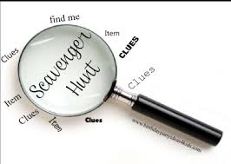
Division for Early Childhood (DEC)
Website Scavenger Hunt

Directions:

The Division for Early Childhood (DEC) website is an ongoing source of information for people who care about or work with young children, and especially young children with or at risk for disabilities.

The URL for the website is https://www.dec-sped.org/ That is where you’ll find all the answers to this scavenger hunt.

- In 2014, DEC identified the evidence-based and Recommended Practices for supporting young children with or at risk for disabilities and their families. What are the eight topical areas of recommended practice?

- DEC has a position statement on challenging behavior. What does that position statement say about culturally sustaining and equitable practices?

- What are two other topics on which DEC has position statements that can inform your work?

- In 2009, DEC partnered with the National Association for the Education of Young Children (NAEYC) to create a position statement on inclusion. According to that position statement, what is the definition of inclusion?

- The CONNECT modules are terrific sources of information and video on how to partner with families and support young children with or at risk for disabilities. At which URL on the DEC website can you find the CONNECT modules?

- DEC journals are great sources of ongoing information for people in the early childhood field. What are the names of the two DEC journals?

- Where will DEC’s 2020 conference be held?

- Every other month, DEC shares free resources to support professionals who work with young children through a publication called Resources within Reason. What was the topic of the December issue of Resources within Reason?

- At which URL can you find each issue of Resources within Reason?
When you find that URL, why not sign up to get a free copy of the resources every other month?

- At which URL will you find the latest news from the early childhood special education field?

- One important part of advocating for young children is writing to advocate for young children and families. What is the URL for the section of the DEC website that has examples of advocacy letters?

