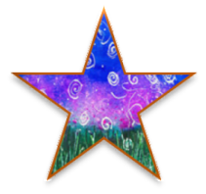  The Right Stuff  Resources to Help Realize the  Promise of Each Vermont Child  Colorful star | 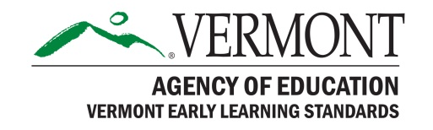
Issue No. 16 December 2017

Featured Domain: Social Studies

In the Vermont Early Learning Standards (VELS), the social studies domain includes inquiry, physical and cultural geography, civics, government and society, history, and economics. Learn more below and on page 113 of the VELS.
Exploring Social Studies through Children's Books (0-8)
http://fliphtml5.com/nfys/dsvt
Children’s books offer an excellent way for teachers and children to explore the many themes of social studies. Through books children can learn about their own culture and family, cultures around the world, geography, history, community, and more. This article shares a selection of books touching on these themes.

Social Studies in Preschool? Yes! (3-5) https://www.mbaea.org/documents/resources/Young_Children__March_2014_Social_S_F240BFB7A4BAC.pdf
Author Ann Epstein highlights how children learn to get along, make friends, and participate in decision making through engaging in social studies learning. Her article highlights practical ways to build children’s capacity to value diversity, learn about community roles, create and follow rules, understand history, geography and economic, and appreciate ecology.

Social Studies: The Kindergarten Experience (5-6)

https://www.teachingchannel.org/videos/teaching-kindergarteners-social-studies
In this 15-minute example, the California Gold Rush is the vehicle for sharing ideas about maps, through tactile, auditory, and visual experiences.

PreK-8 Environmental Education Activity Guide (3-9)
https://www.plt.org/curriculum/environmental-education-activity-guide/
This collection of 96 hands-on interdisciplinary activities address diverse topics including water, air, energy, waste, climate change, invasive species, community planning, and more. Each activity is tailored to specific grade levels and learning objectives. The materials provide the tools to bring the environment into a classroom, and children into the environment.

10 Best Social Studies Tools for Elementary School (5-9)

https://www.commonsense.org/education/top-picks/10-best-social-studies-tools-for-elementary-school

This collection of elementary-focused social studies tools will get kids digging into history and exploring places near and far, all while learning about different societies and cultures, and how they fit into the big picture.

Want more information about the VELS? Check out the Vermont Early Learning Standards (VELS) online at http://education.vermont.gov/student-support/early-education/vermont-early-learning-standards

Want more free resources related to this domain? An annotated collection of free resources related to science is available at http://fpg.unc.edu/presentations/vermont-resource-collections It includes free evidence-based sources, print materials, videos, websites and more.

The Right Stuff is a free listserv that is distributed monthly. Each issue features a domain of the Vermont Early Learning Standards (VELS) and resources for supporting the learning and development of young children, birth to Grade 3, in that domain. All resources are evidence-based, readily available and free. All or part of The Right Stuff may be freely shared or reproduced. Past issues are available at http://fpg.unc.edu/presentations/right-stuff

The Right Stuff is compiled by Camille Catlett, supported by the Vermont Agency of Education, and funded by the Vermont Race to the Top Early Learning Challenge Grant. To receive your copy of The Right Stuff each month, send an email with no message to subscribe-the_right_stuff_listserv@listserv.unc.edu

