Family Stories Project: Initial Voices

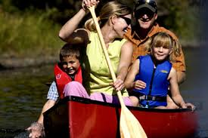
Families with young children in several parts of Vermont were asked the same questions:

- What can people do to help you feel respected?
- What does a program/school need to do to support your family’s priorities, values, & culture?
- What is your greatest worry for your children when they are in the care of someone else?
- What is your greatest hope for your children when they are in the care of someone else?
- Imagine the best program/school that supports your children and includes your family. What does it look like?

From the families’ responses across all questions, five consistent themes emerged. What follows are examples of family responses in each thematic areas. No family’s voice is represented more than once in the quotes for each category. Attention was given to including quotes from families who represent the diversity of responders, such as hometown, racial/ethnic background, income, and whether they have children with disabilities.

CLEAR COMMUNICATION: Families noted that open, clear communication was one way that they were shown respect. A key part of communication was for teachers to know both about the children in their care and about the children’s families. Consistent communication was often mentioned as a way to help families feel connected to and welcomed in their children’s early care and education environment. Being able to communicate with one another about needs, interests, concerns, and priorities were often mentioned as ways that teachers could support families.

“Where everyone is on the same page and is willing to work with the families and parents with disabilities and children. The providers are willing to communicate with families and work with parents with disabilities in knowing how to help them understand what is going on at the daycare and with their children.”

“Communicate. Find out what our family is like and what is important to us, and then talk to us regularly about what is going on with our daughter.”

“Show interest in our parenting philosophy and family values, greet us daily during pick up and drop off, remember, our names and other individuals important to our family, and ask questions about family routines.”

“Greet my child upon arrival, communicate about my child's day, and value my voice.”

SAFETY: Safety was an idea heard throughout family responses when addressing hopes, worries, and qualities of a great program. This not only included keeping children safe in terms of health/wellness, but also to keep them safe from the consequences of adult neglect. The mention of safety often coincided with discussion of building communities of respect and facilitating children’s social relationships.

“My greatest worry is that she'll get hurt, teased or made to feel badly about herself and the teachers won't be aware or able to prevent it.”

“That [children] feel safe, respected, and inspired to be their best self. They will also have positive relationships among peers as well as faculty and/or staff.”

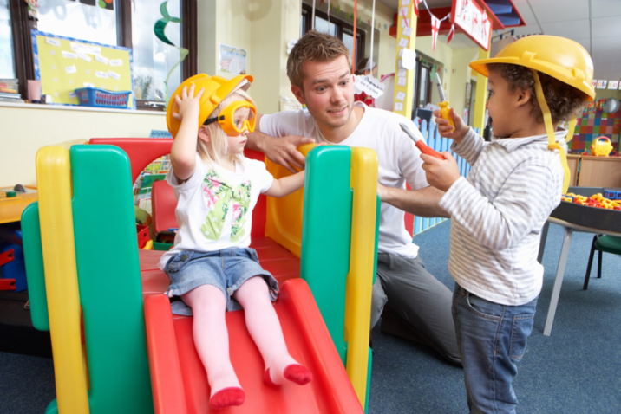
CREATING COMMUNITY: This theme emerged as families discussed the ways they could feel supported and included as part of a larger, welcoming community. Across a great number of families, there was emphasis on the simple act of being greeted by teachers/
administrators. Quotes in this category include actions that could be taken to help families connect with each other. Comments in this category also include families’ wishes for the type of classroom community they would like to see created for their children.

“The greatest challenge for me is that I don't have the time I wish I had to be a part of that "best" scenario, because I have to work -- but I would hope that the "best" program would be inclusive, positive, patient, and inspiring, both to the children and their families.”

“That she will have joy and be enjoyed and that there will be balance between her needs and the needs of the larger group. Through this balance she will learn to be part of a community. That she will learn to love learning and be full of curiosity.”

“It would celebrate diversity, art, imagination, creativity and a healthy lifestyle. It would also have a strong sense of community where students would feel valued for who they are and what they have to offer.”

To make sure early learning communities feel welcoming to all children and families, I want each and every professional to remember why they got started in education in the first place.

RESPECTING DIVERSITY: The theme of respecting and celebrating what makes children and families unique was a theme heard from answers across several questions, but especially the question related to what teachers could do to help families feel respected. Some families shared that they desired professionals in early care and education environments to promote the exploration of diversity and to not push conformity on young children. Families voiced their preference for differences to be viewed as a positive quality. The message of respect often coincided with comments mentioning the importance of feeling included, welcomed, and having open communication with teachers/administrators.

“The best school would value kids as individuals, rather than trying to fit square pegs into round holes. Every activity and event would be accessible to ALL students, and families would be involved in creating a culture that welcomes and accommodates all kids…I wish our school, which celebrates its racial and ethnic diversity, would value and include its students with disabilities as part of that diversity. I wish our school would make explicit efforts to include families like ours, and would try to understand why children with disabilities struggle to participate in school. To support our family's priorities, values, and culture, our school needs to openly and vocally embrace disabled kids, instead of considering them broken, or behavior problems. Many teachers do these things well, but the administration and school culture as a whole do not.”

“Have a positive outlook on the differences and nurture them if possible.”

“They can honor parents as their child's first teacher. They can understand that each family has their own culture and may adapt advice to fit what their family values. They can assume that parents are doing the best they can.”

“Listen to our requests and needs for our child. Be aware of our common racial and cultural history so as to be appropriate and sensitive to our children and their backgrounds.”

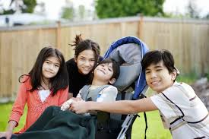
CREATING A RESPONSIVE & CARING CULTURE: Comments in this category present the idea of educators and administrators understanding and supporting children’s individual needs and the importance of educators understanding young children’s development. This includes nurturing children, creating a positive environment, encouraging children to grow at their own pace, scaffolding their learning, and promoting their exploration of new interests. Comments in this category also included aspects of the curriculum that families valued and would like to see make up the classroom culture (e.g., hands-on activities, project-based work, play-based curriculum, nature/
outdoors, natural materials, physical activity).

“I think that a culture that treats all people as an equal while fostering a loving caring environment that enables the child to grow and advance at his or her own pace is important. In terms of culture I enjoy the fact that they follow through on things that are true to our Vermont heritage and culture such as farming, maple syrup production and the like.”

“Teachers who love teaching, who are flexible thinkers, who inspire creativity and scaffold learning for every child. Placing great emphasis on social emotional wellbeing of everyone children and adults and prioritizing that above academics and test scores.”

“[Children] are loved, encouraged to expand their sense of self, learn to engage with others, are safe, and learn many skills and topics.”

“That she will be loved and valued for the individual that she is.”

“They will be able you work with our son, and understand his needs as a child with autism.”

“My kids would get there excited and leave inspired each and every day.”

“That he will discover new interests, make good friends and have positive social experiences that challenge him and help him grow, and that his intellect will be fostered in many ways and appropriately for his developmental stage.”

“That my son is happy, engaged, with friends socially, valued, known, heard, understood & presumed competent - I could go on!”

“Treat my child fairly and respect how I raise my children.”

“I hope my child is treated with love and respect. I hope others always have high expectations of him, and hold him accountable for appropriate behavior and provide developmentally appropriate discipline. I also never want my son to be treated any differently or be made to feel different because of a medical condition.”

The Family Stories Project is being coordinated by Dr. Lori Erbrederis Meyer in collaboration with other colleagues at the University of Vermont including Beth Peloquin and the students in EDSP 210. The stories were collected in May 2016.

