High Quality Inclusive Practices:
Preparing Early Childhood Professionals

Camille Catlett  FPG Child Development Institute  camille.catlett@unc.edu | Andrea Racek  Early Childhood Programs, Franklin Northwest Supervisory Union aracek@fnwsu.org

Opening Activity

The Myth of Average https://www.youtube.com/watch?v=4eBmyttcfU4

What Do We Mean By Inclusion?
DEC/NAEYC. (2009). Early childhood inclusion. Chapel Hill: UNC, FPG Child Development Institute. http://npdci.fpg.unc.edu/resources/articles/Early_Childhood_Inclusion

Early childhood inclusion embodies the values, policies, and practices that support the right of every infant and young child and his or her family, regardless of ability, to participate in a broad range of activities and contexts as full members of families, communities, and society. The desired results of inclusive experiences for children with and without disabilities and their families include a sense of belonging and membership, positive social relationships and friendships, and development and learning to reach their full potential. The defining features of inclusion that can be used to identify high quality early childhood programs and services are access, participation, and supports.

Supporting Each and Every Young Child and Family’s Full and Equitable Participation: Vermont Guiding Principles
http://fpg.unc.edu/presentations/full-and-equitable-participation-principles

Sample Activity
Which of the principles is directly related to supporting children with disabilities and their families? (HINT: Try this with personas)

Andrea’s Bottom Line: Equal vs. equitable vs. Universal Design for Learning
Expanding and Strengthening Best-Practice Supports for Students Who Struggle Preliminary Highlights for Discussion http://education.vermont.gov/sites/aoe/files/documents/edu-legislative-report-dmg-expanding-and-strengthening-best-practice-supports-for-students-who-struggle.pdf

Camille’s Bottom Line: Catlett’s Corollary

Vermont-Specific Details

Vermont Agency of Education (state laws, federal laws, special education rules, statutes and acts) http://education.vermont.gov/student-support/special-education/policy-and-regulations

Act 157 requires that schools develop a comprehensive educational support system (ESS) with the capacity to provide a range of social, academic and behavioral supports http://education.vermont.gov/sites/aoe/files/documents/edu-state-board-rules-series-2360.pdf

Children’s Integrated Services Partners One Plan http://cispartners.vermont.gov/one-plan

Facilitating the Meaningful Participation of Culturally and Linguistically Diverse Families in the IFSP and IEP Process http://bottemabeutel.com/wp-content/uploads/2014/01/Zhang-Bennett-IEP-CLD-familes.pdf

Supporting Young Learners of Diverse Abilities syllabus (2016 online course)

What Do We Know About Inclusion?

Sample Activity

Inclusion Quiz

Inclusion Quiz answers: Research synthesis points on early childhood inclusion http://npdci.fpg.unc.edu/sites/npdci.fpg.unc.edu/files/resources/NPDCI-ResearchSynthesisPoints-10-2009_0.pdf

Factsheet of Research on Preschool Inclusion http://ectacenter.org/~pdfs/topics/inclusion/research/Research_Supporting_Preschool_Inclusion_R.pdf

Preschool Inclusion: Key Findings from Research and Implications for Policy http://www.nccp.org/publications/pub_1154.html

Sedlack, J. (2009, Summer/Fall). How inclusion is benefiting one child without disabilities: Dillon’s story. Impact, 22(1), 12. https://ici.umn.edu/products/impact/221/9.html

Sample Activity

Evidence-based talking points activity

What Are Evidence-Based Practices That Support Each and Every Young Child in Home and Community Settings?

Bowling and inclusion https://www.youtube.com/watch?v=RYtUlU8MjlY

Research synthesis points on practices that support inclusion¹

ACCESS PRACTICES

Universal Design for Learning

Classroom Visuals and Supports http://headstartinclusion.org/classroom-visuals

Integrating Principles of Universal Design into the Early Childhood Curriculum http://www.southernearlychildhood.org/upload/pdf/Dimensions_Vol41_1_Dinnebeil.pdf

Early Childhood Building Blocks: Universal Design for Learning in Early Childhood Inclusive Classrooms¹
http://teachingcommons.cdl.edu/tk/modules_teachers/documents/Buildingblocks.pdf

Handout 15: Using Choice and Preference to Promote Improved Behavior http://csefel.vanderbilt.edu/briefs/handout15.pdf

Using Visual Supports with Infants and Toddlers https://www.ctdinstitute.org/sites/default/files/file_attachments/TnT-News-VisualSupports-Oct12.pdf

Sample Activities

Identify five ways in which UDL is being used in your community

Create a photo album slide show, PPT of examples of UDL in the community.

Assistive Tools and Supports

Adapt and Accommodate http://connectability.ca/2014/06/14/adapt-and-accomodate/

CONNECT Module 5: Assistive Technology http://community.fpg.unc.edu/connect-modules/learners/module-5

Emerging Literacy through Assistive Technology¹ http://webzoom.freewebs.com/sallydoxie/VOL.35NO.2NOVDEC2002_TEC_Article%206.pdf

EZ AT https://www.yumpu.com/en/document/view/30717393/ez-at-pacer-center

Supporting Early Literacy Through UDL & AT http://headstartinclusion.org/family-literacy-2

Toy Tips: Ideas and Options for Children with Special Needs¹ https://ganinfo.org/docs/gan-toy-workshop.pdf
PARTICIPATION PRACTICES

Embedded Learning

CONNECT Module 1-Embedded Interventions http://community.fpg.unc.edu/connect-modules/learners/module-1
- Routine in a program: reading at circle time
http://community.fpg.unc.edu/connect-modules/resources/videos/video-1-16

Head Start Center on Inclusion – Embedded Learning Opportunities http://headstartinclusion.org/elo#elo

Embedding IFSP or IEP Goals into Daily Routines
- Goal Activity Matrix
- Goal Activity Matrix for Dylan
- Classroom Activity Matrix

Sample Activities

Using a persona, ask learners to identify how they might use daily classroom routines to support that child in areas identified on their IFSP/IEP.

Using a persona, ask learners to identify how family members might use daily routines to support that child in areas identified on their IFSP/IEP.

Scaffolding
CARA’s Kit Source: Milbourne, S. A., & Campbell, P. H. (2007). CARA’s Kit: Creating adaptations for routines and activities. DEC, NAEYC, Brookes Publishing.

Adaptation Notes ¹

Interview

Sample Activity

Present learners with a dilemma and require them to use the CARA’s Kit Adaptation Notes to consider ways in which they might resolve the dilemma.

Gerry Brooks on Differentiation https://www.youtube.com/watch?v=BxtCw_ucqOQ

Tiered Models
The Pyramid model
- National Center for Pyramid Model Innovations http://challengingbehavior.cbcs.usf.edu/

Vermont’s Early Multi-Tiered System of Supports (Early MTSS)
http://ectacenter.org/~pdfs/topics/inclusion/VT_EC_MTSS_One_Pager_SPDG_and_RTT-ELC.pdf

Response to Intervention (RTI)
- Frameworks for Response to Intervention in Early Childhood: Description and Implications
https://s3-us-west-2.amazonaws.com/kpfsite/dec+RTI+paper/Position+Statement+-+Frameworks+for+Response+to+Intervention+in+Early+Childhood.pdf

[SYSTEMIC] SUPPORTS

Professional Development
DEC Recommended Practices

Fabulous Site #1: DEC Recommended Practices

The following resources are available at http://www.dec-sped.org/dec-recommended-practices
- DEC Recommended Practices with Interactive Glossary
- DEC Recommended Practices with Examples

Fabulous Site #2: The following resources are available at
- Recognizing and Performing the DEC Recommended Practices http://ectacenter.org/decrp/
EXAMPLE: Interaction Resources http://ectacenter.org/decrp/topic-interaction.asp

Interaction Checklists http://ectacenter.org/decrp/type-checklists.asp

→Adult-Child Interaction Checklist

http://ectacenter.org/~pdfs/decrp/INT-1_Adult-Child_Interaction.pdf

Illustrations http://ectacenter.org/decrp/type-illustrations.asp

Practice Guides for Practitioners http://ectacenter.org/decrp/type-pgpractitioner.asp

→Interaction Practice Guide for Practitioners: Peer Interaction http://ectacenter.org/~pdfs/decrp/ECTAprac_PeerInteraction_PRACT_print.pdf

Practice Guides for Families http://ectacenter.org/decrp/type-pgfamily.asp

→Interaction Practice Guide for Practitioners: Peer Interaction http://ectacenter.org/~pdfs/decrp/ECTAprac_PeerInteraction_PARENT_print.pdf

Fabulous Site #3: Early Childhood Recommended Practices Modules https://rpm.fpg.unc.edu/

Sample Activities
Create a scavenger hunt for key words or concepts through the DEC Recommended Practices (e.g., where do you see an emphasis on Universal Design for Learning?)

Introduce a persona (e.g., Rose), then ask learners to identify a recommended practice from each area that would be particularly relevant to supporting his/her success.

Use practice checklists as guides with videos or field experiences (e.g., which of these practices did you observe?)

Use examples from the DEC Recommended Practices with Examples to provide specific illustrations for your courses/presentations

Inclusive Classroom Profile
Soukakou, E. P. (2016). The Inclusive Classroom Profile. Baltimore: Brookes. http://products.brookespublishing.com/The-Inclusive-Classroom-Profile-ICP-Set-Research-Edition-P969.aspx

Sample Activity
Use Looking for the Indicators of Inclusive Classroom Quality: An Observation Guide¹ in conjunction with a video like Playing Red Light, Green Light ( http://community.fpg.unc.edu/connect-modules/resources/videos/video-1-17)

Family and Professional Collaboration

Family Engagement: From the Early Years to the Early Grades http://www2.ed.gov/about/inits/ed/earlylearning/files/policy-statement-on-family-engagement.pdf

CONNECT Module 4: Family-Professional Partnerships
http://community.fpg.unc.edu/connect-modules/learners/module-4

Engaging Families in Planning and Goal Setting https://hsicc.cmail20.com/t/ViewEmail/j/C4D6DDF05BFB05CA2540EF23F30FEDED/FA208C9D2D6FD0F9948D468F162BC46E

DEC Recommended Practices Module 5: Family https://rpm.fpg.unc.edu/module-5-family

Sample Activity
Show the following clip: Routine in a program: Rolling with friends http://community.fpg.unc.edu/connect-modules/resources/videos/video-1-12 Ask participants to identify the ways in which family members, educators, therapists, and others need to collaborate to make this activity work for all the children.
What Does Quality Inclusion Look Like?

As you watch each of these videos, please consider the following:
- How might you use this clip in the work you do?
- For which other children might the practices in this video be effective?

At Home - Nolan’s Story from Just Being Kids http://www.cde.state.co.us/resultsmatter/rmvideoseries_justbeingkids

For Infants and Toddlers - Deaf grandma and baby https://www.youtube.com/watch?v=E7IlnTG7wzk

In Preschool - Song of our Children

In Early Elementary School (Including Samuel) https://www.includingsamuel.com/video

How Could Courses/Presentations Be Adjusted To Incorporate An Emphasis on Inclusion?

Rubric for Assessing Inclusion Content and Practices

Rose’s IEP Meeting http://studio.stupeflix.com/v/M8FHT7JW6u/?autoplay=1

Rose’s Great Year http://studio.stupeflix.com/v/fAwFtbCaiiY0/

What Terrific, Free Resources Are Available to Support My Work?

Books
Barton, E. E., & Smith, B. J. (2015). The preschool inclusion toolbox: How to build and lead a high-quality program. Baltimore: Brookes.

Brillante, P. (2017). The essentials: Supporting young children with disabilities in the classroom. Washington, DC: NAEYC.

Brillante, P., & Nemeth, K. (2018). Universal design for learning in the early childhood classroom: Teaching children of all languages, cultures, and abilities, birth – 8 years. New York: Routledge.

McWilliam, R. A., & Casey, A. M. (2007). Engagement of every child in the preschool classroom. Baltimore: Brookes.

Sandall, S. R., & Schwartz, I. S. (2008). Building blocks for teaching preschoolers with special needs. (2nd ed.). Baltimore: Brookes.

Free Collection: Supporting Inclusive Practices for Young Children with Diverse Abilities

Classroom Routine Support Guides
- Routine-Based Support Guide (2-5) http://challengingbehavior.fmhi.usf.edu/do/resources/teaching_tools/toc/folder1/1e_routine_based.pdf
- Early Elementary K-2nd Grade (5-8) http://challengingbehavior.fmhi.usf.edu/do/resources/documents/tool_class_routine_guide_early_ele.pdf

Family Routine-Based Support Guides
- Family Routine-Based Support Guide: Building Relationships with Infants
http://challengingbehavior.fmhi.usf.edu/do/resources/documents/tool_fam_routine_guide_infants.pdf
- Family Routine Based Support Guide: Early Elementary http://challengingbehavior.fmhi.usf.edu/do/resources/documents/tool_fam_routine_guide_early_ele.pdf

Websites
SCRIPT-NC https://scriptnc.fpg.unc.edu/children-exceptionalities

Listservs
- Resources within Reason – bi-monthly, birth-8, emphasis on children with or at risk for disabilities and inclusion. Subscribe or view past issues at http://www.dec-sped.org/resources-within-reason

- Head Start Disability Services Newsletter
This monthly electronic newsletter provides good, free resources for supporting young children with disabilities and their families. Each month is organized around a different topic (e.g., April 2017 was Environment Modifications to Support Learning). Past issues are archived for easy access at https://eclkc.ohs.acf.hhs.gov/hslc/tta-system/teaching/Disabilities/Staff%20Support%20and%20Supervision/Support%20and%20Supervision%20for%20Staff%20Serving%20Children%20with%20Disabilities/HeadStartDisabi.htm Content has applicability well beyond Head Start settings. Sign up at https://eclkc.ohs.acf.hhs.gov/eclkc/customerservice/cmalerts

Videos
5th Grade Friends Fight School to Include Brady https://www.youtube.com/watch?v=TaoJe4ntfa0

Deaf Children Talk About Inclusion https://www.youtube.com/watch?v=8ZpgAx8nrgk

When It Comes to Difference, Children See Things Differently https://www.youtube.com/watch?v=1MJrRvpjB1I

I’m Tyler http://www.imtyler.org

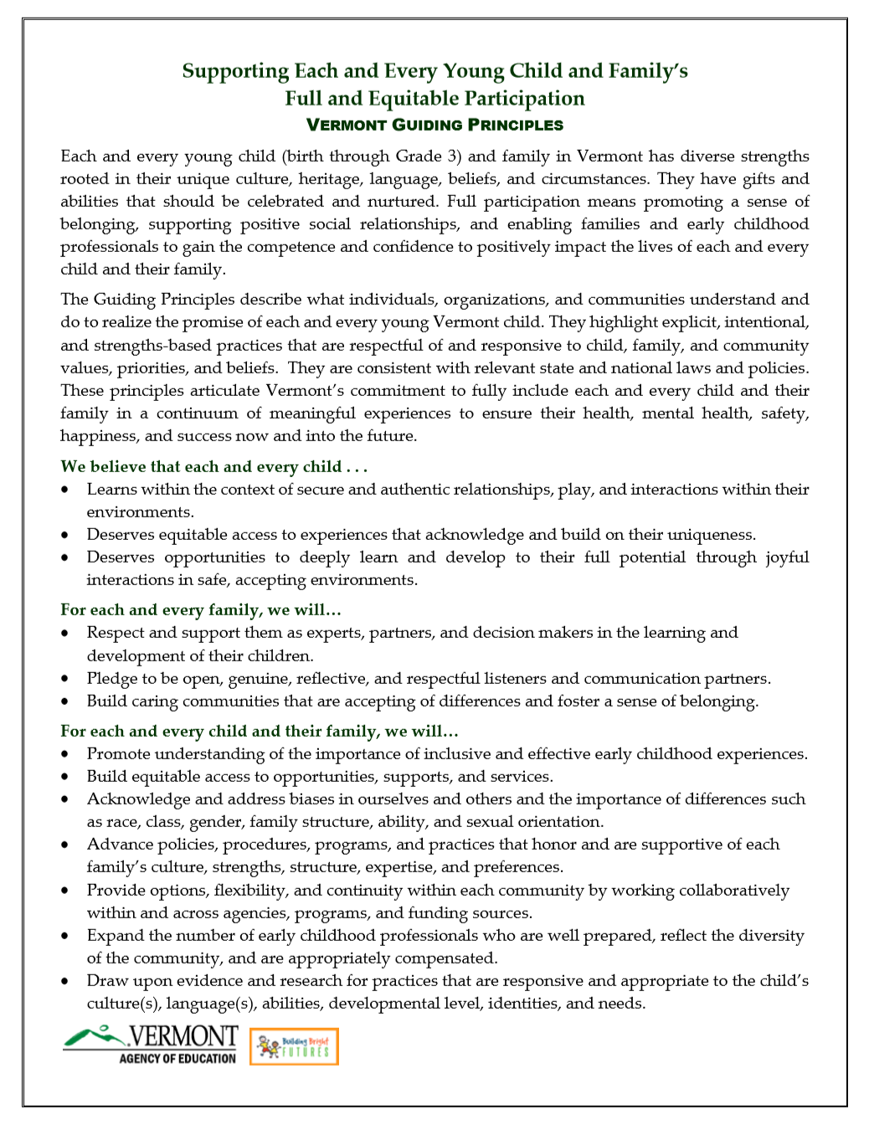
Just the Facts, Ma’am: An Inclusion Quiz

Please indicate whether you think each statement is true or false.

1. There is a national definition of inclusion. True False

2. Families of young children with disabilities can find inclusive programs in their community if they look hard enough.
True False

3. Inclusion can benefit children with and without disabilities, particularly in the area of social development.
True False

4. A variety of factors (policies, resources, beliefs) influence the implementation of inclusion. True False

5. Specialized intervention practices and supports are not an important component of quality inclusive programs.
True False

6. Collaboration among family members, teachers, and specialists is a cornerstone of inclusion. True False

7. The quality of early childhood programs is negatively impacted when they include children with disabilities.
True False

8. A high-quality early childhood program is not necessarily the same thing as a high quality inclusive early childhood program. True False

9. Early childhood professionals may not be well prepared to support young children with disabilities. True False

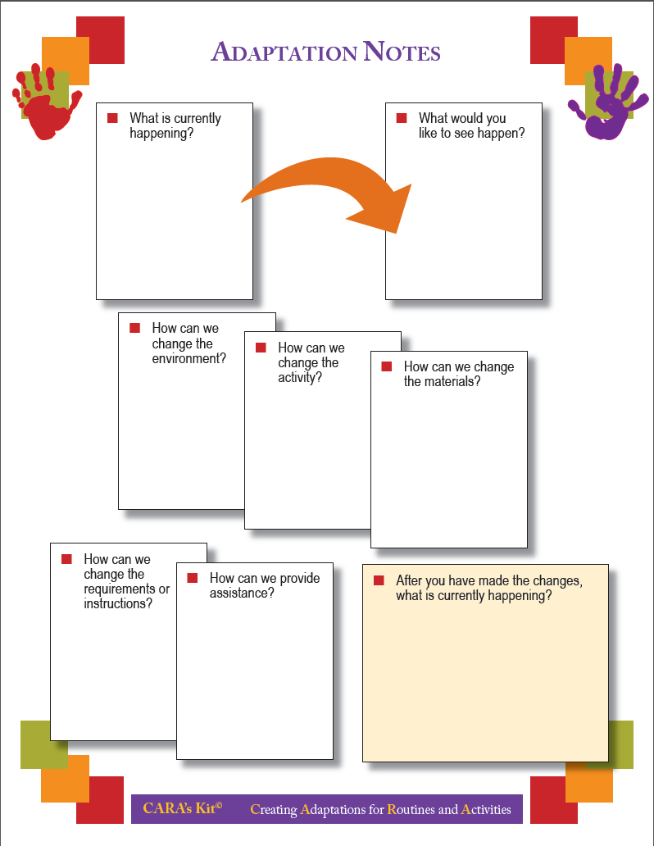
Looking for the Indicators of Inclusive Classroom Quality: An Observation Guide

To what extent do you see . . . | What did you observe?
- Adaptations of Space, Materials, and Equipment

Inadequate: Materials and equipment are not accessible to all children.

Excellent: Adults intentionally organize the physical space and materials throughout the day to accommodate individual needs and encourage peer interaction.
- Adult Involvement in Peer Interactions

Inadequate: Adults consistently control and restrict the initiation and development of spontaneous social interactions.

Excellent: Adults consistently encourage and support children’s social engagements through scaffolding strategies that aim to help children engage in many sustained interactions with their peers.
- Adult’s Guidance of Children’s Free-Choice Activities and Play

Inadequate: No free time is set aside in the daily schedule. Adults make no attempts to become involved in children’s free-choice activities and play.

Excellent: Adults observe children’s response to support and adjust their level and type of scaffolding as needed to facilitate sustained engagement.
- Conflict Resolution

Inadequate: Adults mainly use strict ways to redirect children’s peer conflicts (e.g., children put in time out, adults use harsh tone).

Excellent: Adults encourage children to take an active role in negotiating their differences while providing the necessary individual support.
- Membership

Inadequate: Adults do not intervene to stop the bullying and teasing of children in the class.

Excellent: Adults consistently and intentionally promote a sense of belonging and membership by encouraging children’s participation.
Looking for the Indicators of Inclusive Classroom Quality: An Observation Guide

To what extent do you see . . . | What did you observe?
- Relationships Between Adults and Children

Inadequate: Most social interactions are mainly nonverbal, involving routine caregiving (e.g., adult passes out tissues).

Excellent: Adults consistently respond to each child’s emotional needs through supportive interactions.
- Support for Communication

Inadequate: Adults make no attempt to adapt their communication for individual children.

Excellent: Adults create many opportunities to facilitate communication among children.
- Adaptations of Group Activities

Inadequate: Children are excluded from all planned group activities.

Excellent: Adults consistently use strategies to differentially support each child’s learning and behavior needs while encouraging children’s active engagement in the group.
- Transitions Between Activities

Inadequate: No provisions are made to help children transition between classroom activities.

Excellent: Adults consistently support each child who has difficulty making the transition between activities throughout the day.
- Feedback

Inadequate: Negative feedback predominates in the classroom.

Excellent: Each child’s learning experiences, efforts, and progress are acknowledged and reinforced multiple times for much of the day.

Rubric for Assessing Inclusion Content and Practices¹
Listed below are indicators that may be important to consider when preparing professionals who will work with young children with and without disabilities and their families. These may be found throughout or in one specific section of a syllabus or training plan. When deciding on a rating, consider how much the area is reflected in the syllabus/training plan as a whole. In addition to scoring the extent to which each indicator is reflected in the syllabus, please mark where the indicator was found.
Indicators | Extent the Syllabus  Reflects Indicator |  |  | Where Was the Indicator Found?
 | None | Some | Significantly | Course Description | Outcomes/ Objectives | Texts, Readings, Resources | Instructional Experiences | Assignments
- To what extent have you included evidence-based practices for supporting young children with or at risk for disabilities? (e.g., DEC Recommended Practices)? | 0 | 1 | 2
- To what extent have you included an emphasis on evidence-based practices that support inclusion (e.g., Inclusive Classroom Profile)? | 0 | 1 | 2
- To what extent have you incorporated an emphasis on engagement of parents/families as essential components of inclusion? | 0 | 1 | 2
- To what extent have you addressed aspects of culture, diversity, and equity in supporting opportunities for young children with disabilities to be fully included? | 0 | 1 | 2
- To what extent have you incorporated an emphasis on including young children with disabilities who are dual language learners? | 0 | 1 | 2
- To what extent have you included an emphasis on collaboration with educators, therapists, and other colleagues? | 0 | 1 | 2
 |  |  |  | TOTALS=

Access PowerPoints and handouts at http://fpg.unc.edu/presentations/master-class-inclusion
The content of this observation guide is drawn from the following source: Soukakou, E. P. (2016). Inclusive Classroom Profile (ICP): Research edition. Baltimore: Brookes.
¹ Developed by Camille Catlett (May 2018) None = indicator is not mentioned. Some = indicator is mentioned 1-2 times in any location. Significantly = indicator is mentioned 3 or more times and is connected to both knowledge acquisition (course description, outcomes/objectives, texts/readings/resources, instructional experiences) and knowledge application (assignments).

