HOW TO GET YOUR WORK OUT THERE

DISCUSSION LEADERS

Camille Catlett
Listservs and other free FPG/UNC dissemination tools

Adam Holland & Kim Meunier
From local tool to published measure

Chih-Ing Lim
Re-purposing project products

Megan Vinh
Re-thinking conferences and professional development events

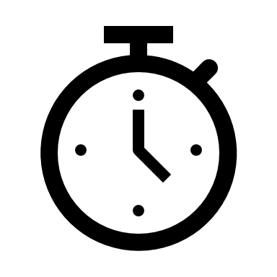 | SCHEDULE  12:15 – 12:40 Discussion #1  12:40 – 12:45 Transition  12:45 – 1:10 Discussion #2  1:00 – 1:15 Transition  1:15 – 1:30 Discoveries; Areas to Learn More About
HANDOUTS
http://fpg.unc.edu/presentations/how-get-your-work-out-there

