Inclusion, Diversity, and Equity: Building Explicit and Intentional Emphasis into

Early Childhood Preservice Teaching and Professional Development

Camille Catlett  FPG Child Development Institute  camille.catlett@unc.edu | Cathy Collie-Robinson  Durham Technical Community College  collierobinsonc@durhamtech.edu | Marye Vance  Durham Technical Community College  vancem@durhamtech.edu

- Why do we need to be more explicit?

Simon Sinek TED Talk https://youtu.be/IPYeCltXpxw?t=9

National Shifts

Transforming the Workforce for Children Birth Through Age 8: A Unifying Foundation
The Institute of Medicine’s seminal report supports building a workforce unified by the science of child development and early learning and the shared knowledge and competencies needed to provide consistent, high-quality support for the development and early learning of children from birth through age 8.
Source: http://www.nationalacademies.org/hmd/Reports/2015/Birth-To-Eight.aspx

Power to the Profession
Power to the Profession is a national collaboration to define the early childhood profession by establishing a unifying framework for career pathways, knowledge, and competencies, qualifications, standards, and compensation. Sources: https://www.naeyc.org/our-work/initiatives/profession
https://www.naeyc.org/our-work/initiatives/profession/decision-cycles/power-profession-decision-cycles-3456

Draft Professional Standards and Competencies for Early Childhood Educators
This draft document, which addresses priorities raised by Transforming the Workforce and Power to the Profession, includes references for each standard, a glossary, and other resources. A second draft of the leveling of the standards and competencies to the ECE I, II and III levels recommended was provided in a recent update.
Sources: https://www.naeyc.org/resources/position-statements/draft-professional-standards-competencies

Other Whys: Community input, feedback from students, current events

Do Early Educators’ Implicit Biases Regarding Sex and Race Relate to Behavior Expectations and Recommendations of Preschool Expulsions and Suspensions https://medicine.yale.edu/childstudy/zigler/publications/Preschool%20Implicit%20Bias%20Policy%20Brief_final_9_26_276766_5379_v1.pdf

Real World Applications: SCRIPT-NC Retreat & Durham Tech Graduate of the Future¹

DT Graduate of the Future¹

EDU 280 Rubric Indicator Checklist¹

- What do we know about being explicit?

DEC-NAEYC Joint Position Statement on Early Childhood Inclusion¹
DEFINITION: Early childhood inclusion embodies the values, policies, and practices that support the right of every infant and young child and his or her family, regardless of ability, to participate in a broad range of activities and contexts as full members of families, communities, and society. The desired results of inclusive experiences for children with and without disabilities and their families include a sense of belonging and membership, positive social relationships and friendships, and development and learning to reach their full potential. The defining features of inclusion that can be used to identify high quality early childhood programs and services are access, participation, and supports. Source: http://npdci.fpg.unc.edu/resources/articles/Early_Childhood_Inclusion

Delivering on the Promise of Effective Early Childhood Education: Eliminating Exclusionary Discipline and Concentrating on Inclusion¹ https://www.nbcdi.org/sites/default/files/resource-files/Delivering%20on%20the%20Promise%20of%20Effective%20Early%20Childhood%20Education.pdf
Culturally Responsive Teaching¹
This document starts by defining culturally responsive teaching (CRT) and delineating the benefits to children and families that accrue from teachers who are prepared to implement CRT. Teacher competencies that promote CRT are spelled out and followed by an analysis of ways in which professional teaching standards are being used to build early childhood educators who are prepared to use culturally responsive teaching practices.

Source: https://d1y8sb8igg2f8e.cloudfront.net/documents/Culturally_Responsive_Teaching_2019-03-28_130012.pdf

NAEYC Position Statement: Advancing Equity in Early Childhood Education¹

DEFINITION: The state that would be achieved if individuals fared the same way in society regardless of race, gender, class, language, disability, or any other social or cultural characteristic. In practice, equity means all children and families receive necessary supports in a timely fashion so they can develop their full intellectual, social, and physical potential. Source: https://www.naeyc.org/resources/position-statements/equity

NAEYC Equity Landing Pad https://www.naeyc.org/resources/position-statements/equity

Equity Resources Handout¹

What Do We Mean by Professional Development in the Early Childhood Field?¹

DEFINITION: Professional development is facilitated teaching and learning experiences that are transactional and designed to support the acquisition of professional knowledge, skills, and dispositions as well as the application of this know-ledge in practice. The key components of professional development include: (a) the characteristics and contexts of the learners (i.e., the “who” of professional development, including the characteristics and contexts of the learners and the children and families they serve); (b) content (i.e., the “what” of professional development; what professionals should know and be able to do; generally defined by professional competencies, standards, and credentials); and (c) the organization and facilitation of learning experiences (i.e., the “how” of professional development; the approaches, models, or methods used).
Source: http://npdci.fpg.unc.edu/sites/npdci.fpg.unc.edu/files/resources/NPDCI_ProfessionalDevelopmentInEC_03-04-08_0.pdf

Catlett, C., Maude, S., & Skinner, M. (2016, October). The blueprint process for enhancing early childhood preservice programs and courses. Unpublished manuscript.¹

Real World Applications: Examples from Two Durham Technical Community College Courses

- EDU 284 Syllabus Rubric Indicator Checklist – pre/post¹

- EDU 284 pre/post course calendar

- Equity and Inclusion Reflection Tool¹

- EDU 280 Rubric Indicator Checklist¹

- How can we be explicit in preservice and ongoing PD work?

Content to Promote Inclusion, Diversity, and Equity

Content Area | Source for Free, Annotated, Evidence-Based Resources (evidence, print, audiovisual, online)  https://fpg.unc.edu/presentations/toolkit
Engaging Diverse Families | Family Engagement Resources
Children with Disabilities, Inclusion | Resources to Support Inclusive Practices
Culture-Diversity- Equity | Culture-Diversity-Equity Resources
Supporting Children who are Dual Language Learners and their Families | Resources for Supporting Children who are Dual Language Learners and their Families
Supporting Children who have Experienced Trauma or Adversity | Resources for Building Resilience
Talking with Adults and Young Children About Race and Racism | Race-Racism Resources

Tools that Promote Inclusion, Diversity, and Equity
- Rubric for assessing a course syllabus¹
- Assignment Alignment tool + specific emphasis¹
- PD Content Alignment tool¹

Practices that Promote Inclusion, Diversity, and Equity
- Personas – infant/toddler, preschool, early elementary¹
  - Joseph persona¹
  - Storytelling Skills Support Early Literacy for African American Children http://fpg.unc.edu/node/7889

- Creating personas – the work of Florianna Thompson¹

Frameworks that Promote Inclusion, Diversity, and Equity
- Pyramid Model Equity Coaching Guide¹

- BUILD Equity Action Framework¹ https://www.buildinitiative.org/Portals/0/Uploads/Documents/2019%20NCIT%20Planning%20Grantees/EquityActionFramework.pdf?ver=2019-09-21-233721-673

Resources that Promote Inclusion, Diversity, and Equity
SCRIPT-NC Website https://scriptnc.fpg.unc.edu/
- Course-specific resources
- Tools for Enhancing Program Quality
- Free Webinars ¹
  - Shifting Blackboards handout¹
    - Content – modules and multimedia
    - Reframing assignments from seated to virtual
    - Video sources
    - Online tools and techniques

ADL Connect 3 – weekly listserv offers free examples of resources and activities to address bias, gender diversity, religious diversity, equity, and other issues with adults and children. To view a sample of the quality of the resources they are sharing, take a look at the lesson plan on Everyday Bias (https://www.adl.org/media/11324/download). Don’t miss the 3-minute Peanut Butter, Jelly, and Racism video at that site. To sign up for Connect3, go to https://www.adl.org/sign-up-to-receive-adl-email-newsletters?_ga=2.160472570.651945255.1592167304-750485239.1589293380 and check the box for Education Updates.

Equity and Inclusion Reflection Tool

Self-Audit | Agree/  Disagree | if agree, what is an example of how you do that? | If disagree, what might you try to MOVE toward agreement?
- I uphold the unique value and dignity of each and every child and family.
- I recognize each and every child’s unique strengths and support the inclusion of all children – given differences in culture, family structure, language, racial identity, gender, abilities, and economic class.
- I develop trusting relationships with each and every child that build on their knowledge and skills.
- I consider the developmental, cultural, linguistic, and individual appropriateness of the learning environment and my teaching practices for each and every child.
- I involve children, families, and the community in the design and implementation of learning activities.
- I actively promote children’s agency (e.g., provide opportunities for rich, engaging play; support learning across all areas of development and curriculum).
- I scaffold children’s learning to achieve meaningful goals.
- I design and implement learning activities using language(s) that the children understand.
- I recognize and am prepared to provide different levels of support to different children depending on what they need.
- I consider how my own biases (implicit and explicit) may be contributing to my interactions and relationships with particular children and families.
- I use multi-tiered systems of support.

Adapted from the NAEYC position statement Advancing Equity in Early Childhood Education (p. 4-6) https://www.naeyc.org/resources/topics/equity

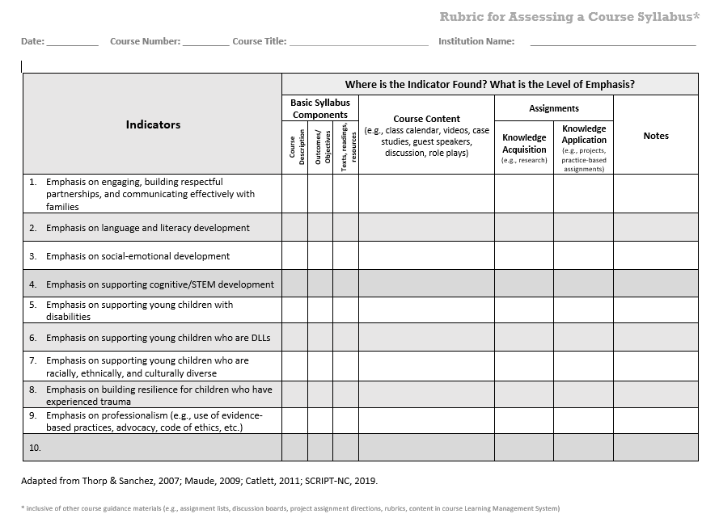
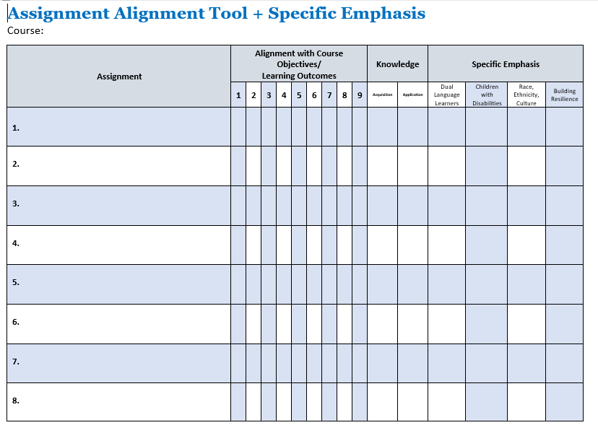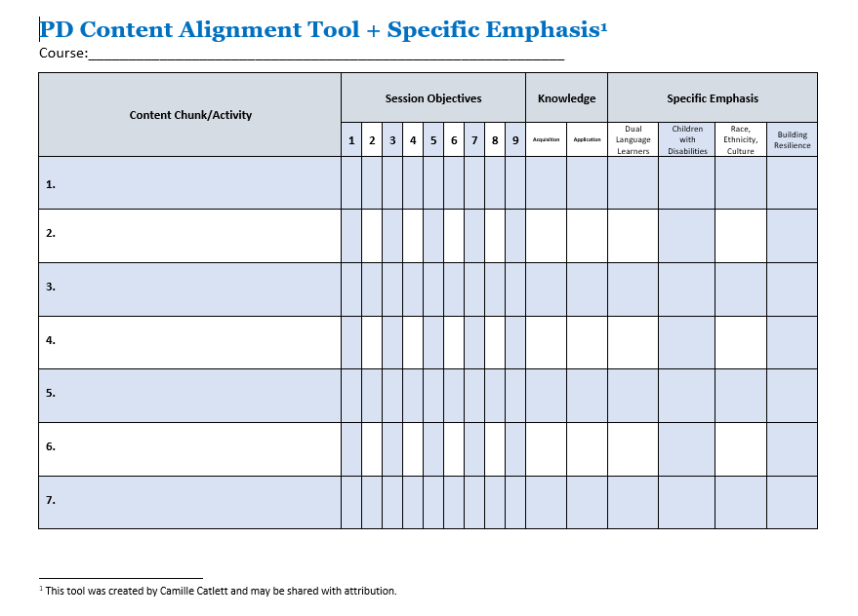

Handouts and PowerPoints for this session are at https://fpg.unc.edu/presentations/inclusion-diversity-and-equity

