Listening to Family Stories: Conversations for Engaging Each and Every Family

To learn more about ways in which to support each and every family, it’s important to participate in thoughtful conversations that explore the components of engagement. Consider asking families the following questions and using their responses to build the capacity of your classroom, program, or school to fully reflect the Vermont Guiding Principles.

CLEAR COMMUNICATION

How can we maintain clear, open, and consistent communication?

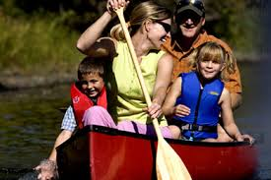
What is it important for us to know about your interests, concerns, and priorities so we are well-prepared to support your child?

What would be the most helpful way for us to keep in touch on an ongoing basis?

What can we do to be open, genuine, reflective and respectful listeners and communication partners?

What would be helpful ways for us to collaborate so we’re working together to support your child’s learning and development?

SAFETY

What is your greatest worry for your children when they are in the care of someone else?

What questions or concerns do you have about how we build safe, accepting environments for each child?

What questions or concerns do you have about how we make certain each child has access to each environment and activity?

CREATING COMMUNITY
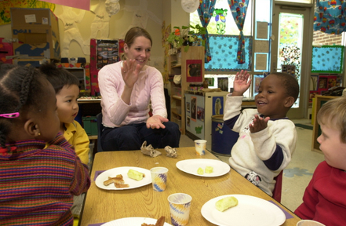
What can we do to help you feel respected?

What questions or concerns do you have about our efforts to make this program/school one that is accepting of individual differences?

What would it be helpful for us to know so we make sure your child is valued for who they are?

What may we share about our ongoing efforts to facilitate each child’s social relationships, membership, and sense of belonging?

RESPECTING DIVERSITY

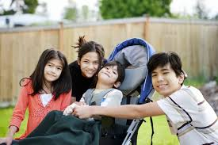
What does our program/school need to do to support your family’s priorities, values, & culture?

How can we learn more about your family story, including customs, values, and priorities, so we build connections and cohesion between your home and our program/school?

What questions or concerns do you have about the way in which our program supports children and families with differences in race, class, gender, family structure, ability, life circumstances, and needs?

How can our program/school do a better job of building equitable access to opportunities, supports, and services for each child and family?
As a program/school, we prioritize policies, procedures, programs, and practices that honor and are supportive of each family’s culture, strengths, structure, expertise, and preferences. Do you have any suggestions for how we could do that more effectively?

CREATING A RESPONSIVE & CARING CULTURE

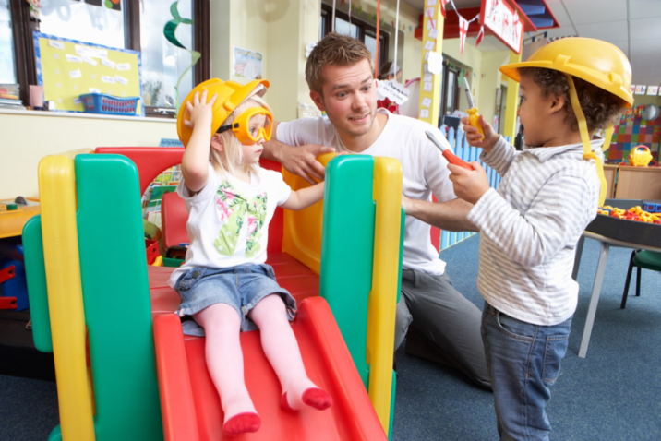
What is your greatest hope for your children when they are in the care of someone else?

Imagine the best program/school that supports your children and includes your family. What does it look like?

Our staff members work to create a positive environment, nurture each child, encourage children to grow at their own pace, scaffold learning experiences, and promote exploration and creativity. What can you know about your child as a learner that can help us to do that successfully?

WHAT OTHER QUESTIONS DO YOU HAVE?

¹Some of these questions were developed by Dr. Lori Erbrederis Meyer and colleagues at the University of Vermont including Beth Peloquin and students in ECSP 210/310. Others evolved from conversations with families in 2016.
Supporting Each and Every Young Child and Family’s Full and Equitable Participation: The Vermont Guiding Principles https://fpg.unc.edu/presentations/full-and-equitable-participation-principles

