Playful Learning:
Evidence and Resources for Supporting Social and Emotional Development

Camille Catlett  FPG Child Development Institute  camille.catlett@unc.edu | Robin Ploof  Champlain College  rploof@champlain.edu

- The Evolving National Context

Draft Professional Standards and Competencies for Early Childhood Educators
The second Public Draft of this document includes references for each standard, a glossary, and, most importantly, a first draft of the leveling of the standards and competencies to the ECE I, II and III levels recommended in Power to the Profession. Please review and provide input on this draft before June 14 at https://www.naeyc.org/resources/position-statements/draft-professional-standards-competencies

NAEYC Position Statement: Advancing Equity in Early Childhood Education
Although equity and diversity are referenced in our NAEYC’S core values and beliefs, they have never had a separate position statement focused solely on these issues. Based on multiple drafts and significant feedback, this final draft is currently circulating for input to guide NAEYC’s work to ensure high-quality early learning for all young children.
Source: https://www.naeyc.org/resources/position-statements/equity-draft

- Check Your Play IQ (see page 4)
Play Facts – Answers to True/False Quiz¹

- Being Mindful About Play

To Chew or Not to Chew¹

Erwin, E. J., Robinson, K. A., McGrath, G. S., & Harney, C. J. (2015, July). “It’s like breathing in blue skies and breathing out storm clouds”: Mindfulness practices in early childhood. Young Exceptional Children, 20(2), 69-85. https://doi.org/10.1177/1096250615593326¹

What about the Grown Ups?
Flourishing (PERMA)

Managing Stress (Positive Emotions)
- Take your full lunch break. Leave work at work as much as possible. Take mental health days. Say NO. Set boundaries. Use your vacation time. Cry. Laugh
- Maintain social connections (Engagement and Relationships)
- Make time for friends and family. Enjoy physical intimacy like hugs and holding hands. Cuddle with your pet. Join or start a support group. Engage with your community. Volunteer for a cause. Social media?
- Stay Active:
- Get regular medical care. Exercise. Sing. Dance. Yoga. Get a massage.

Meaning and Purpose
- Keep a Journal. Practice mindfulness. Take time for self-reflection. Practice self-love. Practice forgiveness. Reflect on who you are and what makes you special.
- Brain Healthy Diet (Accomplishment)
- Make and eat yummy nutritious food. Plan and set goals. Learn a new skill. Read a book. Do something creative. Explore a hobby.
- Quality Sleep
- Get enough sleep. Splurge on good bed linens and sleepwear. De-clutter your bedroom. Get room darken-ing shades. Eliminate ambient light sources. Eliminate electronics with blue light for an hour before bed.

Resources for Flourishing
- Yoga for Beginners https://www.youtube.com/watch?v=v7AYKMP6rOE or https://www.youtube.com/watch?v=jsLAc-2y0bE

- Journal and self- reflection prompts
What went well – come up with three things. Next to each event ask the question - why did this happen?
What am I grateful for? Write down one gratitude each day.
Who is someone who shaped my life before the age of 13? What was it about them that inspired you?
Who is someone who shaped my life after the age of 13? What was it about them that inspired you?
What is your purpose, your mission, your song?

- Mindfulness Exercises
Mindful Breathing:
Since our minds tend to wander, it can help to follow a guided audio track as you get familiar with the technique. Try this short five-minute breathing track by Stop, Breathe, Think https://www.youtube.com/watch?v=vVaMLYAiR8o
Body Scan
During the body scan exercise, you will pay close attention to physical sensations throughout your body. The goal isn’t to change or relax your body, but instead to notice and become more aware of it. Don’t worry too much about how long you practice but do move slowly. Begin by paying attention to the sensations in your feet. Notice any sensations such as warmth, coolness, pressure, pain, or a breeze moving over your skin. Slowly move up your body--to your calves, thighs, pelvis, stomach, chest, back, shoulders, arms, hands, fingers, neck, and finally your head. Spend some time on each of these body parts, just noticing the sensations. After you travel up your body, begin to move back down, through each body part, until you reach your feet again. Remember: move slowly, and just pay attention.

- Authentic Happiness – Marty Seligman https://www.authentichappiness.sas.upenn.edu/ (tons of resources)

- The Science of Well-Being – Laurie Santos’ free 6-week course https://www.coursera.org/learn/the-science-of-well-being

- Happy Acts by Live Happy https://www.happyacts.org/#celebrate

- Sir Anthony Seldon: "Beyond Happiness" https://www.youtube.com/watch?v=yYVvUnnwW9k

- Why are we still talking about play?
Yogman, M., Garner, A., Hutchinson, J., Hirsh-Pasek, K., Golinkoff, R. M., & Committee on Psychosocial Aspects of Child and Family Health. (2018). The power of play: A pediatric role in enhancing development in young children. Pediatrics, 142(3), e20182058. https://pediatrics.aappublications.org/content/142/3/e20182058.full¹

- Supporting Social and Emotional Development through Play
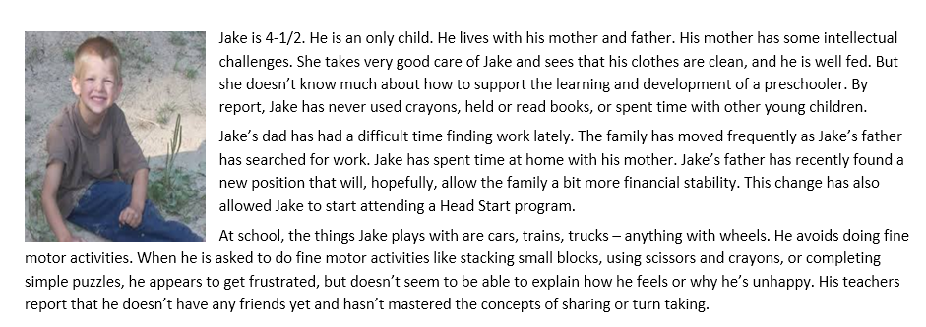
More personas¹

- These are a Few of our Favorite Things

Robin’s favorites
The Center of Early Childhood Education at Eastern Connecticut University (website)
http://www.easternct.edu/cece/

Nurturing Preschool Children's Emotional Health Through Active Play https://www.youtube.com/watch?v=CKUfraBmjy8

Encyclopedia on Early Childhood Development http://www.child-encyclopedia.com/
Playing with Others is Important
http://www.child-encyclopedia.com/peer-relations/introduction/playing-others-important

The Australian Parenting Website https://raisingchildren.net.au/
A website with amazing parenting resources supported by the Australian Government.
Talking and Play: Toddlers
https://raisingchildren.net.au/toddlers/connecting-communicating/communicating/talking-play-toddlers

The Power of Play https://www.childrensmuseums.org/images/MCMResearchSummary.pdf
Comprehensive research summary on play and learning from the Minnesota Children’s Museum with a really nice section on the social and emotional benefits of play.
White, R. E. (2012). The power of play: A research summary on play and learning. Rochester: Minnesota Children's Museum.

Camille’s favorites

A Special Place for Play in Special Education (online article) http://www.communityplaythings.com/resources/articles/2014/a-special-place-for-play-in-special-education

Culturally Responsive Teaching¹
https://d1y8sb8igg2f8e.cloudfront.net/documents/Culturally_Responsive_Teaching_2019-03-28_130012.pdf

Play Resources (10-page annotated collection of free evidence, print, audiovisual, and online resources) ¹

Social and Emotional Resources (11-page annotated collection of free evidence, print, audiovisual, and online resources) ¹

- Closing Remarks
Opal School Children on Play and Learning https://www.youtube.com/watch?v=V0mCy9asVk0&list=PLJdq3OzEoR1gL79_6UoiMrleB1_jwzQaw&index=1

2019 True-False Quiz
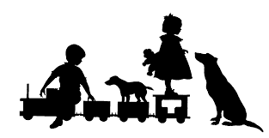 | Imaginary pretend play has little connection to social emotional development.
 | Children who grow up with greener surroundings have better mental health.
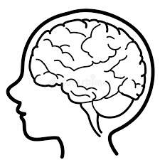 | Healthy social emotional development helps children develop the ability to learn and concentrate.
 | Classroom schedules and routines do not contribute very much to children’s wellbeing.
 | Support from teachers can make a great difference in whether children with disabilities get to play with peers.
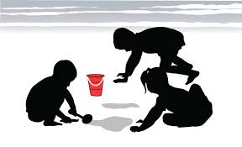 | Social skills can be taught through play.
 | Physical development and social emotional development are not closely connected.
OMMM | Mindfulness refers to repetitive, prescriptive breathing and movements.

This handout and other resources in it may be downloaded at https://fpg.unc.edu/presentations/playful-learning

