From Possible to Powerful: Selecting, Using, and Evaluating Evidence-Based Practices

Camille Catlett  camille.catlett@unc.edu | Beth Peloquin  bethcpeloquin@gmail.com | Andrea Racek  aracek@maplerun.org

- Evolving national context

Transforming the Workforce for Children Birth Through Age 8: A Unifying Foundation
http://www.nationalacademies.org/hmd/Reports/2015/Birth-To-Eight.aspx

Power to the Profession https://www.naeyc.org/our-work/initiatives/profession
https://www.naeyc.org/our-work/initiatives/profession/decision-cycles/power-profession-decision-cycles-3456

Draft Professional Standards and Competencies for Early Childhood Educators
https://www.naeyc.org/resources/position-statements/draft-professional-standards-competencies

NAEYC Position Statement on Developmentally Appropriate Practice: 2019
A draft of this revised position statement is currently circulating. Comments are requested by July 15 at
https://www.surveymonkey.com/r/DAP-4
- What’s new in DAP handout

- The new intentional teacher
- Epstein, A.S. (2007). The intentional teacher: Choosing the best strategies for young children’s learning. Washington: NAEYC.
- Epstein, A.S. (2014). The intentional teacher: Choosing the best strategies for young children’s learning. Washington: NAEYC.

Teach with intention activity¹

- Evidence-based practices

Defining evidence-based practices
- Evidence-Based Practice Empowers Early Childhood Professionals and Families¹

Putting Practices into Practice

Lesson Plan for Clean Up Time: What Does It Look Like When a Teacher Practices the Practices?¹

Count the Decisions | Notice the 5 Categories of Developmentally Practice | Track the Components of Practicing the Practices
 | - creating a caring, equitable community of learners  - establishing respectful, reciprocal partnerships with families and communities  - observing, documenting and assessing children’s development and learning;  - teaching to enhance each child’s development and learning;  - planning and implementing an engaging curriculum to meet meaningful goals | UNDERSTANDING AND SELECTING THE PRACTICE  THINKING THROUGH THE PRACTICE  IMPLEMENTING THE PRACTICE  FOLLOWING THROUGH

- Skills and frameworks for intentional faculty and professional development providers
- Knowledge acquisition AND knowledge application

Professional Development
http://npdci.fpg.unc.edu/sites/npdci.fpg.unc.edu/files/resources/NPDCI_ProfessionalDevelopmentInEC_03-04-08_0.pdf

- Multiple lenses

A Creative Adventure
https://eclkc.ohs.acf.hhs.gov/video/creative-adventure
https://eclkc.ohs.acf.hhs.gov/es/video/una-aventura-creativa

VELS Domains | Categories of DAP | Cultural/Linguistic Diversity | Individualizing
Approaches to Learning  Social-Emotional  Growing, Moving, Being Healthy  Language  Literacy  Creative Arts  Math  Science  Social Studies | See above

- Photos
- Extensions
- Personas
- Integrate practices in coaching, mentoring, and supervision
  - Pyramid Model Equity Coaching Guide¹
- New resources that incorporate EBPs - Catlett-Soukakou article
  - Web-based overview of Inclusive Classroom Profile

https://npdci.fpg.unc.edu/web-based-icp-overview-training

- Universal Design for Learning resource: CARA’s Kit
  - CARA’s Kit: Creating Adaptations for Routines and Activities $25 purchase from NAEYC
    - PowerPoints and Adaptation Notes¹
  - Dinnebeil, L., Boat, M., & Bae, Y. (2013). Integrating principles of universal design into the early childhood curriculum. Dimensions of Early Childhood, 41(1), 3-24. http://www.southernearlychildhood.org/upload/pdf/Dimensions_Vol41_1_Dinnebeil.pdf
  - Visual Supports (May 2019 issue of The Right Stuff)¹

  - Example: Morning Greeting Routine https://www.youtube.com/watch?v=fZZ8zpQPPnY
  - Morning Circle at Preschool https://www.youtube.com/watch?v=PZY-hB2C_Iw&t=178s + Adaptation Notes

- Embedded Learning/Teaching/Intervention
  - Embedded Instruction Practices https://ectacenter.org/~pdfs/decrp/PG_Ins_EmbeddedInstr_prac_print_2017.pdf
  - CONNECT Module 1: Embedded Interventions http://www.connectmodules.dec-sped.org/connect-modules/learners/module-1/
  - Embedded learning opportunities http://headstartinclusion.org/elo
  - Embedded learning opportunities website http://olms.cte.jhu.edu/olms2/10634
  - Embedded learning opportunity video example https://www.youtube.com/watch?v=1zHY44H4RDA
  - EarlyEdU Alliance Media Library – Individualizing Instruction videos https://www.earlyedualliance.org/

Directions: Join the EarlyEdU Alliance (requires email address & password). As a member, select “Media Library” and create an account. Log in with your account to search for videos by “embed.”

  - Example: Video 1.16: Routine in a program – reading at circle time https://www.connectmodules.dec-sped.org/connect-modules/resources/videos/video-1-16/

- New sets of practices to integrate

Focus of Practices | Resources
Culturally responsive teaching | - Culturally Responsive Teaching (includes 8 components of culturally responsive teaching) https://d1y8sb8igg2f8e.cloudfront.net/  documents/Culturally_Responsive_Teaching_2019-03-28_130012.pdf  - Culture, Diversity, and Equity Resources¹  - Pyramid Model Equity Coaching Guide¹ https://fpg.unc.edu/sites/fpg.unc.edu/files/resources/presentations-and-webinars/Pyramid%20Model%20Equity%20Coaching%20Guide.pdf  - Resources for coaching on culturally responsive practices https://challengingbehavior.cbcs.usf.edu/Implementation/Equity/Guide/3.html  - Starting Small (video/DVD of six culturally responsive early childhood classrooms) – order from https://www.tolerance.org/classroom-resources/film-kits/starting-small  - Vermont Master Class with Rosemarie Allen https://fpg.unc.edu/presentations/vt-guiding-principles  Example: Diversity: Contrasting Perspectives (https://vimeo.com/127276780) + 8 components of culturally responsive teaching

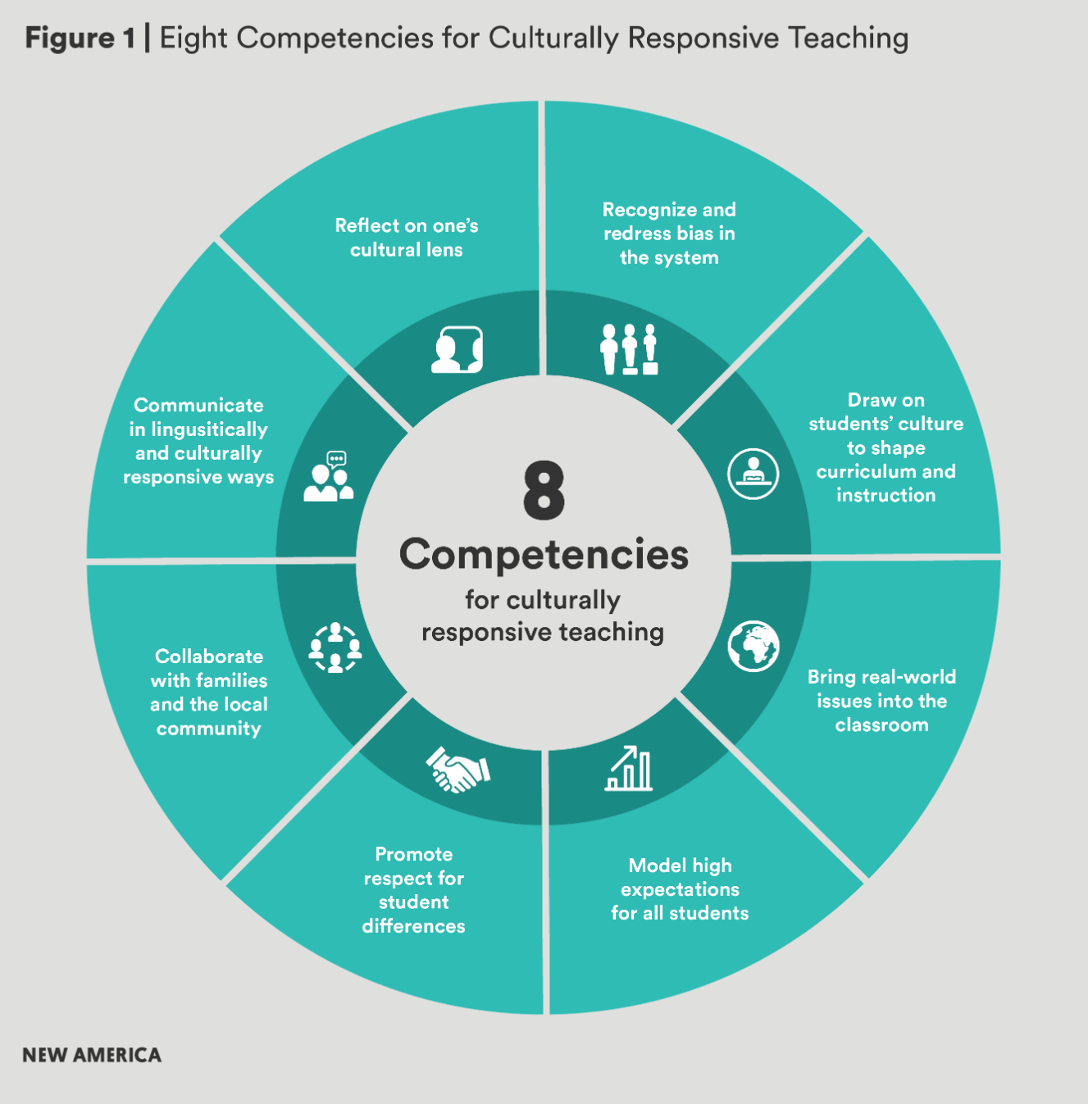

Focus of Practices | Resources
Children with or risk for disabilities and their families | - DEC Recommended Practices https://www.dec-sped.org/dec-recommended-practices  - Embedded examples https://divisionearlychildhood.egnyte.com/dl/NRAghl7roM/  - DEC Recommended Practices: Practice Improvement Tools http://ectacenter.org/decrp/  - Early Childhood Recommended Practice modules https://rpm.fpg.unc.edu/  - Instructor Area https://rpm.fpg.unc.edu/groups/instructor-area  - Search videos https://rpm.fpg.unc.edu/resource-search-facets  - CONNECT modules https://www.connectmodules.dec-sped.org/  - CONNECT module resource library https://www.connectmodules.dec-sped.org/connect-modules/resources/  - Video 1.12 Routine in a Classroom - Rolling with Friends (CONNECT Module 1) https://www.connectmodules.dec-sped.org/connect-modules/resources/videos/video-1-12/  - Head Start ECLKC Children with Disabilities  https://eclkc.ohs.acf.hhs.gov/children-disabilities  Example: Song of Our Children + Child-Child Interaction Checklist https://ectacenter.org/~pdfs/decrp/INT-4_Child-Child_Interaction_2018.pdf

Excerpt from Child-Child Interaction Checklist
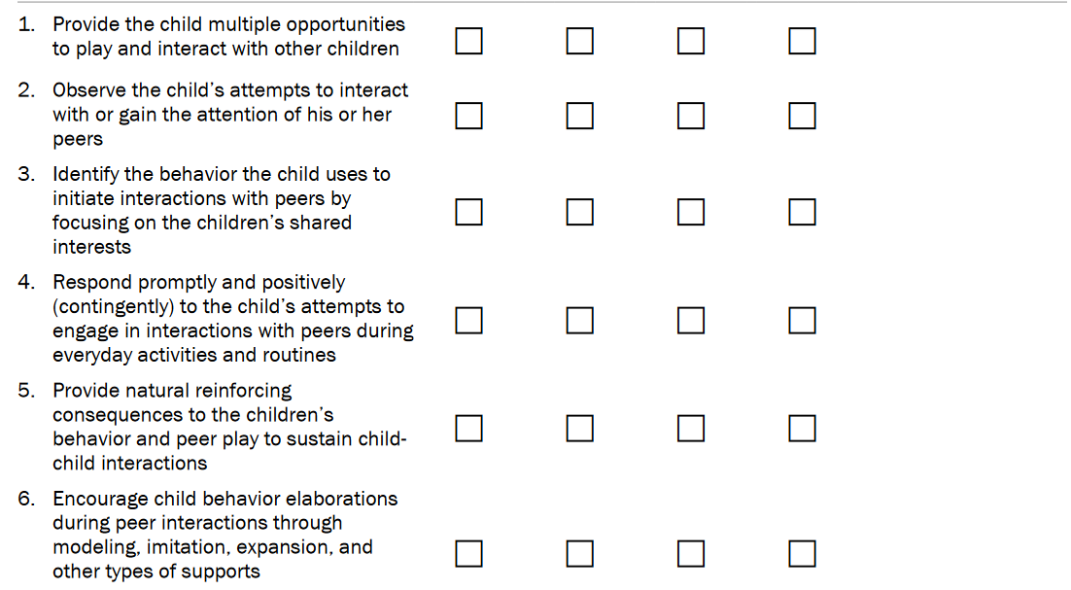
Focus of Practices | Resources
Inclusion | - DEC-NAEYC Joint Position Statement on Inclusion https://npdci.fpg.unc.edu/resources/articles/Early_Childhood_Inclusion (landing pad)  - Research Synthesis Points on Quality Inclusive Practices¹ https://npdci.fpg.unc.edu/sites/npdci.fpg.unc.edu/files/resources/NPDCI-ResearchSynthesisPointsInclusivePractices-2011_0.pdf  - Inclusive Classroom Profile  - Web-based overview of Inclusive Classroom Profile  https://npdci.fpg.unc.edu/web-based-icp-overview-training  - Head Start Center for Inclusion http://headstartinclusion.org/  - Embedded Learning Opportunities videos http://headstartinclusion.org/elo#elo  - Individualizing Videos http://headstartinclusion.org/individualizing/videos  - Inclusive Practices Resources¹  - Vermont Master Class on Inclusion resources https://fpg.unc.edu/presentations/master-class-inclusion-0  Example: Rolling with Friends from CONNECT module 1 + Joint Position Statement defining features (access/participation/[systemic] supports)
Children who are dual language learners | - Dual Language Learner Teacher Competencies http://publications.unidosus.org/bitstream/handle/123456789/1127/DLLTCRPTallLOW-RES.pdf?sequence=1&isAllowed=y  - Policy Statement on Supporting the Development of Children who are Dual Language Learners in Early Childhood Programs https://www.acf.hhs.gov/sites/default/files/ecd/dll_policy_statement_final.pdf  - Resources for Supporting Children who are Dual Language Learners¹  - The Young Dual Language Learner: 20 Short Videos https://www.youtube.com/channel/  UCKQ5FgGVIFpdt36_sv9FL-Q/featured?utm_content=&utm_medium=email&utm_name=&utm_source=govdelivery&utm_term  - Vermont Master Class on Children who are Dual Language Learners resources https://fpg.unc.edu/presentations/master-class-2  Example: What Did You Say? (https://www.youtube.com/watch?v=MWMgyiEFDCA) + backwards brainstorming
Equity | - NAEYC Position Statement: Advancing Equity in Early Childhood Education  https://www.naeyc.org/resources/position-statements/equity-draft  - The Right Stuff https://fpg.unc.edu/presentations/right-stuff  - Similarities and Differences (February)  - Gender (March)  - Children’s Books (April)  - Equity and Inclusion (June)  - Culture, Diversity, and Equity Resources¹  - Equity Resources Handout¹  - What Stories Do My Classroom and Its Materials Tell? Preparing Early Childhood Teachers in Equitable and Inclusive Teaching¹  Example: Self-reflection with Equity and Inclusion Reflection Tool
Cross-cutting | Vermont Guiding Principles  https://fpg.unc.edu/sites/fpg.unc.edu/files/resources/presentations-and-webinars/Vermont%20Guiding%20Principles%20AOE-BBF-HMGV_0.pdf  Example: Jenny Stearns observation activity

Equity and Inclusion Reflection Tool

Self-Audit | Agree/  Disagree | if agree, what is an example of how you do that? | If disagree, what might you try to MOVE toward agreement?
- I uphold the unique value and dignity of each and every child and family.
- I recognize each and every child’s unique strengths and support the inclusion of all children – given differences in culture, family structure, language, racial identity, gender, abilities, and economic class.
- I develop trusting relationships with each and every child that build on their knowledge and skills.
- I consider the developmental, cultural, linguistic, and individual appropriateness of the learning environment and my teaching practices for each and every child.
- I involve children, families, and the community in the design and implementation of learning activities.
- I actively promote children’s agency (e.g., provide opportunities for rich, engaging play; support learning across all areas of development and curriculum).
- I scaffold children’s learning to achieve meaningful goals.
- I design and implement learning activities using language(s) that the children understand.
- I recognize and am prepared to provide different levels of support to different children depending on what they need.
- I consider how my own biases (implicit and explicit) may be contributing to my interactions and relationships with particular children and families.
- I use multi-tiered systems of support.

Adapted from the NAEYC position statement Advancing Equity in Early Childhood Education (p. 4-6) https://www.naeyc.org/resources/position-statements/equity-draft

SOCIAL AND EMOTIONAL DEVELOPMENT
Practices | - Center on the Social and Emotional Foundations for Early Learning http://csefel.vanderbilt.edu/resources/training_modules.html  - National Center on Pyramid Model Interventions (NCPMI)  - Pyramid Model Overview https://challengingbehavior.cbcs.usf.edu/Pyramid/overview/index.html  - Resource Library https://challengingbehavior.cbcs.usf.edu/resources/index.html  - Evidence-based Practice Checklists for Preschool  - https://challengingbehavior.cbcs.usf.edu/docs/Implementation_practice_environment.pdf  - https://challengingbehavior.cbcs.usf.edu/docs/Implementation_practice_relationship.pdf  - https://challengingbehavior.cbcs.usf.edu/docs/Implementation_practice_social.pdf  - https://challengingbehavior.cbcs.usf.edu/docs/Implementation_practice_interventions.pdf  - Infant-Toddler Practice Implementation Checklist (sample)¹
Videos | EarlyEdU Alliance Media Library – Supporting Social and Emotional Development/Positive Behavior Supports videos https://www.earlyedualliance.org/  Directions: Join the EarlyEdU Alliance (requires email address & password). As a member, select “Media Library” and create an account. Log in with your account to search for videos by teaching practice.  NCPMI Resource Library https://challengingbehavior.cbcs.usf.edu/resources/index.html
Personas | Dusty, Qasim, Everly, Taylor, Anthony, Jake, Marcus, Simon, Montgomery
Additional Resources | - Devereaux Center for Resilient Children https://centerforresilientchildren.org/infants/assessments-resources/devereux-early-childhood-assessment-deca-infant-and-toddler-program/  - Dual Language Learners with Challenging Behaviors https://eclkc.ohs.acf.hhs.gov/culture-language/article/dual-language-learners-challenging-behaviors  - Social and Emotional Development Resources  https://eclkc.ohs.acf.hhs.gov/school-readiness/effective-practice-guides/social-emotional-development  - Social-Emotional Development Resources¹
Example | Parachute video https://youtu.be/vZaNcfoCei8 + Pyramid model practices + Adaptation Notes

SCIENCE, TECHNOLOGY, ENGINEERING AND MATH (STEM)
Practices | Math and Science in Preschool: Policies and Practice  http://nieer.org/wp-content/uploads/2016/08/MathSciencePolicyBrief0309.pdf  Next Generation Science Standards https://www.nextgenscience.org/
Videos | EarlyEdU Alliance Media Library https://www.earlyedualliance.org/  Directions: Join the EarlyEdU Alliance (requires email address & password). As a member, select “Media Library” and create an account. Log in with your account and select any of the “Teaching Practices.” Then enter a key word (e.g., math or science) in the search box.  Erikson Institute Early Math Collaborative https://earlymath.erikson.edu/  Directions: Click on “Filter Idea Library.” Select “Topic” and “Age” and then click “video” under “Content formats”  Learning Trajectories for Math https://www.learningtrajectories.org/  Directions: Go to https://www.learningtrajectories.org/and create an account. You will need your email address and a password. Create a class and add one student. This will give you access to the Learning Trajectories tab.
Personas | Qasim, Marisol, Montgomery
Additional Resources | Brain Building in Progress: Resources for Early Learning http://resourcesforearlylearning.org/  Erikson Institute Early Math Collaborative https://earlymath.erikson.edu/  Let’s Talk, Read and Sing about STEM! Tips for Teachers & Providers https://www2.ed.gov/about/inits/ed/earlylearning/talk-read-sing/stem-toolkit-infant-toddler-teachers.pdf  https://www2.ed.gov/about/inits/ed/earlylearning/talk-read-sing/stem-toolkit-preschool-teachers.pdf  Math Resources¹ Science Resources¹  Preschool and Kindergarten Strategies for the Young Scientist¹  STEMIE: Innovation for Inclusion in Early Education https://stemie.fpg.unc.edu/
Example | Want Scientifically Literate Children? https://www.youtube.com/watch?v=AIEJjpVlZu0

ENVIRONMENT
Practices | - DEC Recommended Environmental Practices with Examples (p. 14-15) https://divisionearlychildhood.egnyte.com/dl/NRAghl7roM/  - Using Environmental Strategies to Promote Positive Social Interactions http://csefel.vanderbilt.edu/briefs/wwb6.pdf
Print | - Interculturalism: Addressing Diversity in Early Childhood https://www.southernearlychildhood.org/upload/pdf/  Interculturalism___Addressing_Diversity_in_Early_Childhood___Leslie_Ponciano_and_Ani_Shabazian.pdf
Videos | - EarlyEdU Alliance Media Library https://www.earlyedualliance.org/  Directions: Join the EarlyEdU Alliance (requires email address & password). As a member, select “Media Library” and create an account. Log in with your account and select any of the “Teaching Practices.” Then enter the word “environment” in the search box.  - Recommended Practices Resource Library https://rpm.fpg.unc.edu/resource-search-facets  Directions: Go to URL above. In the “Keyword Search” box type “environment” then filter by resource typ  (e.g., video).
Personas | All
Additional Resources | - Checklists, Practice Guides, & Practice Guides for Environment  http://ectacenter.org/decrp/topic-environment.asp  - Children with Disabilities: Environment  https://eclkc.ohs.acf.hhs.gov/children-disabilities/article/environment  - Recommended Practice Module on Environment  https://rpm.fpg.unc.edu/module-1-environment  - Specific Strategies to Support Dual Language Learners When Adults Do Not Speak Their Languages https://eclkc.ohs.acf.hhs.gov/culture-language/article/specific-strategies-support-dual-language-learners-dlls-when-adults-do-not  - What Stories Do My Classroom and Its Materials Tell? Preparing Early Childhood Teachers in Equitable and Inclusive Teaching¹

INTERACTION
Practices | DEC Recommended Interaction Practices with Examples (p. 27-28) https://divisionearlychildhood.egnyte.com/dl/NRAghl7roM/
Videos | - EarlyEdU Alliance Media Library https://www.earlyedualliance.org/  Directions: Join the EarlyEdU Alliance (requires email address & password). As a member, select “Media Library” and create an account. Log in with your account and select any of the “Teaching Practices.” Then enter the word “interaction” in the search box.  - Recommended Practices Resource Library https://rpm.fpg.unc.edu/resource-search-facets  Directions: Go to URL above. In the “Keyword Search” box type “interaction” then filter by resource type (e.g., video).
Personas | All
Additional Resources | - Checklists, Practice Guides, & Practice Guides for Interaction  http://ectacenter.org/decrp/topic-interaction.asp  - Culturally Appropriate Positive Guidance with Young Children https://www.naeyc.org/resources/pubs/yc/mar2017/culturally-appropriate-positive-guidance  - Engaging Interactions and Environments https://eclkc.ohs.acf.hhs.gov/teaching-practices/article/engaging-interactions-environments  - Recommended Practice Module on Interaction https://rpm.fpg.unc.edu/module-1-interaction  - Supporting Interactions for Children with Disabilities https://eclkc.ohs.acf.hhs.gov/video/supporting-interactions-children-disabilities-or-suspected-delays  - Using Classroom Activities and Routines as Opportunities to Support Interaction http://csefel.vanderbilt.edu/kits/wwbtk5.pdf

LANGUAGE DEVELOPMENT (INCLUDING CHILDREN WHO ARE DLLs)
Practices | Effective Practice Guides  https://eclkc.ohs.acf.hhs.gov/school-readiness/effective-practice-guides/language-literacy
Print | - Many Languages, One Classroom: Supporting Children in Superdiverse Settings https://www.naeyc.org/resources/pubs/tyc/dec2018/supporting-children-superdiverse-settings  - Supporting Language: Culturally-Rich Dramatic Play https://www.naeyc.org/resources/pubs/tyc/  dec2017/supporting-language-culturally-rich-dramatic-play
Videos | EarlyEdU Alliance Media Library - Language Modeling and Conversation videos https://www.earlyedualliance.org/  Directions: Join the EarlyEdU Alliance (requires email address & password). As a member, select “Media Library” and create an account. Log in with your account to search for videos by teaching practice.
Personas | Abby, Gabrielle, Qasim, Everly, Drake, Soyul, Taylor, Marcus, Simon, Rose, Marisol
Additional Resources | IRIS Module: Young Dual Language Learners with Disabilities https://iris.peabody.vanderbilt.edu/module/dll/cresource/q1/p01/#content  Language Resources¹  Resources to Support Children who are Dual Language Learners and their Families¹

LITERACY DEVELOPMENT
Practices | Practice Guides for Practitioners http://www.earlyliteracylearning.org/pgpracts.php
Videos | - Center for Early Literacy Learning (CELL) videos http://www.earlyliteracylearning.org/ta_pract_videos1.php  - EarlyEdU Alliance Media Library https://www.earlyedualliance.org/  Directions: Join the EarlyEdU Alliance (requires email address & password). As a member, select “Media Library” and create an account. Log in with your account and select any of the “Teaching Practices.” Then enter the word “literacy” in the search box.  - Joseph Reading The Three Little Pigs https://www.youtube.com/watch?v=nrK7Ykp5dcQ&feature=youtu.be  - The Young Dual Language Learner: 20 Short Videos  https://www.youtube.com/channel/UCKQ5FgGVIFpdt36_sv9FL-Q/featured?utm_content=&utm_medium=email&utm_name=&utm_source=govdelivery&utm_term
Personas | Qasim, Soyul, Rose, Marisol
Additional Resources | - CELL Tools and Resources http://www.earlyliteracylearning.org/ta_pract_tools1.php  - Dual Language Learners: Developing Literacy (module – video + PD resources) https://www.teachingchannel.org/video/dual-language-learners-literacy-skills  - Literacy Resources¹  - Resources to Support Children who are Dual Language Learners and their Families¹

- Evaluation and farewells

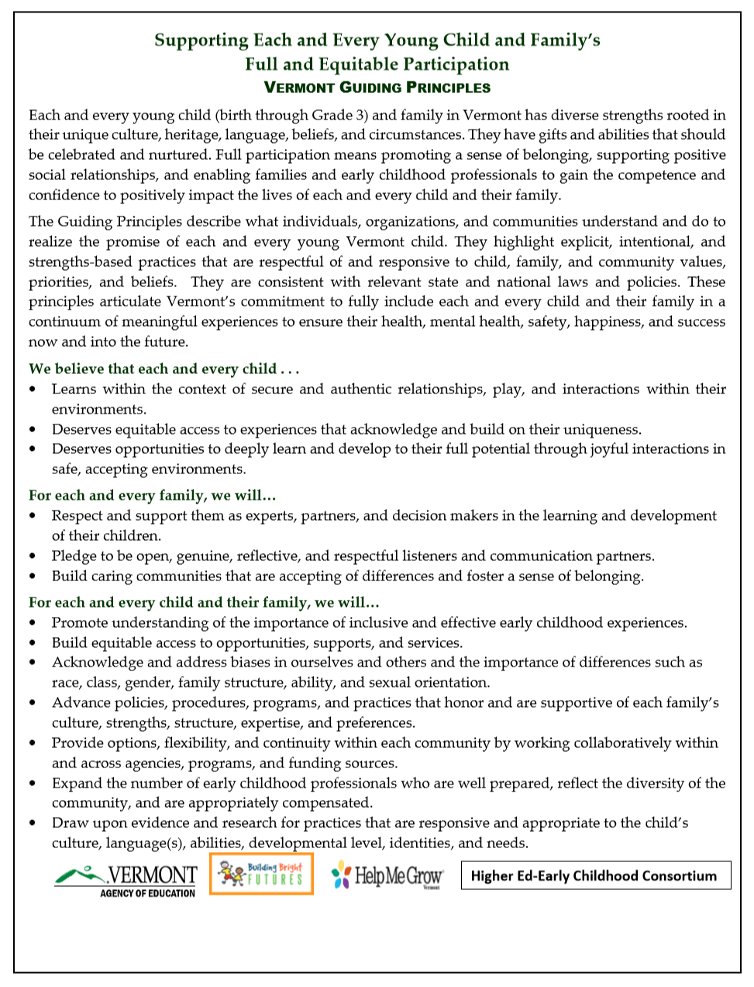

Resources from this Master Class are available at https://fpg.unc.edu/presentations/possible-powerful

