Vermont Early Learning Standards Shorthand Guide
Use these abbreviations to create shorthand that refers to a specific location within the Vermont Early Learning Standards (VELS). Here’s how.

Shorthand | Domain
AL | Approaches to Learning
SE | Social and Emotional Development
GR | Growing, Moving, and Being Healthy
LA | Language Development
LI | Literacy Development
CR | Creative Arts and Expression
MA | Mathematics
SC | Science
SS | Social Studies

Shorthand | Age Group
IN | Infants (0-12 months)
YT | Young Toddler (9-18 months)
OT | Older Toddler (18-36 months)
YP | Younger Preschooler (36-48 months)
OP | Older Preschooler (48-60 months)
K | Kindergarten
FG | First Grade
SG | Second Grade
TG | Third Grade

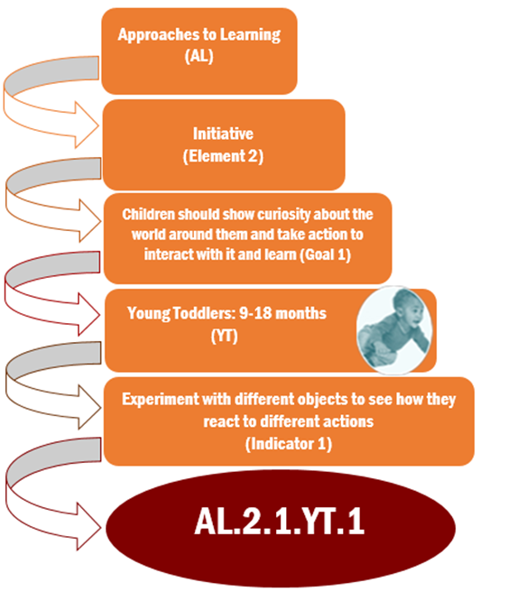
Here are some additional examples of how to write in VELS shorthand:

Creative Arts and Expression (CR) + Music (Element 2) + Children engage in making and listening to music etc. (Goal 1) + Younger Preschoolers (YP) + repeat a short melody (Indicator 2) could be written as CR 2.1.YP.2. This is shorthand for an indicator on page 94 of the VELS.

Mathematics (MA) + Operations and Algebraic Thinking (Element 2b) + children develop and use concepts, properties, and representations etc. (Goal 1) + first graders (FG) + solve word problems that call for addition of three whole numbers whose sum is less than or equal to 20 (indicator 2) could be written as MA 2b.1.FG.2. This is shorthand for an indicator on page 81 of the VELS.

Vermont Early Learning Standards Resources

Free resources are available online to help families and professionals learn about and use the Vermont Early Learning Standards (VELS) to support each and every child. Here are some examples.

VELS resources for families and professionals
http://education.vermont.gov/documents/early-education-early-learning-standards

Resources on each domain of the VELS http://fpg.unc.edu/presentations/vermont-resource-collections

Sign up to get a newsletter called The Right Stuff each month with free VELS resources. To receive your copy, send an email with no message to subscribe-the_right_stuff_listserv@listserv.unc.edu

