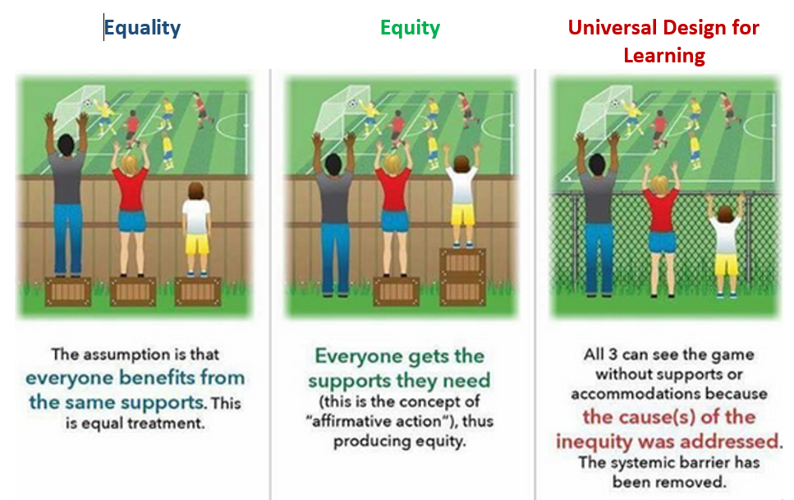

Adapted from an original image by Samty Xiong, Equity Specialist from The Food Group

