Vermont Child Personas

Birth-Grade 3

Each persona is a short story about a Vermont child, from birth through grade 3. The story includes a bit about the child’s family, their learning style and preferences, their interests, and other details. The personas can be a useful tool to support brainstorming or problem solving about how to support an individual child.

Picture of infant
Abby (infant)

Abby lives with her mother, Jill. Her father is currently incarcerated because of crimes related to his opiod addiction. This has created tremendous financial challenges for Jill. Jill’s family lives far away and are not really involved in Abby’s life.

Keeping Abby healthy has been a major focus for her family, based on her multiple and significant allergies. Among other things, she is allergic to milk. Finding things that Abby likes to eat and helping her achieve physical growth milestones has been a challenge. Abby loves to listen and move to music

Picture of Abby, an infant

Piper (younger toddler)

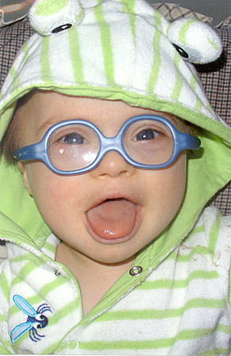Piper is Daniel and Emily’s first child. Emily became pregnant when she was a senior in high school. With help from both sets of grandparents, Daniel and Emily completed high school and have full time jobs. They both admit that they don’t know much about early childhood, but are quickly learning how to support all aspects of Piper’s development. They had never heard of Down syndrome before their doctor shared Piper’s diagnosis with them.

Piper attends a neighborhood childcare program each day, where she receives her early intervention services. Her speech-language pathologist is working with her teacher and family to support early speech and language development.

Piper recently got glasses to correct her significant astigmatism, and everyone has commented on how much this development has supported her interest in puzzles,puppets, and motor games, like rolling a ball.

Picture of Piper,

a younger toddler

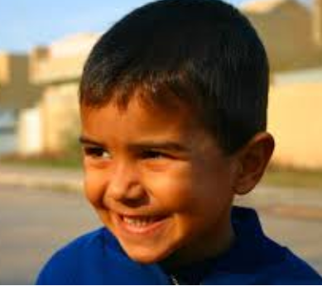Qasim (older toddler)

Qasim is one member of Rutland’s growing immigrant community, having arrived only recently with his mother, father, and older sister, Daba, from Syria. Qasim is two years old.

At home Qasim’s family speaks Arabic, but both parents are taking English classes and are committed to become skilled in the language of their new home. Through an interpreter, Qasim’s parents report that he has an extensive vocabulary and seems to be adding new words and using longer sentences, in Arabic, each day.

The journey to Rutland was a perilous one. His family has shared that Qasim sometimes has bad dreams about their journey that wake him up and require stroking, rocking, and soothing words to get him back to sleep. His family calls him a “little professor” based on the fact that he is extremely curious, quite perceptive, and very interested in how things work.

Picture of Qasim, older toddler

To support his English development and help him begin to feel at home in Vermont, his family is sending him to a nearby early childhood program each day. His teacher reports that he often seems withdrawn and quiet, but is also watching the other children to see and follow what they’re doing.

Soyul (younger preschooler)

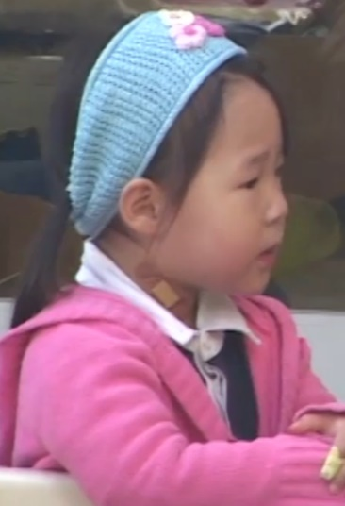Soyul’s mother and father are university faculty members. Both parents are from Korea, and Soyul has only been exposed to the Korean language. She has recently been enrolled in a Vermont PreK program. Conversations with Soyul’s parents, both of whom speak fluent English, have revealed that they are eager for her to learn English in school, and will continue to speak and read Korean at home.

Soyul’s parents are very familiar with the VELS and report that her development is at or beyond age level in all domains. They acknowledged that she is well beyond age level in both Korean language and literacy, though not in English.

Soyul loves reading books and hearing stories in Korean, especially those that have either princesses or heroes. In class, she is very quiet but watches everything that is going on.

Picture of Soyul,

a younger preschooler

Jake (older preschooler)

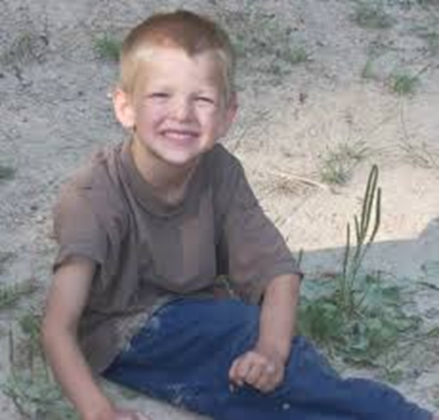Jake is 4-1/2. He is an only child. He lives with his mother and father. His mother has some intellectual challenges. She takes very good care of Jake and sees that his clothes are clean and he is well fed. But she doesn’t know much about how to support the learning and development of a preschooler. By report, Jake has never used crayons, held or read books, or spent time with other young children.

Jake’s dad has had a difficult time finding work lately. The family has moved frequently as Jake’s father has searched for work. Jake has spent time at home with his mother. Jake’s father has recently found a new position that will, hopefully, allow the family a bit more

financial stability. Based on concerns from Jake’s grandparents, he

was recently evaluated and now has an IEP to support his fine motor

and social-emotional development. In addition, Jake has just started attending a PreK program and his therapy services will be delivered in the classroom.

Picture of Jake, an older preschooler

At school, the things Jake plays with are cars, trains, trucks – anything with wheels. He avoids doing fine motor activities. When he is asked to do fine motor activities like stacking small blocks, using scissors and crayons, or completing simple puzzles, he appears to get frustrated, but doesn’t seem to be able to explain how he feels or why he’s unhappy. His teachers report that he doesn’t have any friends yet and hasn’t mastered the concepts of sharing or turn taking.

Simon (kindergartener)

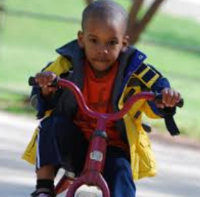

Simon was adopted at birth by his moms, Julie who Simon calls mama and Kathy who Simon calls mommy. Simon is on the autism spectrum, a diagnosis that was made when he was 18 months old.

In PreK, Simon received early childhood special education services at his inclusive child care program. With great support from his teachers, therapists, and family, Simon made significant progress.

In Kindergarten, Simon’s teachers report that he excels in all academic areas. His teachers and family both identify outdoor play as Simon’s favorite activity. After time to run, jump, and climb, Simon is reported to return to the classroom calmer

and more ready to learn.

In interactions with adults, Simon often avoids eye contact. His responses in social interactions with adults are often curt and inconsistent. When there are changes in the classroom routines or other unexplained occurrences, Simon’s teachers report that he becomes agitated and angry.

Picture of Simon, a kindergartener

Rose (1st grader)

First GraderRose’s family says she wakes up every morning full of excitement for school. Her day starts and ends with a song, as music and her younger brother Charlie are her very favorite things.

Rose has Williams Syndrome, a rare, spontaneously occurring genetic syndrome. This makes some things more difficult for her. “*With the right supports*,” say her mom and dad, “*she is able to shine and bring great joy, empathy and perseverance to every task!*”

The ongoing health issues that are part of Williams Syndrome are under control, but Rose has an IEP and benefits from special instruction, speech/language, occupational therapy, and physical therapy services. Rose has a broad-based and unstable gait, which requires attention to environmental design to keep her safe.

Rose is a visual learner who benefits tremendously from concrete

language and examples. Sequential instruction with intentional

encouragement is very important for Rose’s success.

Picture of Rose, a first grader

Marisol (2nd grader)

Marisol’s mother and father came to the US 15 years ago and are now both U. S. citizens. While both parents speak English, they speak Spanish at home to make sure that Marisol is fluent in both languages. Building Marisol’s language, vocabulary, and literacy in both English and Spanish is a very high priority for Marisol’s family.

A complication in achieving this priority is the fact that Marisol, based on a thoughtful referral from her first-grade teacher, has been identified as having a specific language impairment, which is reflected in delays in her receptive and expressive language in both English and Spanish.

Each summer, Marisol and her family spend time in Puerto Rico so she can interact with extended family members in Spanish. Her parents have shared a concern because some children have recently teased her for using a combination of English and Spanish words in her classroom conversations.

Marisol is very interested in geography. She has a globe in her room and loves playing a game where she finds a place on the globe then hears stories from her parents about that place.

Math is her least favorite subject but she struggles to keep up with her classmates. She does best when the mathematical concepts are presented within the context of a story so the context can support her understanding.

Picture of Marisol, a second grader



Montgomery (3rd grader)

Montgomery prefers everyone to call him Monty, so it doesn’t sound like he’s in trouble. He lives with his mom and his younger sister, Evelyn. Monty’s dad was killed in Iraq six months ago. The family has relocated to be near Monty’s paternal grandparents. Stories with fathers in them seem to make Monty sad.

Monty’s family places a high priority on discussing options and solutions. Their idea of how to figure something out is to talk with others, then arrive at a decision. This sometimes means that Monty is talking with other children when given an assignment instead of doing his work alone. Often when he is asked to work independently, his attention wanders.

Picture of Montgomery,

a third grader

Monty’s favorite television program is Chopped and he wants to be a chef when he

grows up. His mother thinks this may be connected to Monty’s strong math skills,

since cooking requires a good deal of measurement and the use of fractions.